***A signed copy of this form must be submitted with every assignment. If the statement is missing your work may not be marked.***

**Student Declaration**

I confirm the following details:



Statement and Confirmation of Own Work

|  |  |
| --- | --- |
| **Candidate Name:** | **Gagan Raj Dangol** |
| **Candidate ID Number:** | 00172900 |
| **Qualification:** | **L5DC** |
| **Unit:** | **Computing Project** |
| **Centre:** | **Softwarica college of IT and E-commence** |
| I have read and understood both NCC Education’s *Academic Misconduct Policy* and the *Referencing and Bibliographies* document. To the best of my knowledge my work has been accurately referenced and all sources cited correctly.  I confirm that this is my own work and that I have not colluded or plagiarised any part of it. | |
| **Candidate Signature:** |  |
| **Date:** | **2019/04/30** |

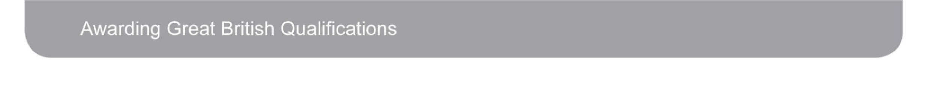

**CN_**

**Woodcraft Store Management System**

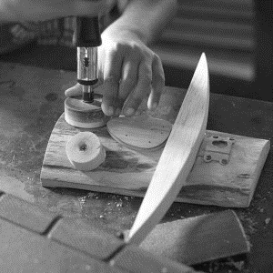

**Gagan Raj Dangol**

**00172900**

**Computing Project**

**Level 5 Diploma in Computing**

**Email:** [dangolgrozen123@gmail.com](mailto:dangolgrozen123@gmail.com)

**Softwarica College of IT & E-Commerce**

***Kathmandu, Nepal***

01/27/2019

**Submitted to**: Kiran Rana

Acknowledgement

I would like to thank Module Leader Kiran Rana Sir for the opportunity to set off this project and for his support and guidance throughout the project.

I would also like to thanks to all my supportive friends and teachers. Their teachings and suggestion were really valuable.

Abstract

Woodcraft Store Management System is a web-based application software that focuses on providing its customers with best web-services. Moreover, e-commerce facilities and also other services that facilitates stock management, information gathering, etc.

**Contents**

Chapter 1: Introduction 1

1.1 Problem Background to the system 3

1.2 Aims 4

1.3 Objectives 4

1.4 Overview of the project design 4

5

Chapter 2: Analysis 5

2.1 Introduction to Analysis 6

2.1.1 Needs for Analysis 6

2.1.2 Object Oriented Analysis 6

2.1.3 Merits and Pitfalls of the Project 6

2.2 Requirements 7

2.2.1 Functional Requirements 7

2.2.2 MoSCoW Prioritization 7

2.3 Natural Language Analysis (NLA) 9

2.4 Initial Class Diagram 9

2.5 Use Case 10

2.6 Development Methodology 12

2.6.1 Waterfall Model 12

2.7 Design Pattern 13

2.8 Architecture 14

16

Chapter 3: Design 16

3.1 Justification 17

3.2 Dynamic Modeling 18

3.2.1 Sequence Diagram: 18

Justifications 18

Advantages 18

Disadvantages 18

3.2.2 Activity Diagram: 20

Justifications 20

Advantages 20

Disadvantages 20

3.3 Structural Modeling 21

3.3.1 Class Diagram: 22

Justification 22

Advantages 22

Disadvantages 22

3.4 Database Modeling 24

3.4.1 ER Diagram: 24

Justification 24

Advantages 24

Disadvantages 24

3.4.2 Data Flow Diagram 26

Justification 26

Advantages 26

Disadvantages 26

3.5 Data Dictionary 28

3.6 Prototype 31

Chapter 4: Implementation 32

4.1 Framework 33

4.2 User Interface (UI) 33

34

Chapter 5: Testing 34

Introduction 35

Unit Testing 35

Black box testing 35

5.1 URL 36

5.2 Registration 37

5.3 Login 38

5.4 Add Item 40

5.5 Delete Item 42

5.6 Items 43

5.7 Order 44

5.8 Order List 46

5.9 Forum 47

49

Chapter 6: Other Project Issues 49

6.1 Risk Management 50

6.2 Configuration Management 52

6.3 Time Scheduling 53

6.4 User Manual 56

6.5 Limitations 57

6.6 Future Work 57

Chapter 7: Conclusion 58

Chapter 8: References 60

Chapter 9: Appendix 62

9.1 User Interface (UI) 63

9.1.1 Home Page 63

9.1.2 Register 64

9.1.3 Login 65

9.1.4 User Home Page 66

9.1.5 Order 67

9.1.6 Order Processing 68

9.1.7 Bill 70

9.1.8 Orderlist 72

9.1.9 Forum 74

9.1.10 Update Profile 75

9.1.11 About Us 76

9.1.12 Inventory 78

9.1.13 Help 79

9.2 Controller 80

9.2.1 Wcmscontroller 80

9.2.2 LoginController 81

9.2.3 RegisterController 82

9.2.4 ForumController 82

9.2.5 ForumReplyController 83

9.2.6 ItemController 83

9.2.7 OrderController 84

9.2.8 Settings 85

9.3 Migrations 86

9.3.1 usertype 86

9.3.2 user 87

9.3.3 item 88

9.3.4 order 89

9.3.5 forum 90

9.3.6 forumreply 91

9.4 Database in SQL Server 92

9.3.1 usertype 92

9.3.2 user 92

9.3.3 item 93

9.3.4 order 93

9.3.5 forum 93

9.3.6 forumreply 94

List of Figures

Figure 1: Initial Class Diagram 9

Figure 2: Use Case Diagram 11

Figure 3: Waterfall Model 12

Figure 4: MVC Pattern 14

Figure 5: 3-Tier Architecture 15

Figure 6: Item Sequence Diagram 19

Figure 7: Login Sequence Diagram 19

Figure 8: Order Item Activity Diagram 21

Figure 9: Inventory Activity Diagram 21

Figure 10: Update Profile Activity Diagram 21

Figure 11: Final Class Diagram 23

Figure 12: ER Diagram 25

Figure 13: Data Flow Diagram 27

Figure 14: Tree Chart 52

Figure 15: GitHub Repository 52

Figure 16: Time Scheduling 54

Figure 17: Gantt Chart 55

# 

# Chapter 1: Introduction

**Introduction**

Woodcraft Store Management System is a web-based application software that focuses on providing its customers with best web-services. Moreover, e-commerce facilities and also other services that facilitates stock management, information gathering, etc.

Laravel is a PHP framework for developing web-base and desktop applications and is object oriented. For the development of Handicraft Store Management system, I chose Laravel.

## Problem Background to the system

The transactions held on the store were based on bills and receipts. Customers order products either by telephone or going into the store. Recordkeeping is paper-based and recorded into registers and files. This led to tenuous working environment. Growing business and customers made it difficult to manage the records.

The sole purpose of this project is to develop a web-application that computerizes above tasks. The application enables customers/users to engage with the store using their phone and computers and held daily transactions, as similar to an e-commerce site. Use of database tools leads to proper management and safety of records. Thus, the project will help in overcoming these difficulties.

## Aims

The major aims of the project are:

* To automate and simplify daily transaction of the store
* Keeping the business relations intact
* Keep the customers/users engaged with the store

## **Objectives**

To obtain above goals following objectives are to be considered:

* Perform analysis and gather requirements
* Create user friendly interface
* Design database
* Perform testing
* Perform maintenance
* Provide online shopping services
* Produce a well-documented report
* Design logical and physical diagrams
* Perform proper Testing
* Perform Maintenance

## Overview of the project design

Woodcraft and its collection is a hobby for many people. Handmade crafts are valued even more. People are less aware of the varieties of products that the store possesses and most people are not even aware of the traditional values that woodcarving carries along with it. It is within the aim of the store to publicize and promote their products but primarily maintain and manage their daily transactions held with their customers and wholesalers.

This project is ought to help complete this aim. It leads to a web-based application that lets the customers to place product-order, bill-order and others through internet. It also allows customers to instantly get information and share if needed, which can contribute in publication and promotion of woodcarving. It also informs the users/customers and wholesalers about ongoing activities. The project ensures to develop an application that is convenient to use and in a way that the users are motivated to keep engaging with the store.

# 

# Chapter 2: Analysis

**Analysis**:

## Introduction to Analysis

Analysis is the process of identification and documentation of requirement of the proposed system. In the analysis phrase, first step is to feasibility study after that we model system in use case diagram and class diagram which is also called system modelling.

### Needs for Analysis

For analysis following things are to be considered before-hand:

1. Identify customer's needs.
2. Evaluate system for feasibility.
3. Perform economic and technical analysis.
4. Allocate functions to system elements.
5. Establish schedule and constraints.
6. Create system definitions.

### Object Oriented Analysis

Object Oriented Analysis (OOA) is an approach to analysis of system by applying object-oriented programming, also using visual modeling throughout the development life cycle. It is used to create a model of the system's functional requirements that is independent of implementation constraints. In OOA, data is modeled by ER diagrams and Data flow diagrams and behaviors are modeled by Activity and Sequence Diagrams.

### Merits and Pitfalls of the Project

**Merits**

* Turn services online i.e. remotely accessible
* Avoids bargains and brawls
* Automate and simplify daily transactions

**Pitfalls**

* Online payment is not available
* Multiple products cannot be ordered at a time
* Services are limited to national borders

## Requirements

Requirements are the conditions/tasks of a project that must be completed to ensure the success of the project. They represent a fine picture of the work that is to be done. On the basis of functionalities, there are two types of requirements: functional and non-functional requirements.

### Functional Requirements

Functional requirements are the features and functions of the product that must be implemented to let users to complete their tasks. It determines **what** a system should do.

**Non-Functional Requirements**

Non-Functional requirements are the behaviors of the system which establish constraints of the system’s functionality. In other words it enhances work flow the functionalities. It determines **how** a system is supposed to be.

### MoSCoW Prioritization

MoSCoWprioritization method is a widely used prioritization technique used for management over business analysis, project management and software development fields to make stakeholders understand the importance of project requirements with respect to their priorities. It is also known as MoSCoW analysis

MoSCoW stands and defines for following phrases:

**M** = Must Have

**S** = Should Have

**C** = Could Have

**W =** Won’t Have

Each of which explains the weight of the priority that requirements get.

Functional Requirements and their dependencies with MoSCoW prioritization:

|  |  |  |  |  |
| --- | --- | --- | --- | --- |
| **S.N.** | **Requirements** | **Prioritization MoSCoW** | **Description** | **Dependency** |
|  | Login | **M** | Log into the site to continue where left off | F2 |
|  | Registration | **M** | Create account to further use the functionalities of the application | - |
|  | Insert Item | **M** | Adding items/products to the site to let users/customer order them | F1 |
|  | Update Item | **S** | Edit the details or information of items originally provided while adding | F3 |
|  | Delete Item | **S** | Delete items that are no longer required or out of stock | F3 |
|  | View Item Information | **M** | Retrieve the data of item for all users and non-users | F3 |
|  | Search and select Item | **S** | Retrieve the data of specific item for all users and non-users when searched | F3 |
|  | Home Page | **M** | Landing page for all visitors also known as index | - |
|  | Edit Profile | **S** | Edit user information originally provided by them | F1 |
|  | Order Items | **M** | Users/customer orders the items/products from the site. | F3 |
|  | User Review | **C** | Take review from users and let them rate the products or the site | F1 |
|  | Log Out | **M** | Log out of the site in purpose of security or to change account in the same device | F1 |
|  | Generate Bill | **M** | Produce a bill of products a user just ordered | F10 |
|  | Forgot Password | **C** | Edit password | F1 |
|  | Contact Information | **S** | Show contact and all sort of necessary information to users | F8 |
|  | Visitor Counter | **C** | Counts the number of visitors that visited the website | F8 |
|  | Manage Inventory | **S** | Stock management and sales report | F1 |

Table 1: Functional Requirements

Non-Functional Requirements with MoSCoW prioritization:

|  |  |  |  |
| --- | --- | --- | --- |
| **S. No** | **Requirements** | **MoSCoW** | **Description** |
|  | Security | **S** | Protection of system and its data from both external and internal threats |
|  | Performance | **S** | Resources required, response time, transaction rates, throughput, benchmark specifications |
|  | Availability | **S** | Is the system available at all time, locations and platforms |
|  | Reliability | **S** | How often does the system fails or doesn’t failed at all. Does it work flawlessly when needed |
|  | Maintainability | **S** | Is system repair possible, if yes, how difficult is it to do so |
|  | Usability | **S** | How difficult is it to learn and operate the system also counts time |
|  | Data Integrity | **S** | Is there any chance of data loss and data counterfeit |
|  | Flexibility | **S** | Effort required to make changes in the software. How easy or hard it is to make changes |

Table 1: Non-Functional Requirements

## Natural Language Analysis (NLA)

NLA (Natural Language Analysis) is a process of selecting out nouns, verbs and adjectives to sort classes, methods and attributes respectively from the given scenario. There are several processes for NLA.

Filtering nouns for classes

Following steps are applied for the noun filtration:

1. Listing out nouns
2. Removing repetitive nouns
3. Removing synonyms
4. Removing predictive nouns
5. Removing nouns that are out of scope

## Initial Class Diagram

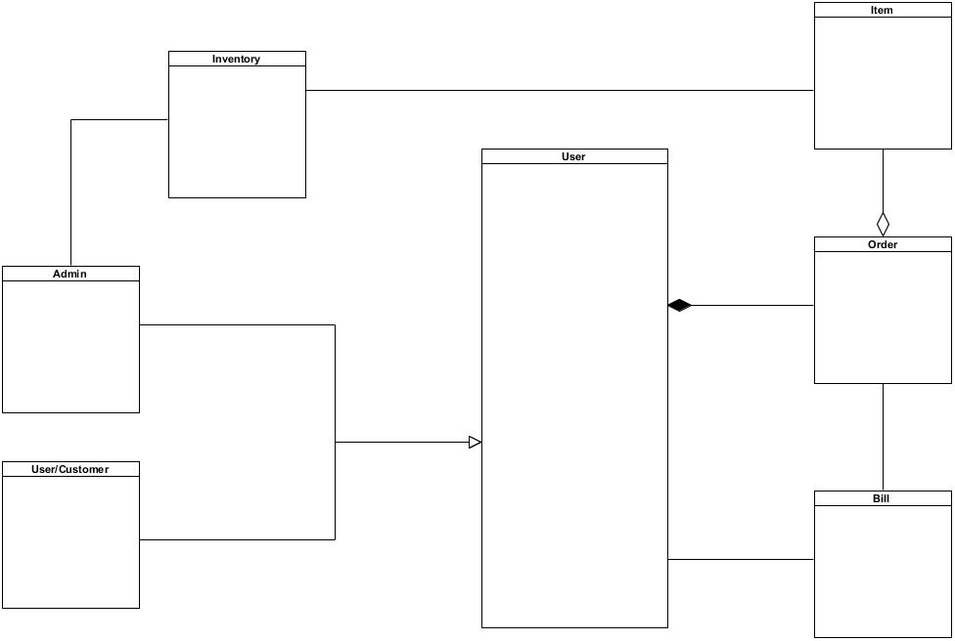

Figure 1: Initial Class Diagram

## Use Case

A use case diagram is the primary form of system requirements for a new software program which is being developed. Simply, it is a graphical representation of the actions that a user and the admin, which are called actors in this context, does with the system. These actions are called use cases.

**Justifications:**

A use case diagram is usually simple, it does not represent the detail of the use cases. It specifies the expected behavior but not the exact method of making it happen. So, the following use case involves user and admin performing their actions in a rough sketch. The system also functions in few ways. Generating bill in this cse.

**Advantages:**

* It helps manage complexity and makes it easier to understand the requirements and the features.
* It can help differentiate actual uses of the system to unnecessary functions.
* It encourages designers to envision outcomes before attempting to specify them.

**Disadvantages:**

* Non-functional requirements are undermined by the use case diagram.
* It is not accurate, it is just a rough sketch of what actually happens.
* There is no interaction between the requirements within it.

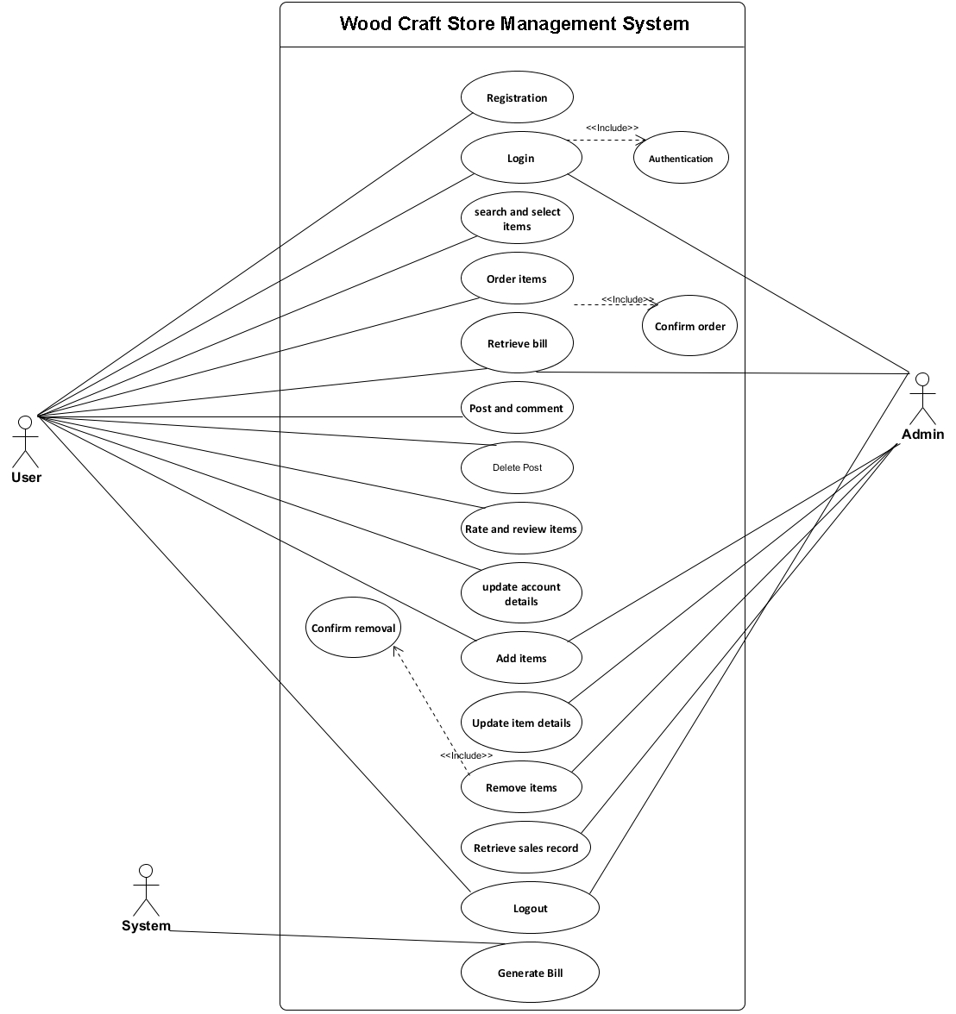

Figure 2: Use Case Diagram

## Development Methodology

### Waterfall Model

Waterfall model is a simple means of software development methodology. It is also referred to as a linear-sequential life cycle model (SDLC). In waterfall model, each phase must be completed before the next phase can begin and there is no overlapping in the phases.

This model is simple and easy to understand and use. It is easy to manage due to the rigidity of the model. Each phase has specific deliverables and a review process. This is the reason why I used waterfall model.

Following are the steps involved in the waterfall model:

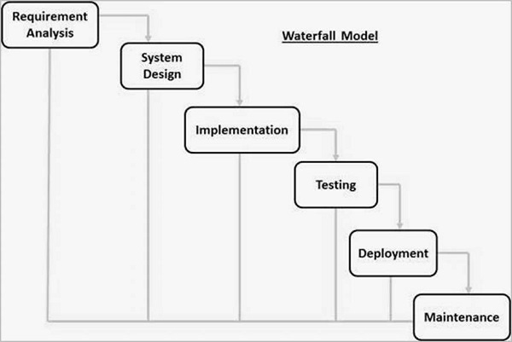

Figure 3: Waterfall Model

* **Requirement Analysis**

It involves understanding what need to be design and what is its function, purpose etc. Here, the specifications of the input and output or the final product are studied and marked.

* **System Design**

The requirement specifications from first phase are studied in this phase and system design is prepared. System Design helps in specifying hardware and system requirements and also helps in defining overall system architecture.

* **Implementation**

With inputs from system design, the system is first developed in small programs called units, which are integrated in the next phase. Each unit is developed and tested for its functionality which is referred to as Unit Testing.

* **Testing**

All the units developed in the implementation phase are integrated into a system after testing of each unit. The software designed, needs to go through constant software testing to find out if there are any flaw or errors.

* **Deployment**

Once the functional and non-functional testing is done, the product is deployed in the customer environment or released into the market.

* **Maintenance**

This step occurs after installation, and involves making modifications to the system or an individual component to alter attributes or improve performance.

## Design Pattern

For this project I chose, Model View Controller (MVC). MVC design pattern specifies that an application consist of a data model, presentation information, and control information. The pattern requires that each of these be separated into different objects. MVC is more of an architectural pattern, but not for complete application.

* The **Model** contains only the pure application data, it contains no logic describing how to present the data to a user.
* The **View** presents the model’s data to the user. The view knows how to access the model’s data, but it does not know what this data means or what the user can do to manipulate it.
* The **Controller** exists between the view and the model. It listens to events triggered by the view (or another external source) and executes the appropriate reaction to these events. In most cases, the reaction is to call a method on the model. Since the view and the model are connected through a notification mechanism, the result of this action is then automatically reflected in the view.

Following are the reasons to choose MVC as the design pattern for this application:

* Multiple developers can work simultaneously on the model, controller and views.
* Changes doesn't affect the model.
* Development process is faster with MVC

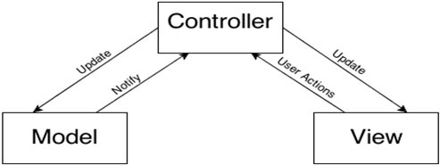

Figure 4: MVC Pattern

## Architecture

A 3-tier architecture is a client-server architecture in which the functional process logic, data access, computer data storage and user interface are developed and maintained as independent modules on separate platforms. Three-tier architecture is a software design pattern and a well-established software architecture.

This architecture is chose for following reasons:

* It helps update one tier's technology stack without affecting other application areas.
* It helps scale up and out the application.
* It adds reliability and more independence of the underlying servers or services.
* It helps cache requests, network usage are minimized and Application and Data Tier loads are reduced. Any tier can load-balanced if necessary.

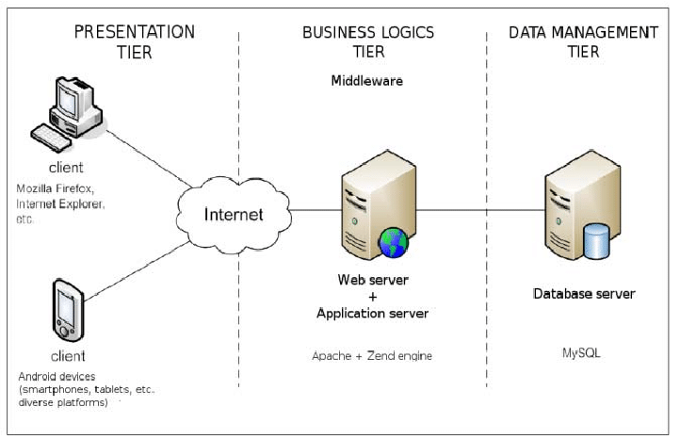

Figure 5: 3-Tier Architecture

# 

# Chapter 3: Design

Design

## Justification

The system is designed to meet the requirements identified in the previous phases during the design phase.The requirements identified in the Requirements Analysis Phase are transformed into a system design document which accurately describes the system design and can be used in the next phase as an input to system development.

The Design Phase's purpose is to transform the requirements into complete and detailed specifications for system design. The Development Team starts the Development Phase once the design is approved. It involves dynamic modeling, structural modeling and database modeling.

## Dynamic Modeling

### Sequence Diagram:

Sequence Diagrams are interaction diagrams that detail how operations are carried out. Sequence Diagrams show elements as they interact over time and they are organized according to object (horizontally) and time (vertically). The sequence diagram is used primarily to show the interactions between objects in the sequential order that those interactions occur.

Justifications**:**

Here, I have drawn sequence diagram to show the high-level interaction between active objects in a system, model the interaction between object instances within a collaboration that realizes a use case, the interaction between objects within a collaboration that realizes an operation and to show all the possible paths through the interaction.

Advantages**:**

* The sequence diagram may be used in object-oriented analysis to validate class diagrams against use cases, or to show the timing of interactions between entities within the system scope.

Disadvantages:

* A sequence diagram must be defined for each possible scenario. Strictly speaking, a sequence diagram requires a fully defined class model.

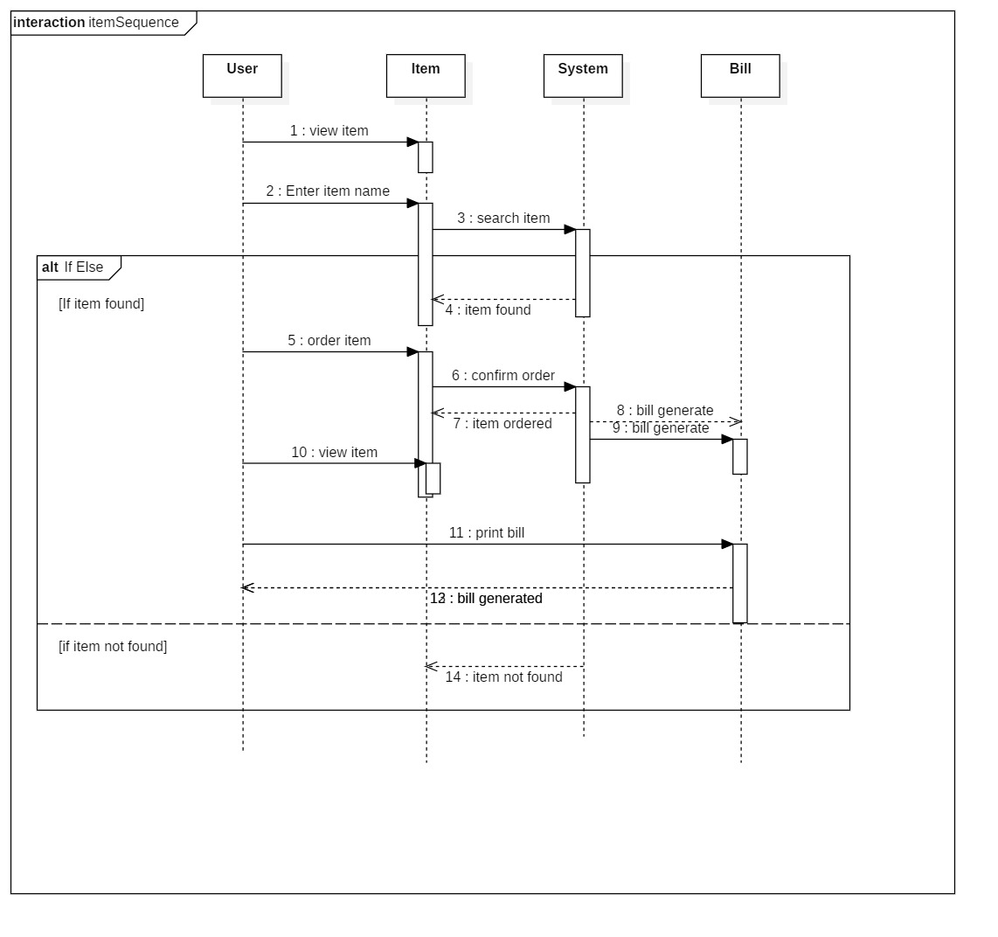

Figure 6: Item Sequence Diagram

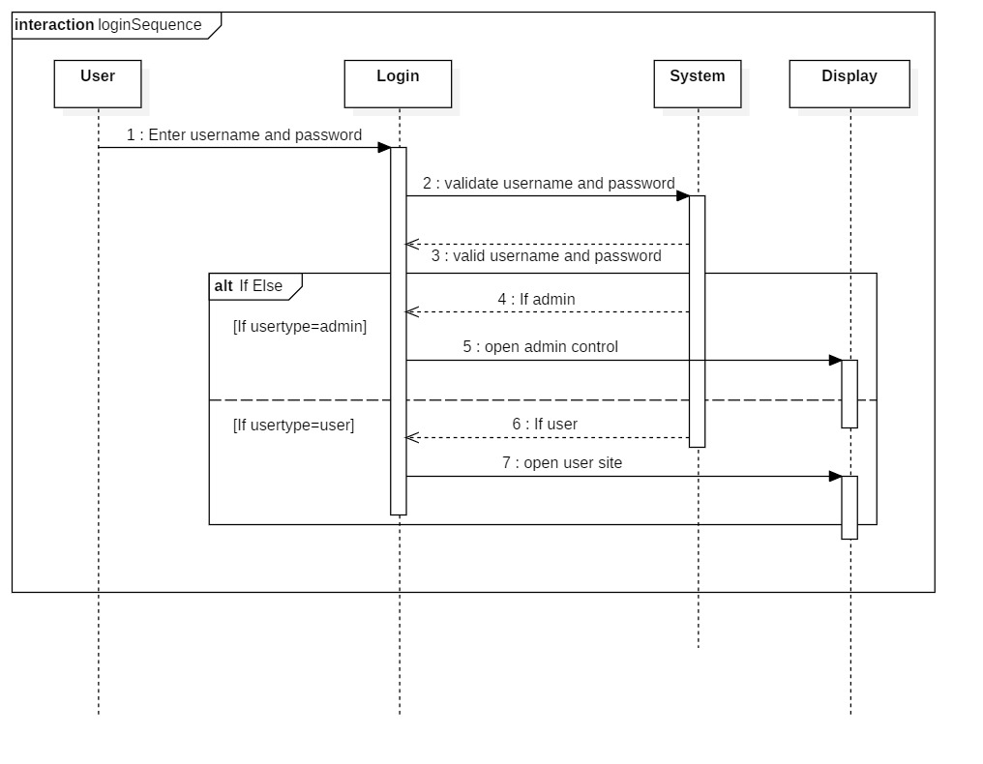

Figure 7: Login Sequence Diagram

### Activity Diagram:

An **activity diagram** is a graphical representation that describe dynamic aspects of the system which is generally considered as an advanced version of flow chart that models the flow from one activity to another activity.

Justifications**:**

The activity diagram here describes how to coordinate activities to deliver a service that can be at various levels of abstraction. Typically, some operations need to achieve an event, especially where the operation is intended to accomplish a number of different things requiring coordination, or how events in a single use case relate to each other, in particular using cases where activities may overlap and need coordination..

Advantages**:**

* UML modeling language included activity diagrams for both analysts and stakeholders are usually easily comprehensible.
* Because they are among the most user-friendly diagrams available, they are generally considered an essential tool in the repertoire of an analyst.
* In addition, as mentioned above, activity diagrams allow an analyst to display multiple conditions and actors through the use of swimlanes within a workflow. However, swimlanes are optional as a single condition or actor is normally shown without the repertoire of them.

Disadvantages**:**

* UML modeling language includes activity diagrams that can become overly complex because their user-friendly nature can lend itself to an all-inclusive description.

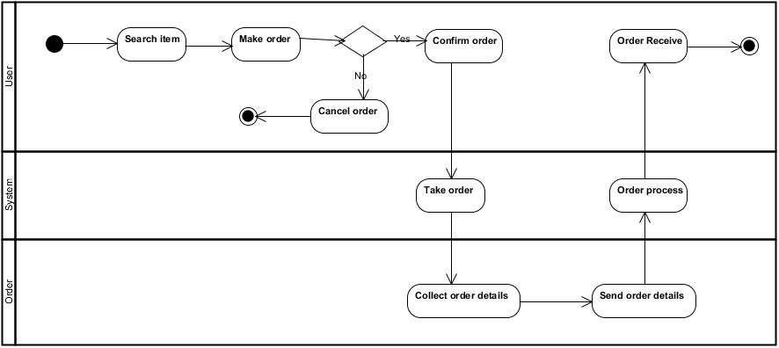

Figure 8: Order Item Activity Diagram

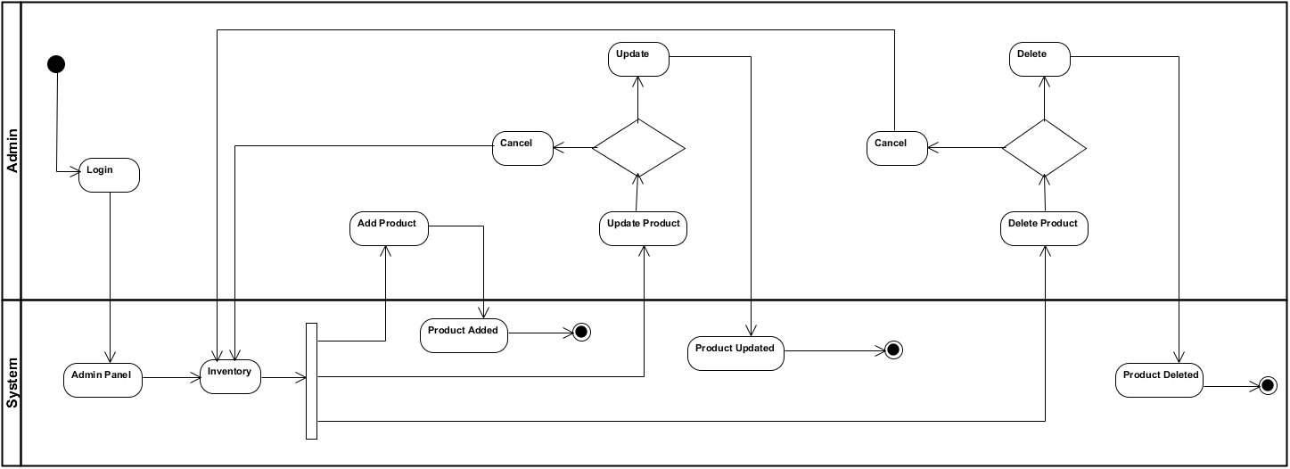

Figure 9: Inventory Activity Diagram

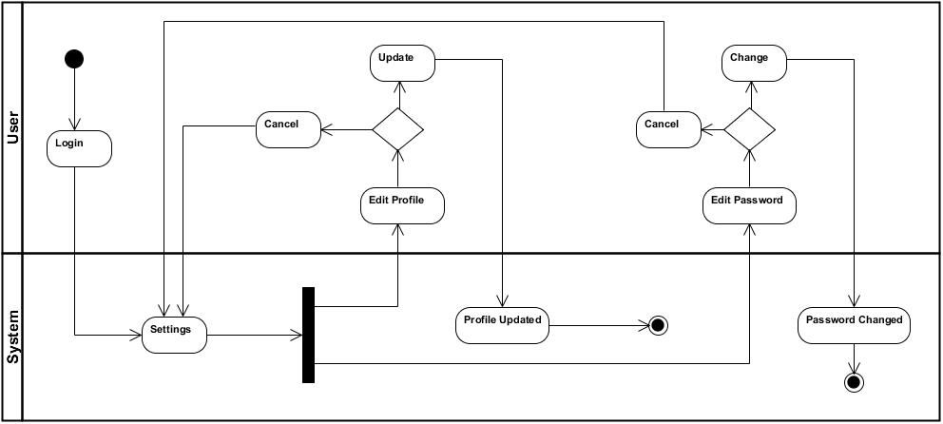

Figure 10: Update Profile Activity Diagram

## **Structural Modeling**

### Class Diagram:

A class diagram is an illustration of the Unified Modeling Language (UML) relationships and source code dependencies between classes. A class defines the methods and variables in an object in this context, which is a specific entity in a program or code unit representing that entity. In all forms of object-oriented programming (OOP), class diagrams are useful. The concept is multiple.

Justification**:**

The classes are arranged in a class diagram in groups that share common features. A class diagram is similar to a flowchart in which classes are portrayed as boxes with three rectangles inside each box. The top rectangle contains the class names; the middle rectangle contains the class attributes; the lower rectangle contains the class methods, also known as operations.

Advantages**:**

* It forces the programmer to think about his / her classes ' structure and how they interact with each other before they actually write any code. This can result in a more robust application.
* It provides a blueprint for maintenance programmers to get an overview of how the application is structured before examining the actual code. This may reduce maintenance time.

Disadvantages**:**

* The programmer may need to learn UML to build the class diagram in the first place.
* The time spent building the class diagram may add to overall development time.

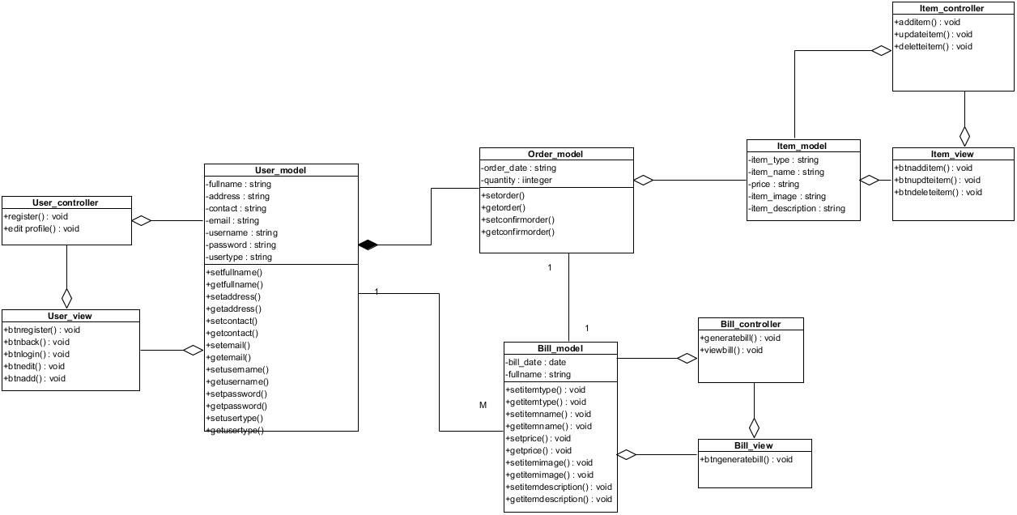Figure 11: Final Class Diagram

## Database Modeling

### ER Diagram:

An **entity-relationship diagram (ERD**) is a data modeling technique that graphically illustrates an information system's entities and the relationships between those entities. An **ERD** is a conceptual and representational model of data used to represent the entity framework infrastructure.

Justification**:**

An entity relationship diagram (ERD), also referred to as an entity relationship model, is a graphical representation of an information system depicting the relationships within that system between people, objects, places, concepts, or events.An ERD is a data modeling technique that can be used as the basis for a relational database to help define business processes.

Advantages**:**

* ER model is very simple because we can easily draw an ER diagram if we know the relationship between entities and attributes.
* ER model is a diagramm of any logical database structure. We can easily understand the relationship between entities and relationship by viewing the ER diagram.
* For database designer, it is an effective communication tool.

Disadvantages**:**

* Some information in the ER model is lost or hidden
* ER model represents a limited relationship in comparison with other models of data such as relational model etc.
* Data manipulation in the ER model is hard to show.

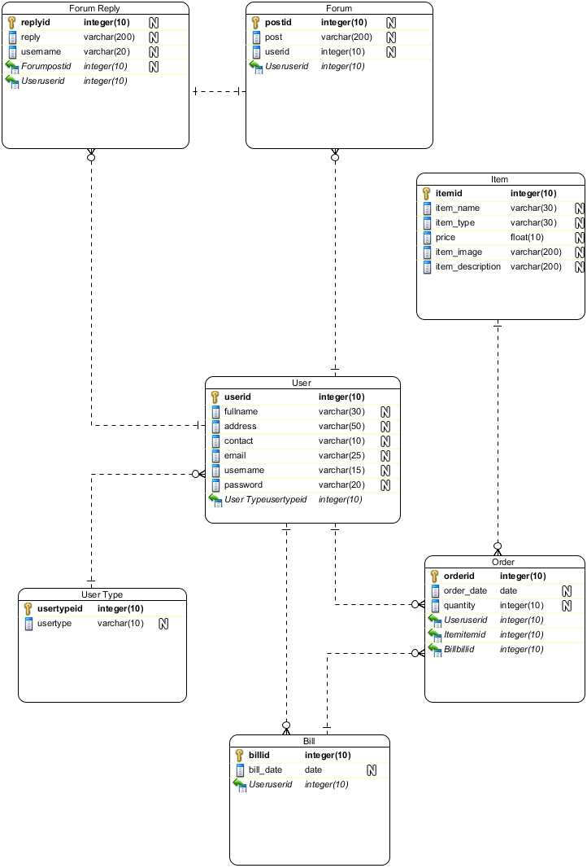

Figure 12: ER Diagram

### Data Flow Diagram

A data flow diagram (DFD) illustrates how data is processed by a system in terms of inputs and outputs. As its name indicates its focus is on the flow of information, where data comes from, where it goes and how it gets stored.

Justification:

Essentially, there are two different types of notes for data flow diagrams (Yourdon & Coad or Gane & Sarson) that define different visual representations for processes, data stores, data flow and external entities.

Data flow diagrams typed by Yourdon and Coad are usually used for system analysis and design, while DFDs typed by Gane and Sarson are more common when viewing information systems.Visually, how processes look is the biggest difference between the two ways to draw data flow diagrams. Processes are depicted as circles in the Yourdon and Coad mode, while the processes are squares with rounded corners in the Gane and Sarson diagrams.

Advantages**:**

* It aids in describing the boundaries of the system.
* It is beneficial for communicating existing system knowledge to the users.
* A straightforward graphical technique which is easy to recognize.
* DFDs can provide a detailed representation of system components.
* It is used as the part of system documentation file.

Disadvantages**:**

* It make the programmers little confusing concerning the system.
* The biggest drawback of the DFD is that it simply takes a long time to create, so long that the analyst may not receive support from management to complete it.
* Physical considerations are left out.

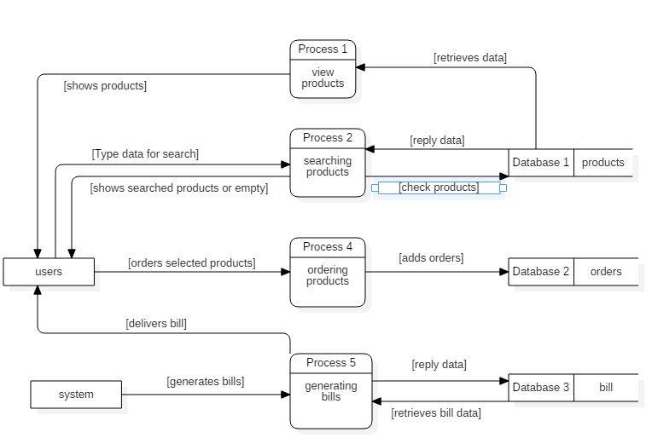

Figure 13: Data Flow Diagram

## Data Dictionary

Data dictionary is a simple yet systematic table that encompasses particular data and information own structures, which is called Metadata. The data dictionary is a crucial component of any relational database. Ironically, because of its importance, it is invisible to most database users. Typically, only database administrators interact with the data dictionary.

**Advantages:**

* It gives the well-structured and clear information about the database. One can analyze the requirement, any redundancy like duplicate columns, tables etc. Since it provides a good documentation on each object, it helps to understand the requirement and design to the great extent.
* It is very helpful for the administrator or any new DBA to understand the database. Since it has all the information about the database, DBA can easily able to track any chaos in the database.

**Disadvantages:**

* Creating a new data dictionary is a very big task. It will take years to create one.
* It should be well designed in advance to take all the advantages of it. Otherwise, it will create problems throughout its life.
* The cost of data dictionary will be bit high as it includes its initial build and hardware charges as well as cost of maintenance

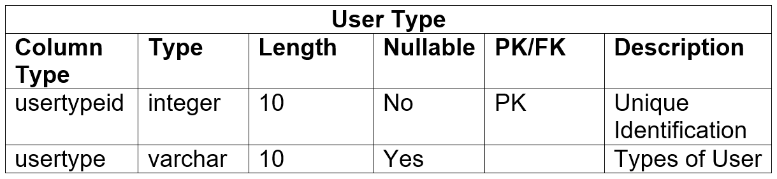

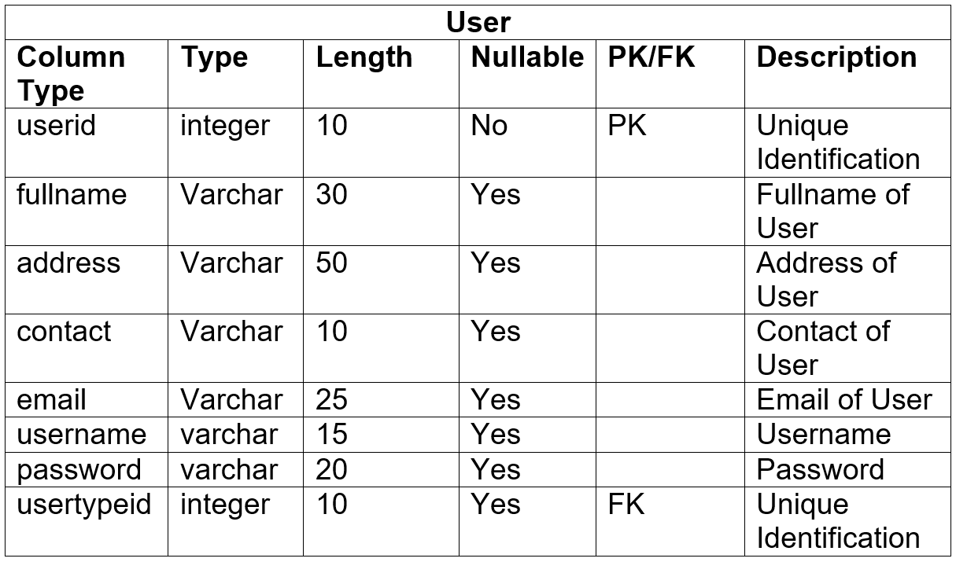

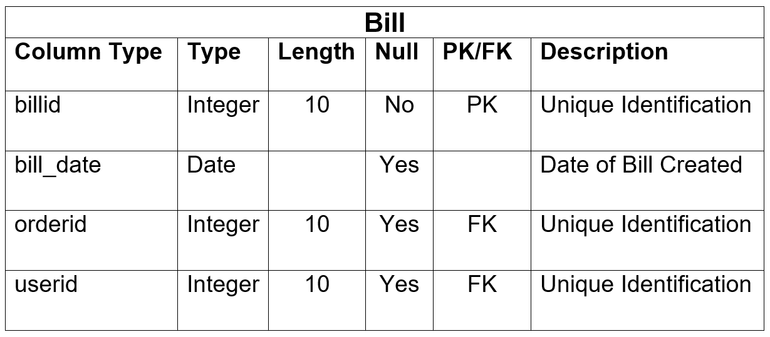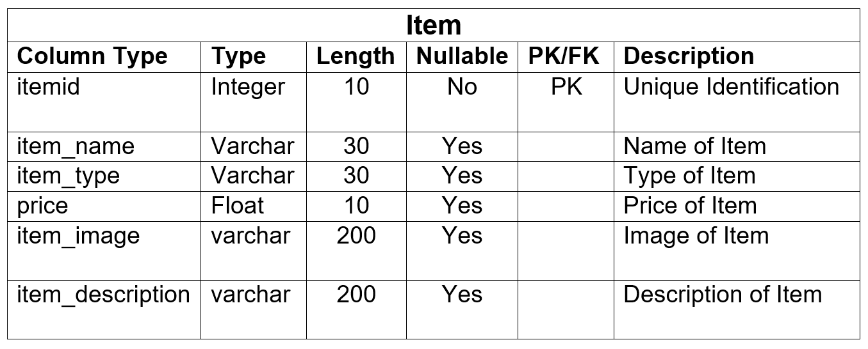

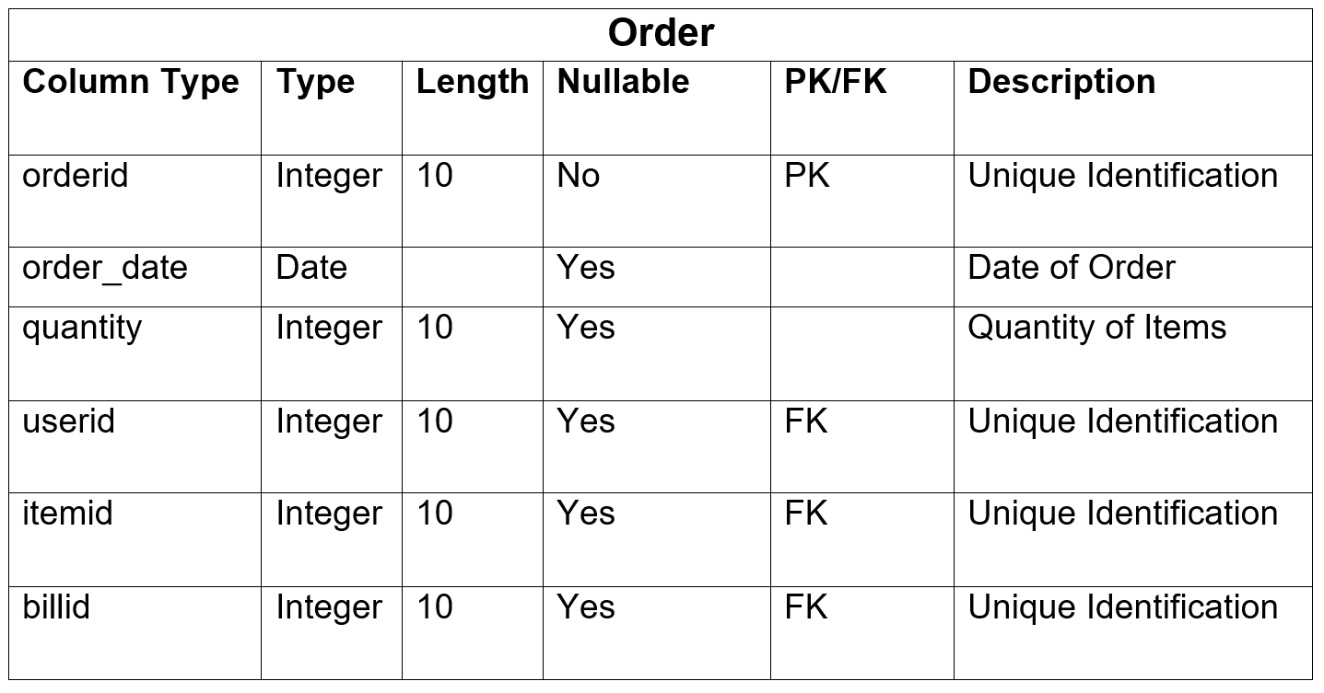

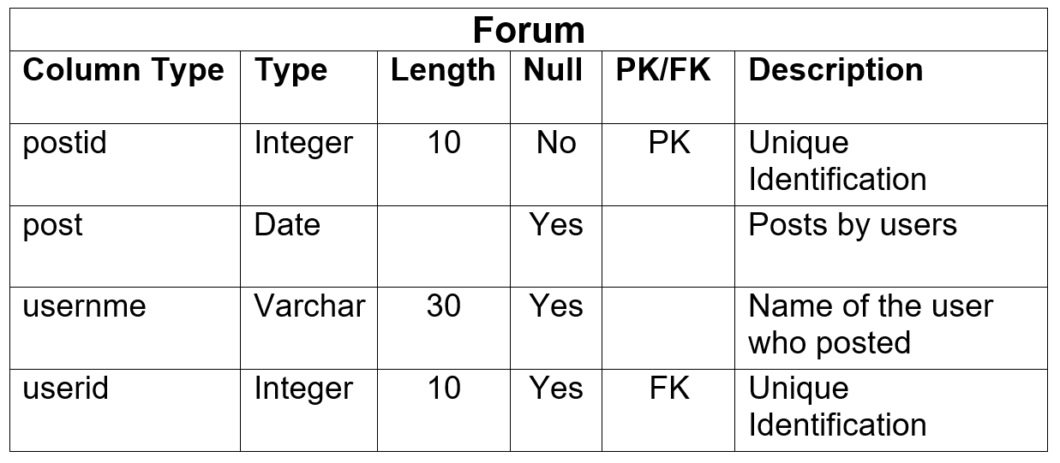

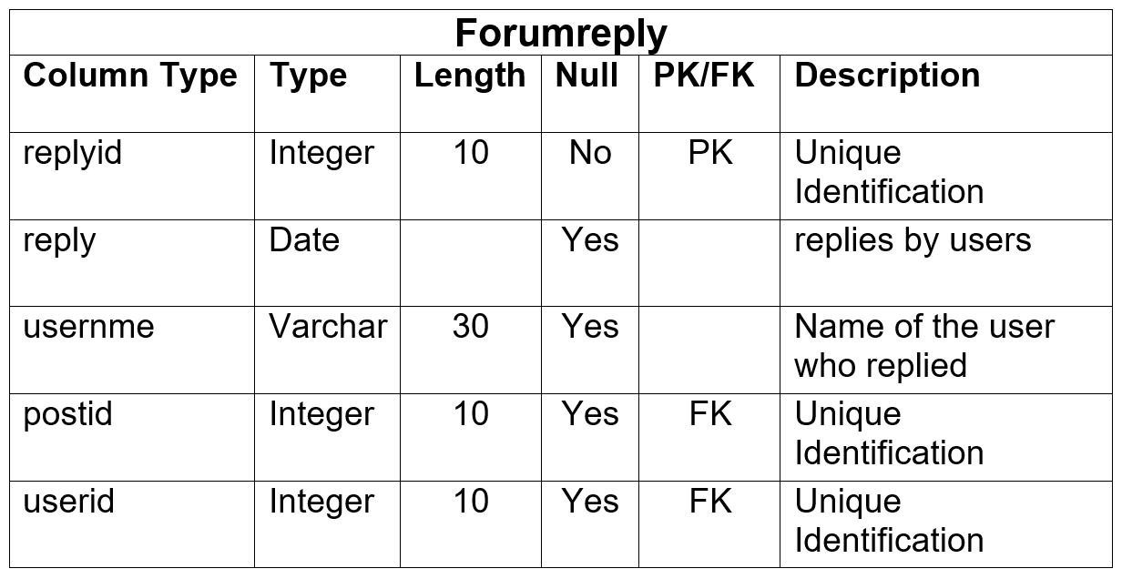

## Prototype

A prototype is an original model, form or an instance that serves as a basis for other processes. In software technology, the term prototype is a working example through which a new model or a new version of an existing product can be derived.

* 1. Login

# Chapter 4: Implementation

Implementation

## Framework

It is the post-design phase where the project plan will begin to work on those plans. The project's entire design is now changing in coding. Accommodation planning will be coded for all projects using PHP programming language. PHP stands for Preprocessor Hypertext (no, the acronym does not follow the name). It is an open source, server-side, and language of scripting used for web application development.

By scripting language, we mean a program written for task automation based on scripts (code lines). Laravel is the framework that is used for this project. Laravel is an expressive, elegant web application framework.

## User Interface (UI)

The user interface (UI) is everything designed into an information device with which a person may interact. This can include display [screens](https://whatis.techtarget.com/definition/screen), [keyboards](https://whatis.techtarget.com/definition/keyboard), [mouse](https://whatis.techtarget.com/definition/mouse) and the appearance of a [desktop](https://searchenterprisedesktop.techtarget.com/definition/desktop). It is also the way through which a user interacts with an [application](https://searchsoftwarequality.techtarget.com/definition/application) or a [website](https://whatis.techtarget.com/definition/Web-site). The growing dependence of many companies on [web applications](https://searchsoftwarequality.techtarget.com/definition/Web-application-Web-app) and mobile applications has led many companies to place increased priority on UI in an effort to improve the user's overall experience.

The screenshots of working application/UI are included in this report (see Appendix) along with the screenshots of its Laravel and HTML codes, respectively.

# 

# Chapter 5: Testing

Testing

## Introduction

Software testing is an investigation conducted to provide stakeholders with information on the quality of the software product or service being tested.[1 ] Software testing can also provide an objective, independent view of the software to enable the company to appreciate and understand the risks of implementing software. Testing techniques include the execution of a program or

**Test case or Test plan**: It is the documentation of specific test with objectives, resource and process of testing.

## Unit Testing

UNIT TESTING is a software test level where a software tests individual units / components. The purpose is to validate the performance as designed by each unit of the software. A unit is any software's smallest testable part. Usually it has one or several inputs and usually one output.

Advantages of unit testing;

* Fix bugs in early development cycle.
* Improves the quality of code.
* Reduces defects and bugs.
* Less costly.

## Black box testing

BLACK BOX TESTING is a software testing method in which the tester does not know the internal structure / design / implementation of the item being tested. These tests, though usually functional, may be functional or non-functional.Advantages of black box testing;

* Validates the functional requirement.
* Test can be done through end user’s point of view.
* No need of technical person for testing.

#### URL

|  |  |
| --- | --- |
| Test case no. | T1 |
| Purpose of the case | Exploring Home Page |
| Test data | url: 127.0.0.1:8000 |
| Class name | UnitTest |
| Function name | testURL |
| Expected result | Open home page |
| Actual result | Open home page (index) |
| Conclusion | Actual results matches the expected results |

Unit Testing

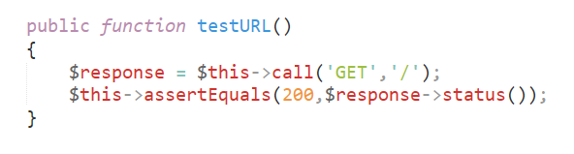

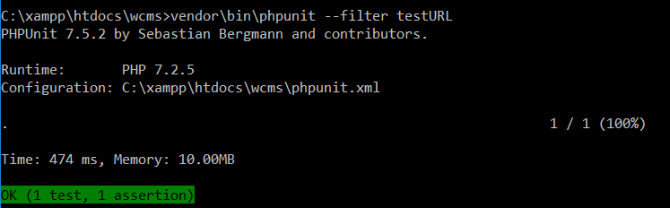

****Black boxTesting

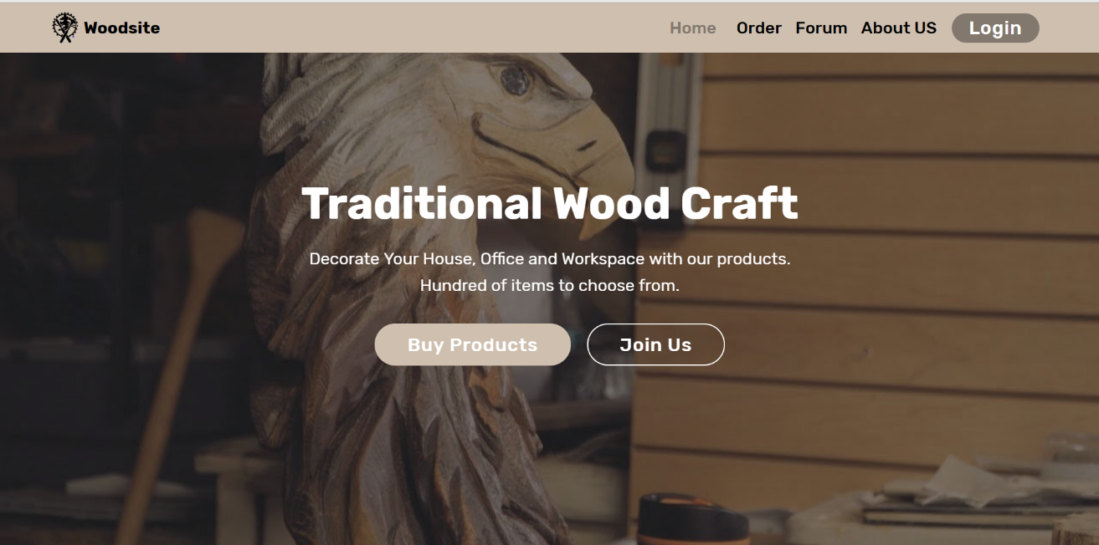

#### Registration

|  |  |
| --- | --- |
| Test case no. | T2 |
| Purpose of the case | Registering new user |
| Test data | fullname: Gagan Raj Dangol  address: Khokana, Lalitpur  contact: 9860058411  email:dangolgrozen123@gmail.com  username: gagan  password: gagrangol |
| Class name | UnitTest |
| Function name | testRegistration |
| Expected result | Register and go to login page |
| Actual result | Register and go to login page |
| Conclusion | Actual results matches the expected results |

UnitTesting

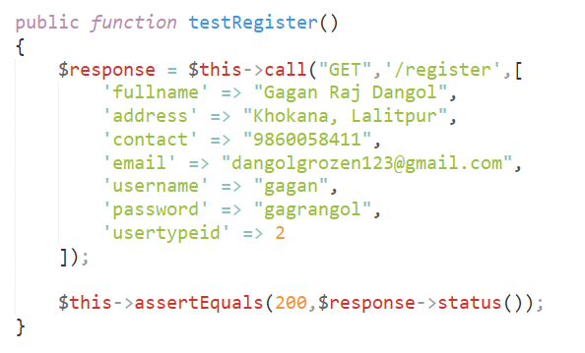

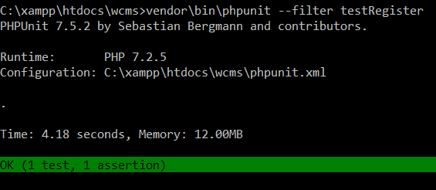

Black box Testing

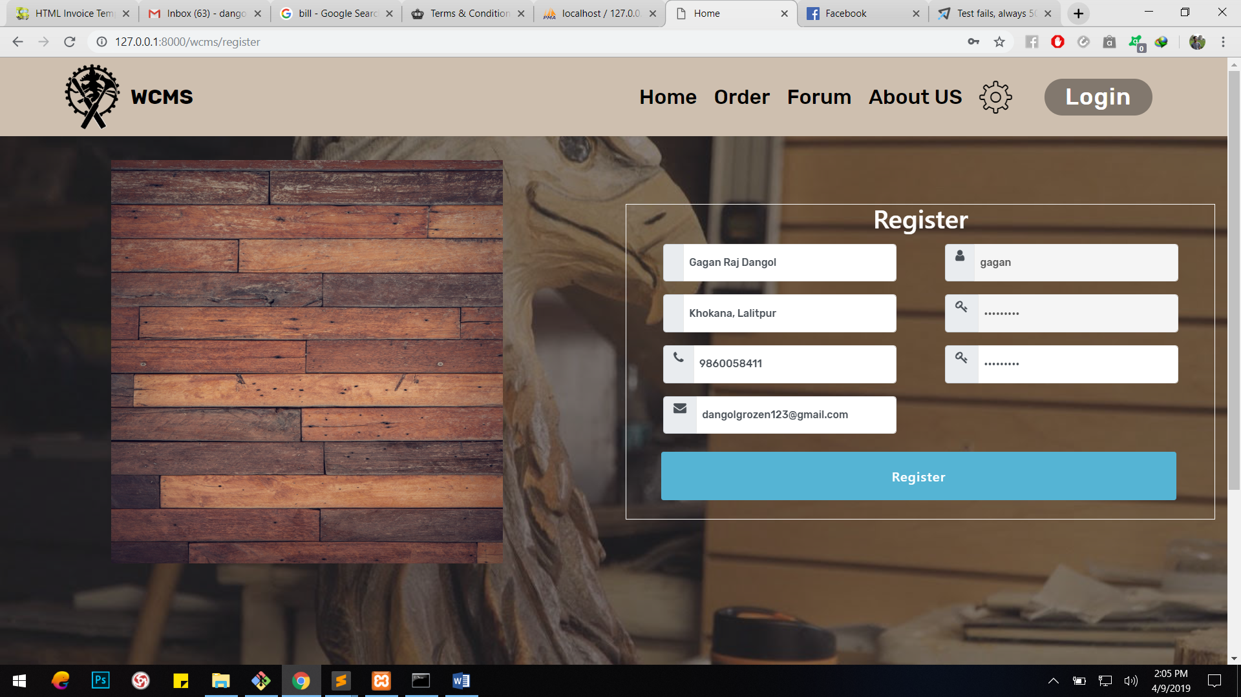

#### Login

|  |  |
| --- | --- |
| Test case no. | T3 |
| Purpose of the case | Login to the site |
| Test data | username: gagan  password: gagrangol |
| Class name | UnitTest |
| Function name | testLogin |
| Expected result | Login and go to index |
| Actual result | Login and go to index |
| Conclusion | Actual results matches the expected results |

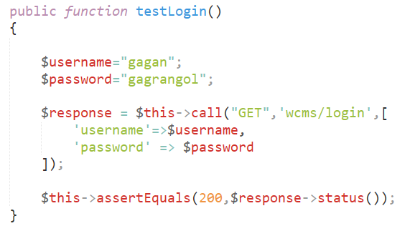 UnitTesting

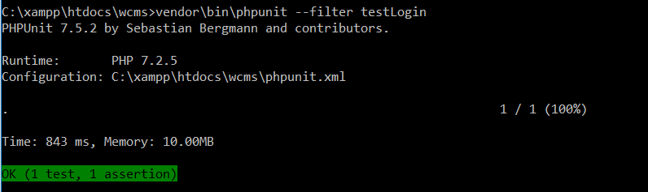

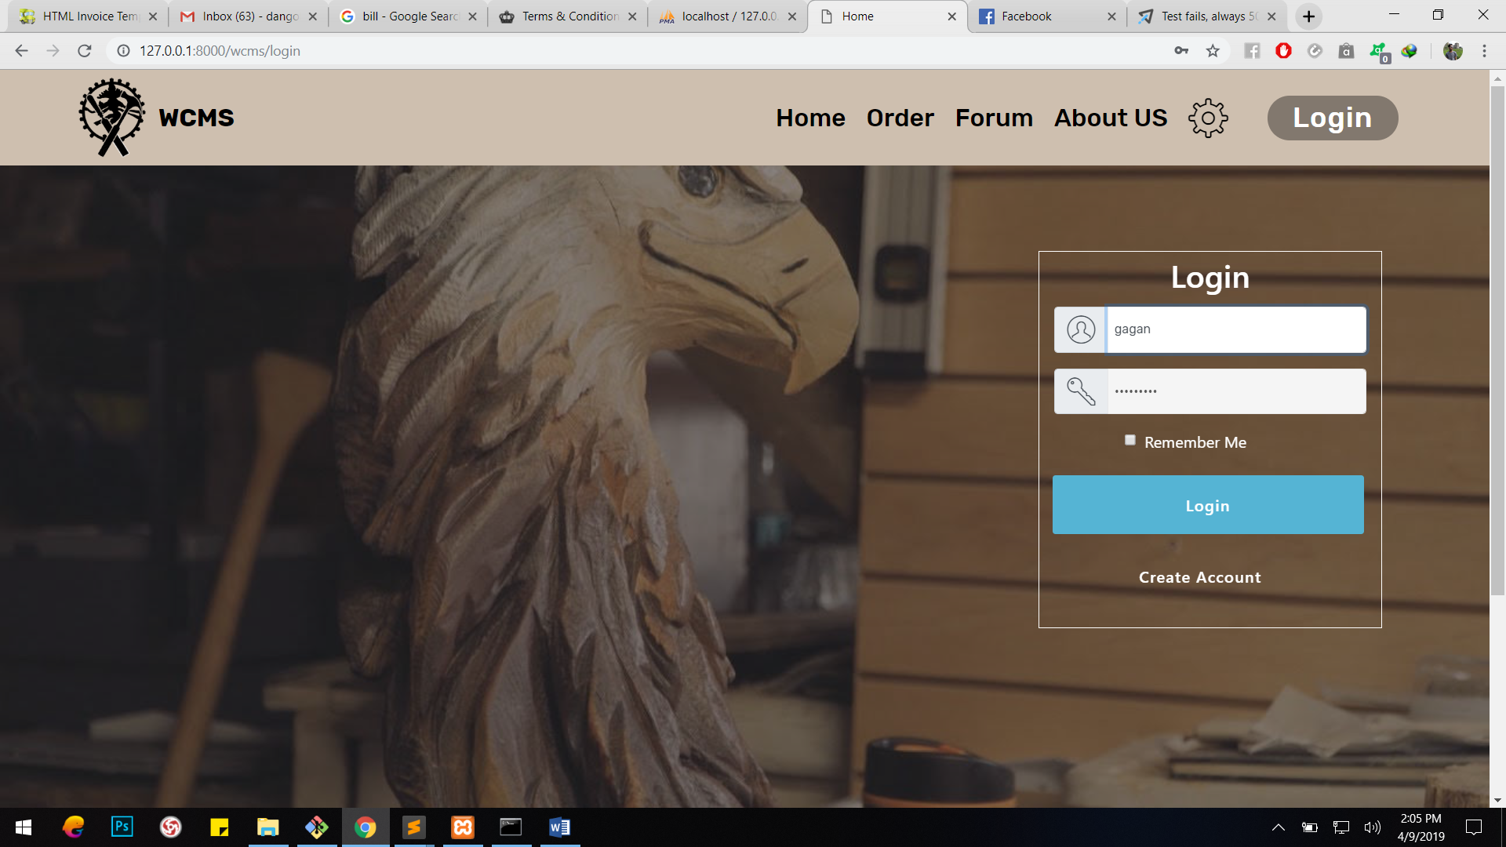BlackboxTesting



#### Add Item

|  |  |
| --- | --- |
| Test case no. | T4 |
| Purpose of the case | Inserting new item |
| Test data | item_name: Ganesh  item_type: C  price: 12000  item_description: Idol |
| Class name | UnitTest |
| Function name | testAddItem |
| Expected result | Add item and go to inventory |
| Actual result | Add item and go to inventory |
| Conclusion | Actual results matches the expected results |

UnitTesting

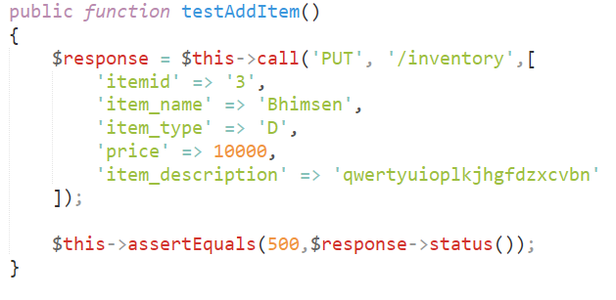

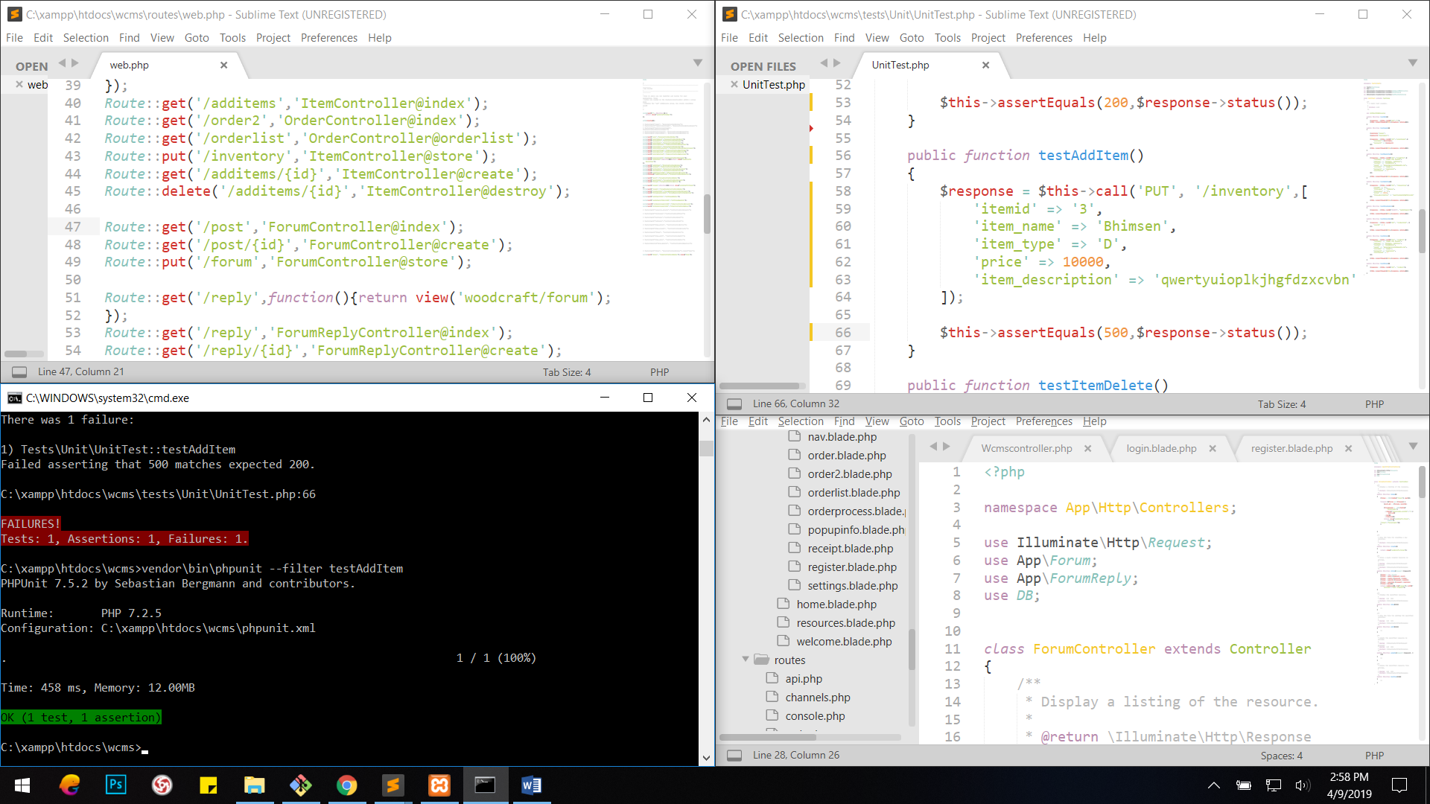

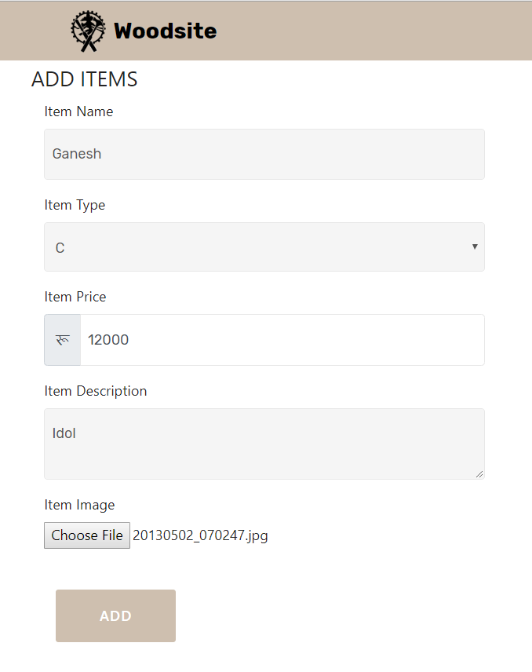

BlackBoxTesting

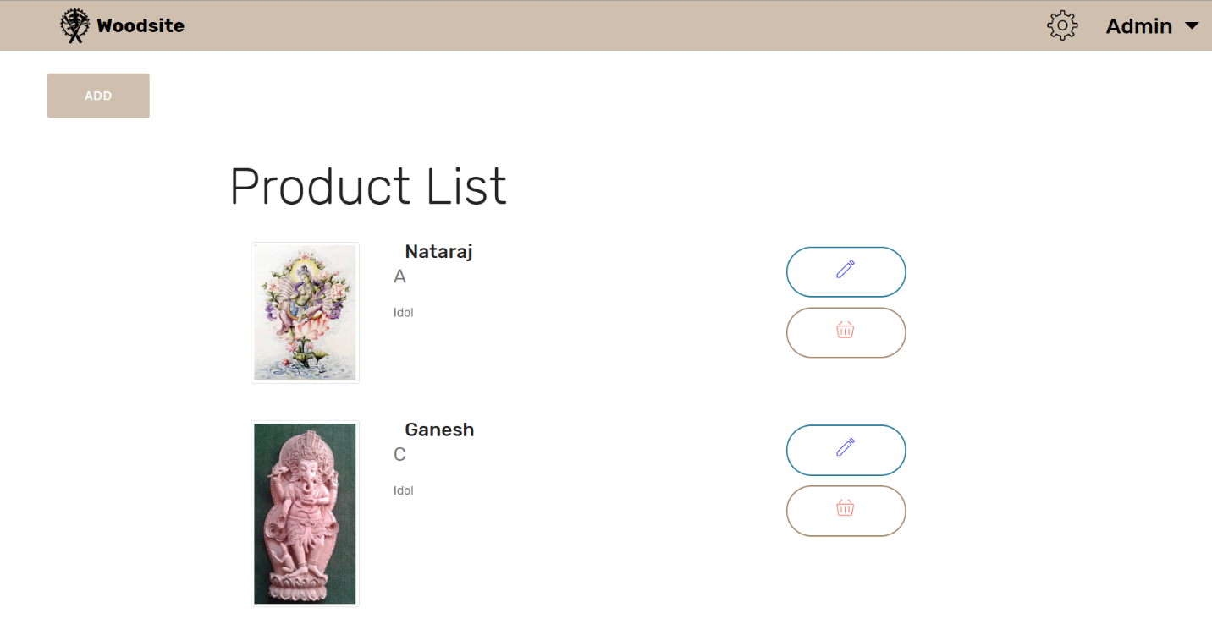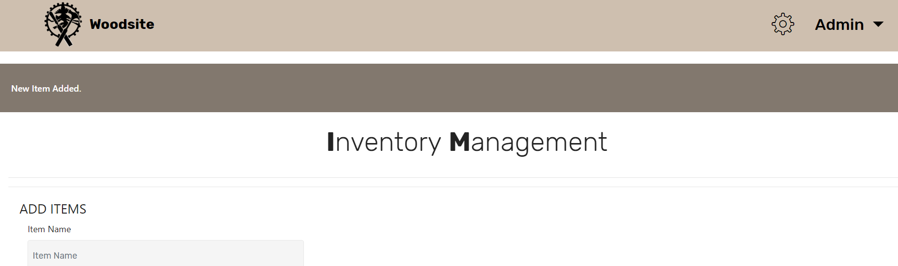

#### Delete Item

Unit testing

|  |  |
| --- | --- |
| Test case no. | T5 |
| Purpose of the case | Deleting an item |
| Test data | Itemid: 2 |
| Class name | UnitTest |
| Function name | testDeleteItem |
| Expected result | Delete item |
| Actual result | Delete item |
| Conclusion | Actual results matches the expected results |

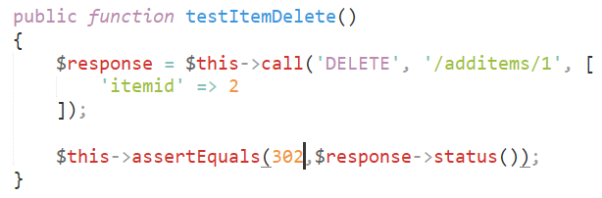

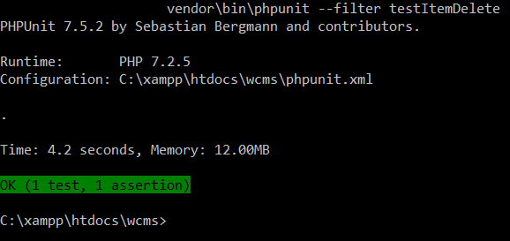

BlackBoxTesting

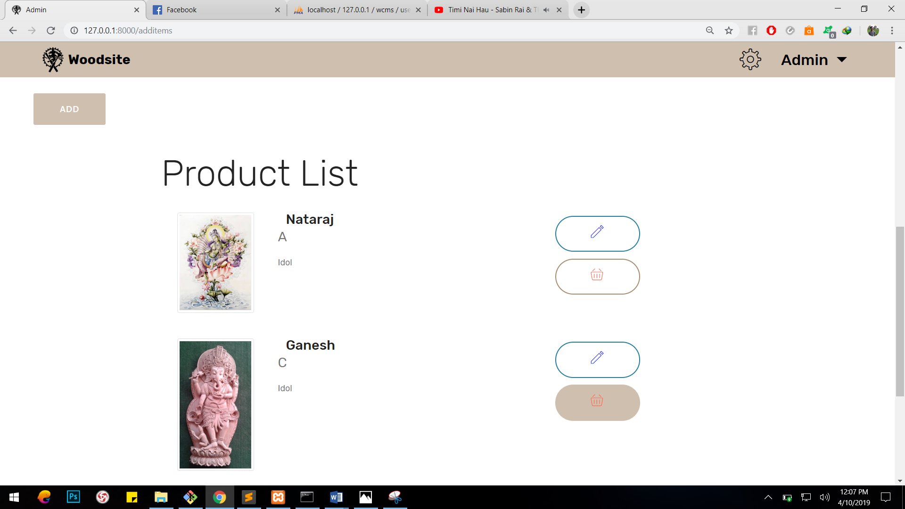

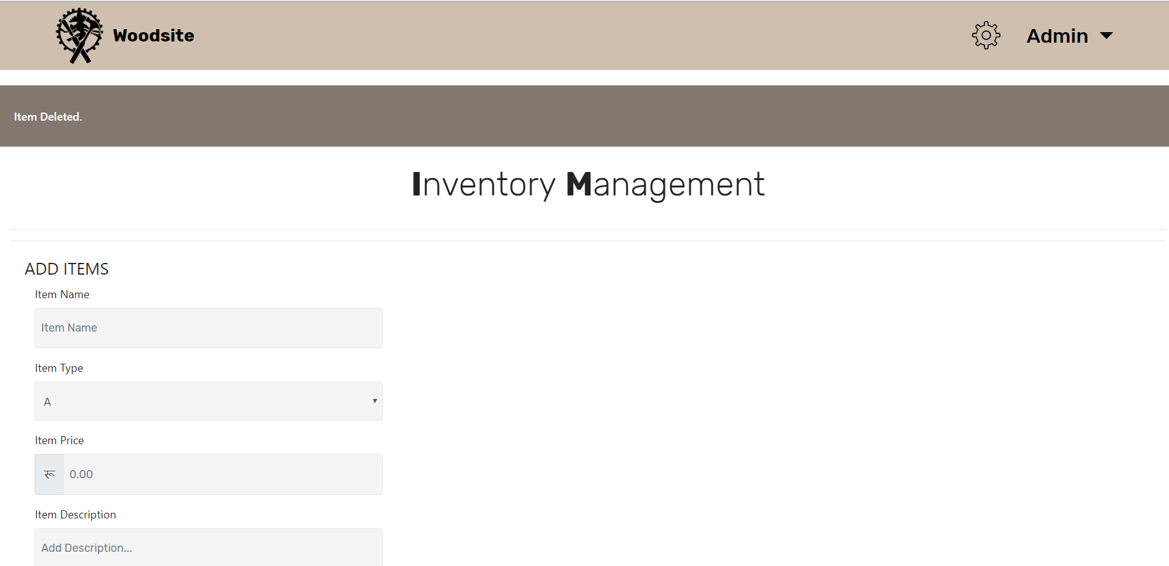

#### Items

|  |  |
| --- | --- |
| Test case no. | T6 |
| Purpose of the case | fetching data from item table to all users |
| Test data | No data |
| Class name | UnitTest |
| Function name | testItems |
| Expected result | Display item data |
| Actual result | Display item data |
| Conclusion | Actual results matches the expected results |

Unittesting

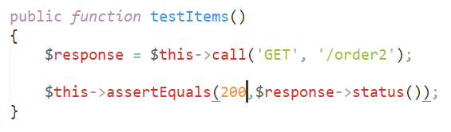

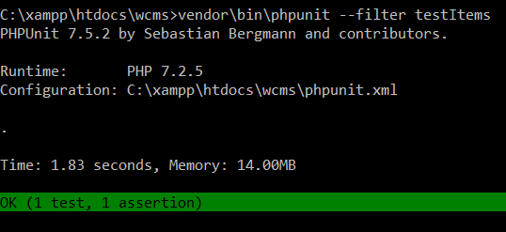

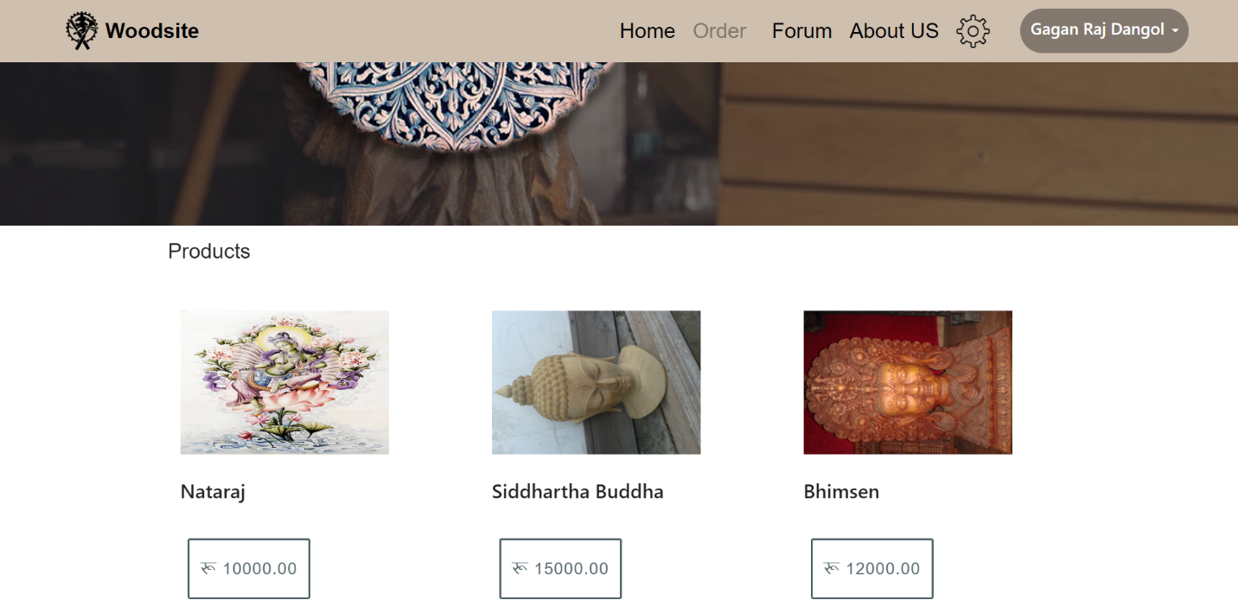Black Box Testing

#### Order

|  |  |
| --- | --- |
| Test case no. | T8 |
| Purpose of the case | inserting data into order table |
| Test data | order_date: 2019-04-09  quantity: 3  userid: 2  Itemid: 1 |
| Class name | UnitTest |
| Function name | testOrderProcess |
| Expected result | insert into table order |
| Actual result | Insertion failed |
| Conclusion | Actual results didn’t match the expected results |

Unit testing

|  |  |
| --- | --- |
| Test case no. | T7 |
| Purpose of the case | fetch item data of particular item to particular user |
| Test data | No data |
| Class name | UnitTest |
| Function name | testOrde |
| Expected result | fetch item data |
| Actual result | fetch item data |
| Conclusion | Actual results matches the expected results |

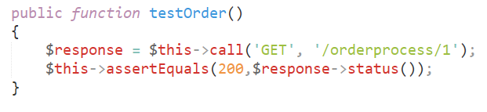

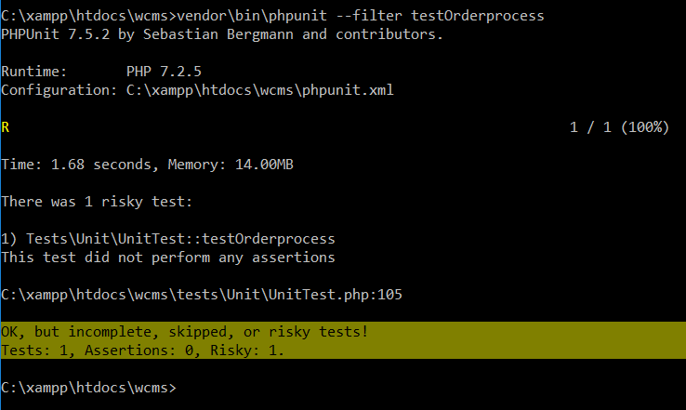

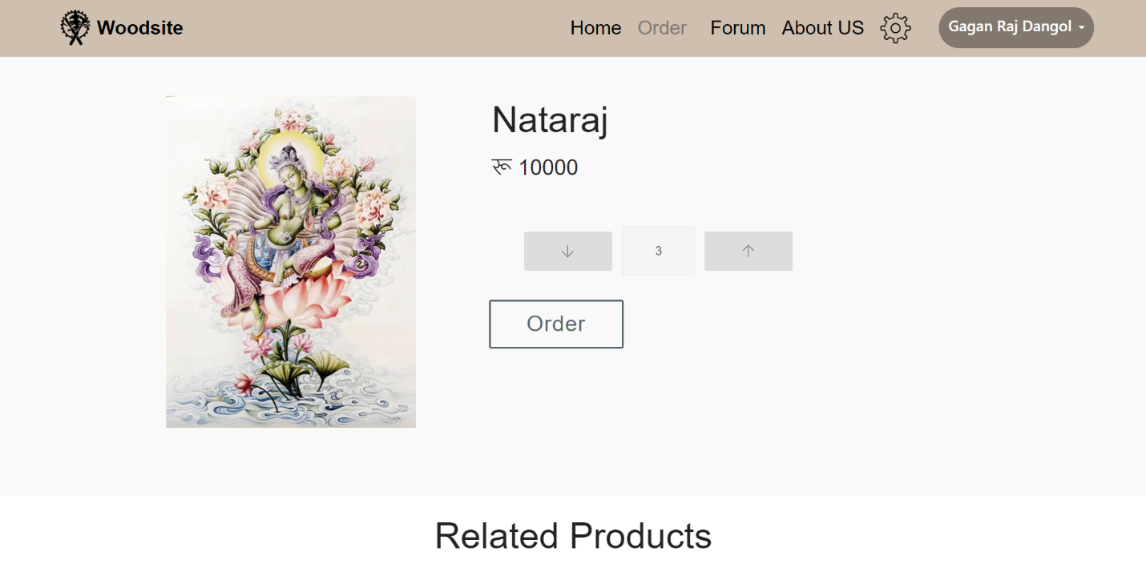Black BoxTesting

#### Order List

|  |  |
| --- | --- |
| Test case no. | T8 |
| Purpose of the case | Fetching order data to particular user |
| Test data | userid: 2  item: 1 |
| Class name | UnitTest |
| Function name | testOrderlist |
| Expected result | Display orderlist |
| Actual result | Display orderlist |
| Conclusion | Actual results matches the expected results |

Unit Testing

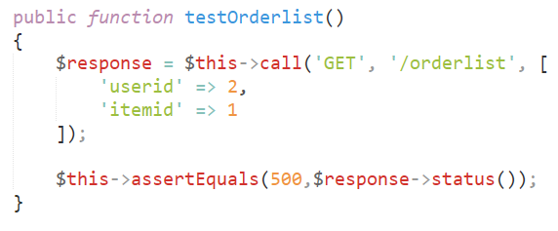

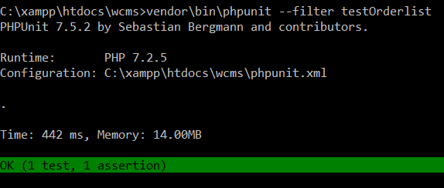

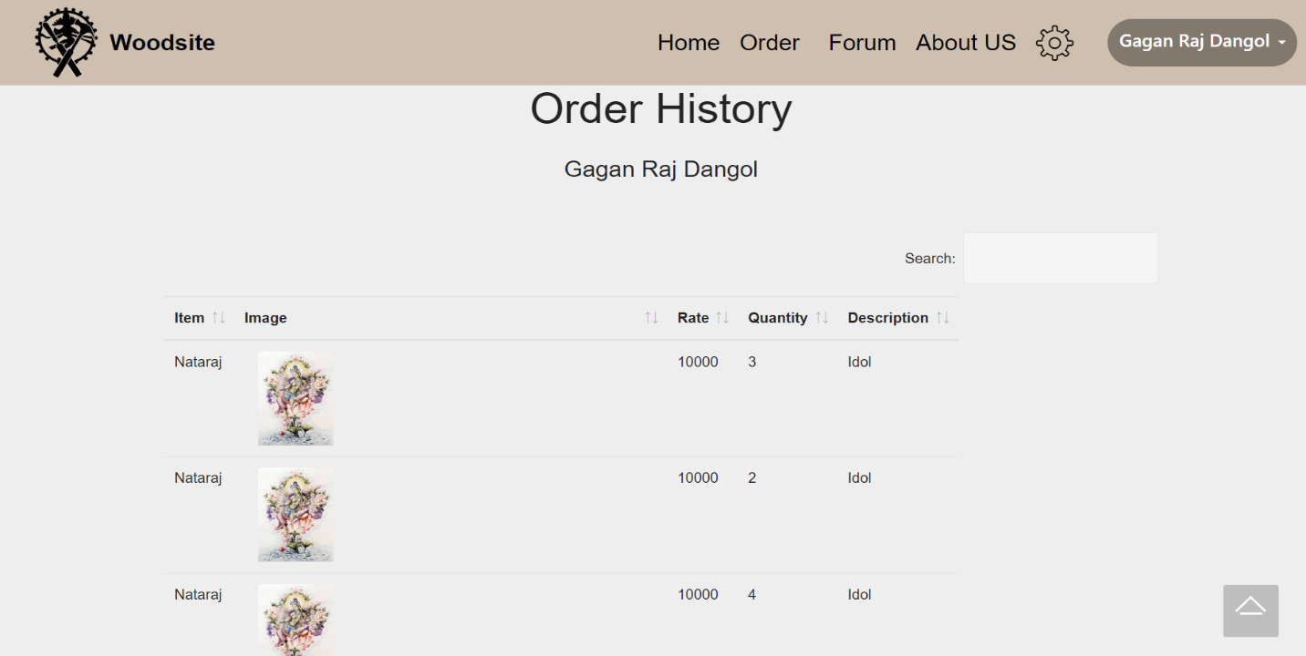BlackBoxTesting

#### Forum

|  |  |
| --- | --- |
| Test case no. | T8 |
| Purpose of the case | Fetching data from forum table to all users |
| Test data | Postid: 1 |
| Class name | UnitTest |
| Function name | testOrderlist |
| Expected result | Display forum data |
| Actual result | Display forum data |
| Conclusion | Actual results matches the expected results |

Unit Testing

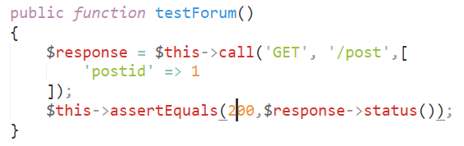

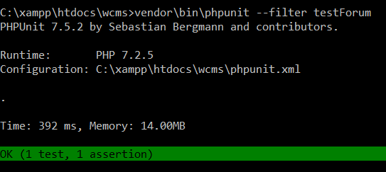

BlackBoxTesting

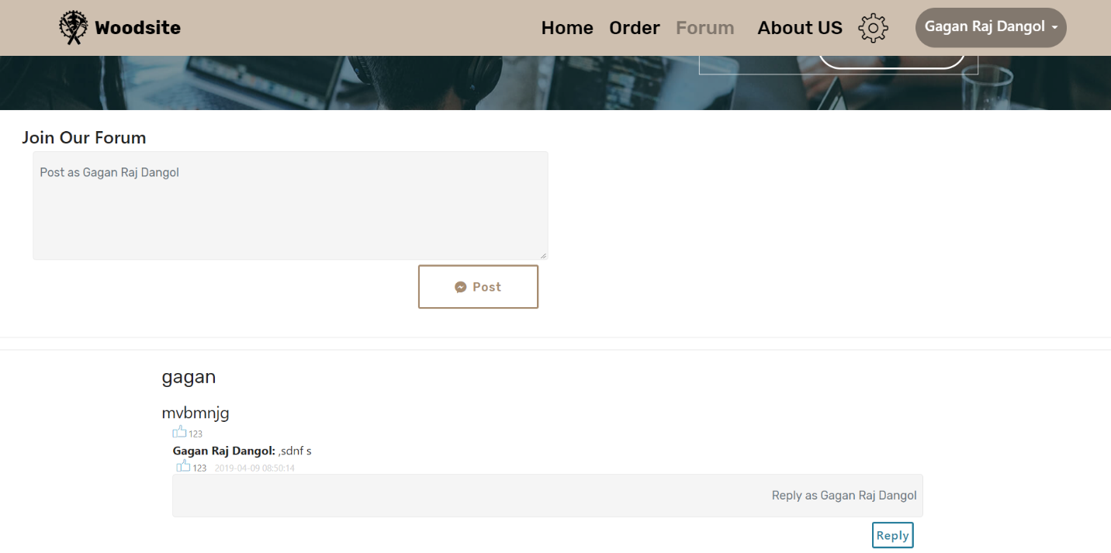

# 

# Chapter 6: Other Project Issues

Other Project Issues

## Risk Management

Risk management refers to the process of identifying potential risks in advance, analyzing them and taking precautionary steps to reduce the risk.

Risk management is held in following ways:

* Risk Identify
* Risk Analyze
* Risk Rank or Evaluate
* Risk Treatment
* Risk Review and Monitor

The impacts that can cause on the project due to the risks is calculated as:

Impact = Likelihood * Consequence

Risk Likelihood values are shown as follows

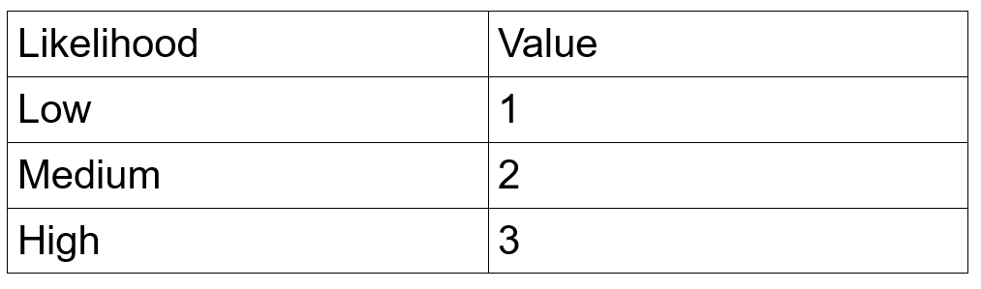

Table 2: Likelihood measurement

Risk Consequence values are shown below

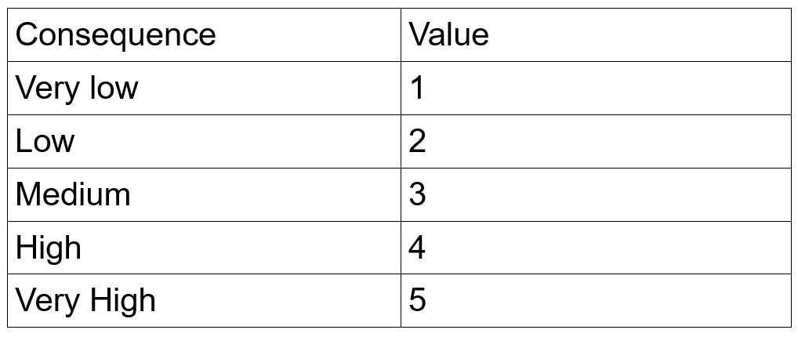

Table 3: Consequences measurement

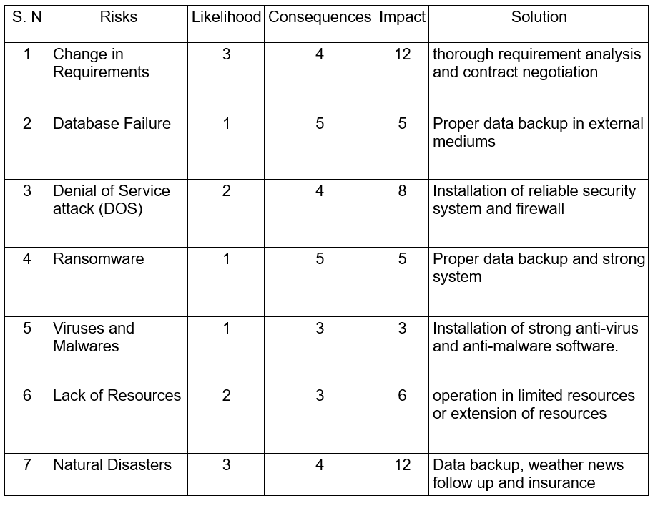Risk Management Chart

## Configuration Management

Configuration Management is a system engineering process designed to establish and maintain the consistency of the performance, functional and physical attributes of a product with its requirements, design and operational information throughout its lifetime. The given figures shows the configuration management process of this project.

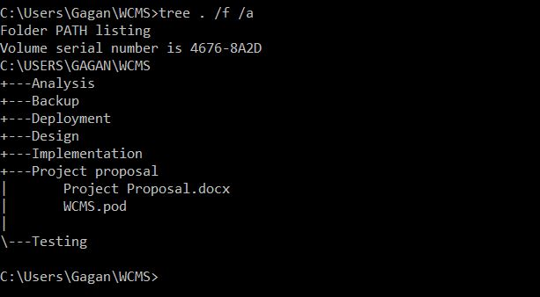

Figure 14: Tree Chart

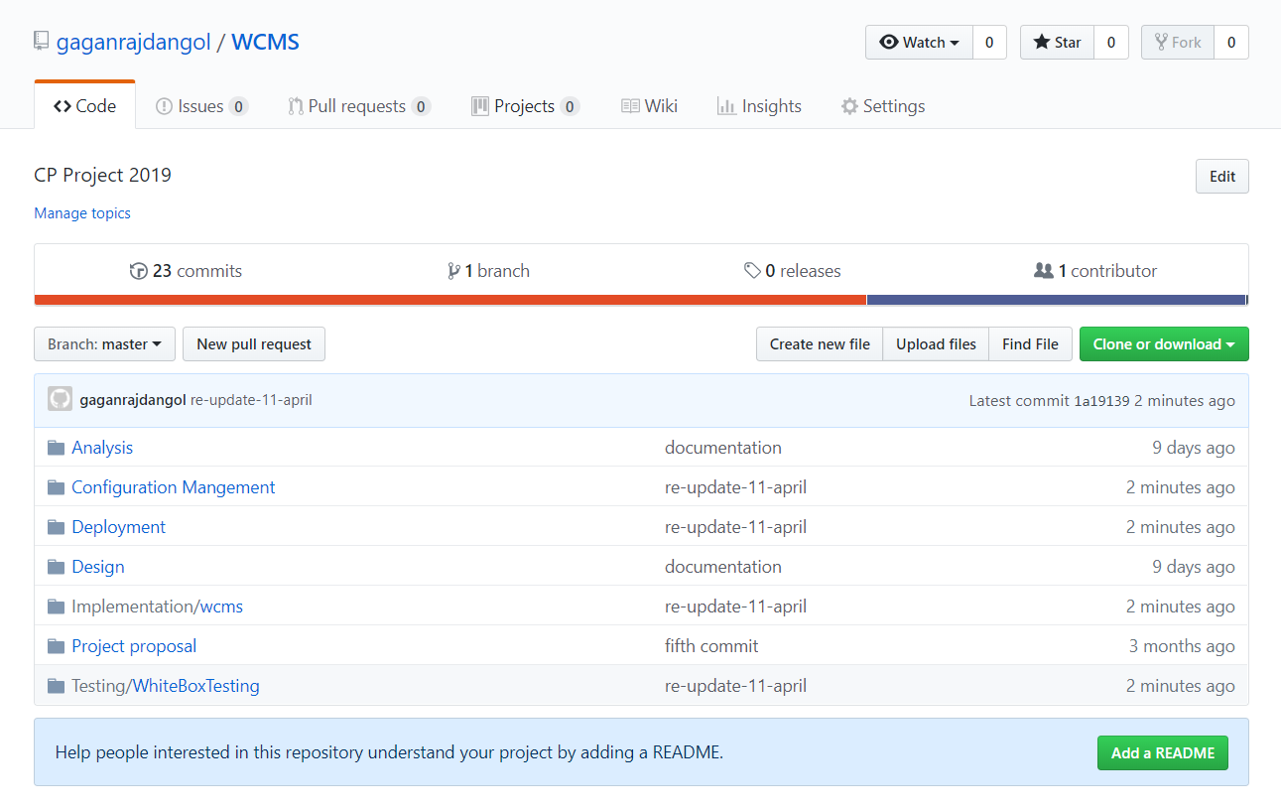

Figure 15: GitHub Repository

GitHub link: <https://github.com/gaganrajdangol/WCMS>

## Time Scheduling

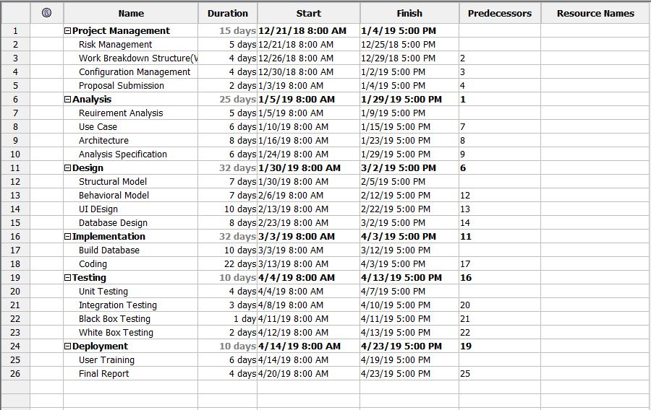

Figure 16: Time Scheduling

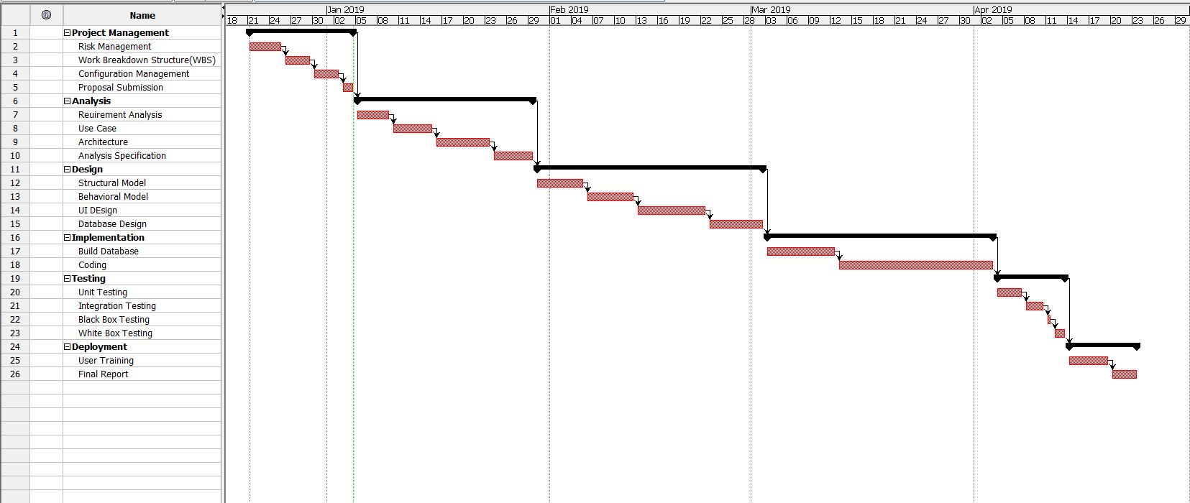

Figure 17: Gantt Chart

## **User Manual**

User Manual is a readable document that encompasses guides and walkthroughs on how to conveniently and properly use an application. It includes processes of the functionalities of the application and carries any other important notes that directly or indirectly effect the application.

**Basic Information:**

The system dashboard displays all system information such as login, signup, featured profiles, etc.

**Authorized users and Non-Authorized:**

Authorized users can use all the features and can search and post profiles and add them to them. But the unauthorized person can search for the user only.

**View Profile:**

Users can view other users ' profile by sending them friend requests and adding them to favorites and sending them the message as well. By clicking the add button and adding to favorites, the user can send the friend request by clicking add to favorites.

The User Manual contains all essential information for the user to use the information system to its full extent. This manual includes a description of the functions and capabilities of the system, contingencies and alternative operating modes, and step-by-step system access and use procedures.

Unregistered users may view the products, but they may not book or order the products, while registered users may book or order the products. In order to get full services on the system, users must first register their account.

**Order Item:**

By clicking the Confirm order buttons on the Bookings page, registered users can order items. Users can view their orders on the Orders page after the item is ordered.If the user wants by clicking on the print icon, the bill can be generated and printed, and they can cancel the order by clicking on the order cancel button on the order page.

**Edit Profile:**

Users can change / update their profiles whenever they want by clicking the Edit Profile button on the drop-down button inside the navbar (username). Users must complete the fields they want to change / update after moving to the Edit Profile page and then click the update button.

**Search Products:**

Users can do their job more efficiently and effectively. The search service will help fulfill the desired user. By typing in the Products page on the search textbox, users can search for products by category, name, date, price etc.

## **Limitations**

Even though the project is ought to solve several problems, it carries few limitations of itself. The Limitations of the project are given below:

* This project doesn’t allow online payment services.
* Even though the application is publicly view and used internationally, goods cannot be shipped or delivered internationally.
* Most of the services are limited to domestic regions.

## Future Work

The project has few scopes that have not been encompassed or better yet, they are to be completed once the project have been deployed and operated.

* Content Writing
* User-Admin Chat box
* Featured Item (display at the top of the gallery)
* Site Usage Graph
* Sales Report

# Chapter 7: Conclusion

Conclusion

In this documentation I have discussed over the key concepts, themes and skills related to the application. Furthermore, the contents in this document will help to develop the fundamental knowledge, understanding, and analysis and synthesis skills that is needed to develop fit-for-purpose software in an organizational context by taking a practice-based approach.

In conclusion, considering all the factors, the project completed and it encompasses and accomplishes all the requirements. All necessary features are built as well.

# Chapter 8: **References**

References

Anon., 2019. *Tutorial point.* [Online]   
Available at: https://www.tutorialspoint.com/software_testing/

Anon., n.d. *stack overflow.* [Online]   
Available at: https://stackoverflow.com/questions/16475979/what-is-the-difference-between-functional-and-non-functional-requirement

Anon., n.d. *Waterfall Model.* [Online]   
Available at: http://toolsqa.com/software-testing/waterfall-model/

# Chapter 9: Appendix

Appendix

The screenshots of the user interfaces are given below. The HTML and Laravel codes are given with respect to their interface. The codes of the controller follows the UI.

## User Interface (UI)

### Home Page

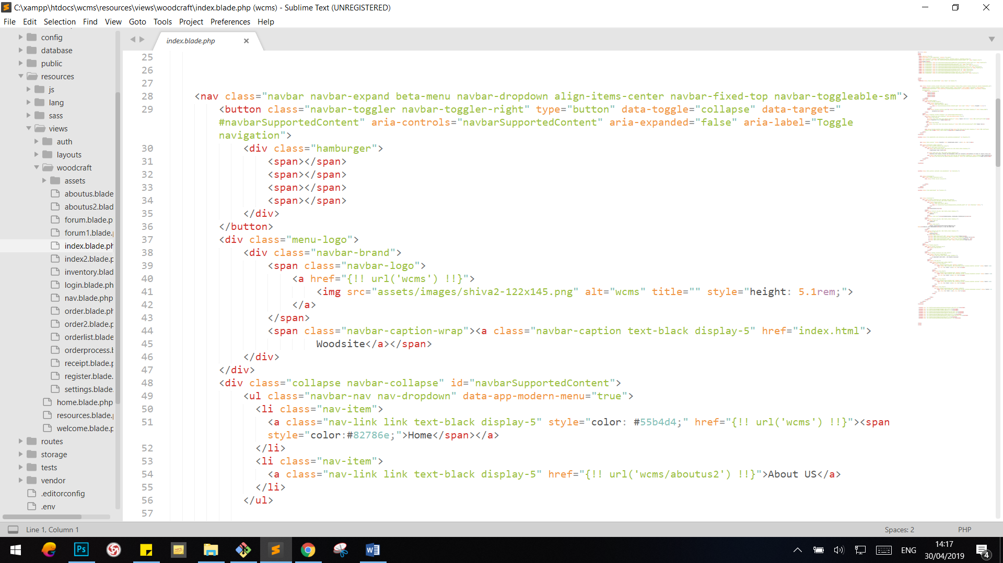

### Register

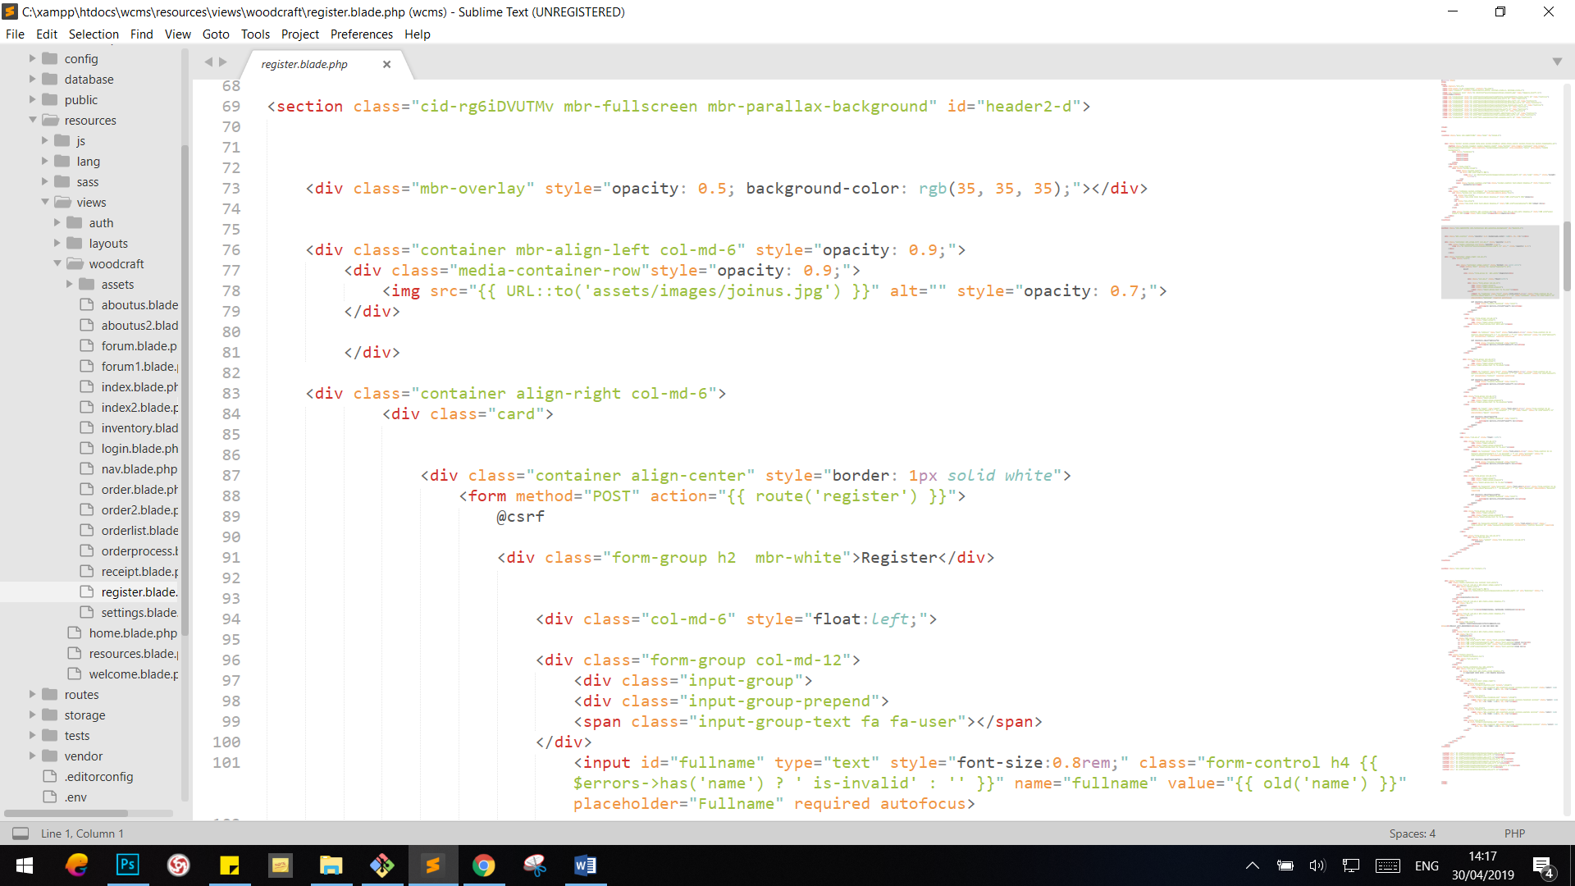

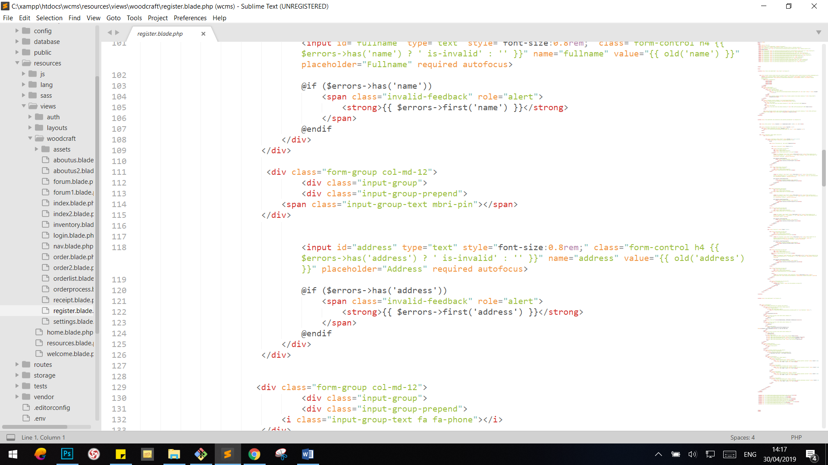

### Login

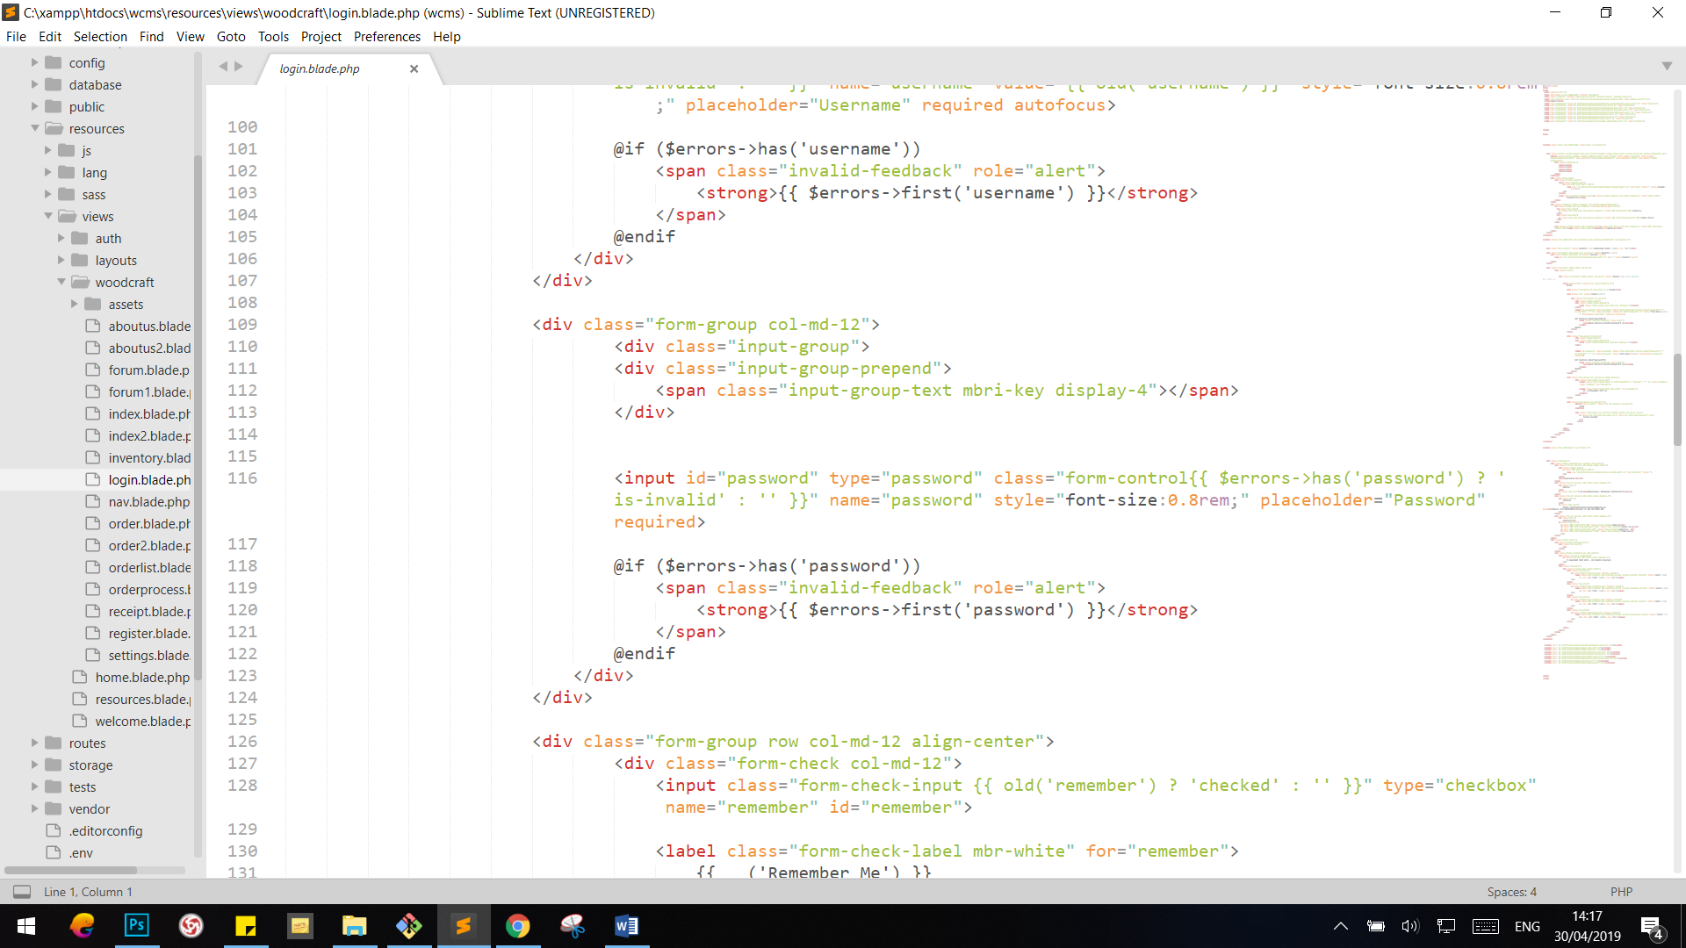

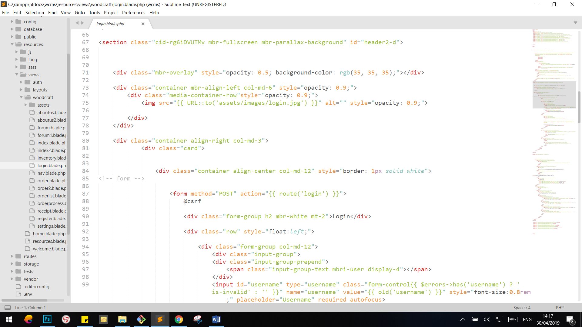

### User Home Page

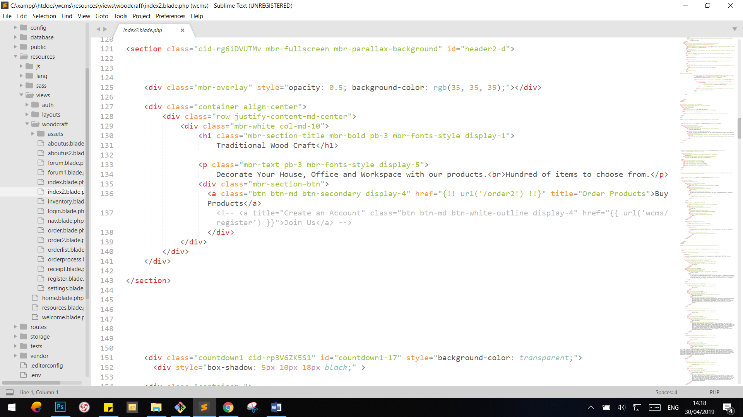

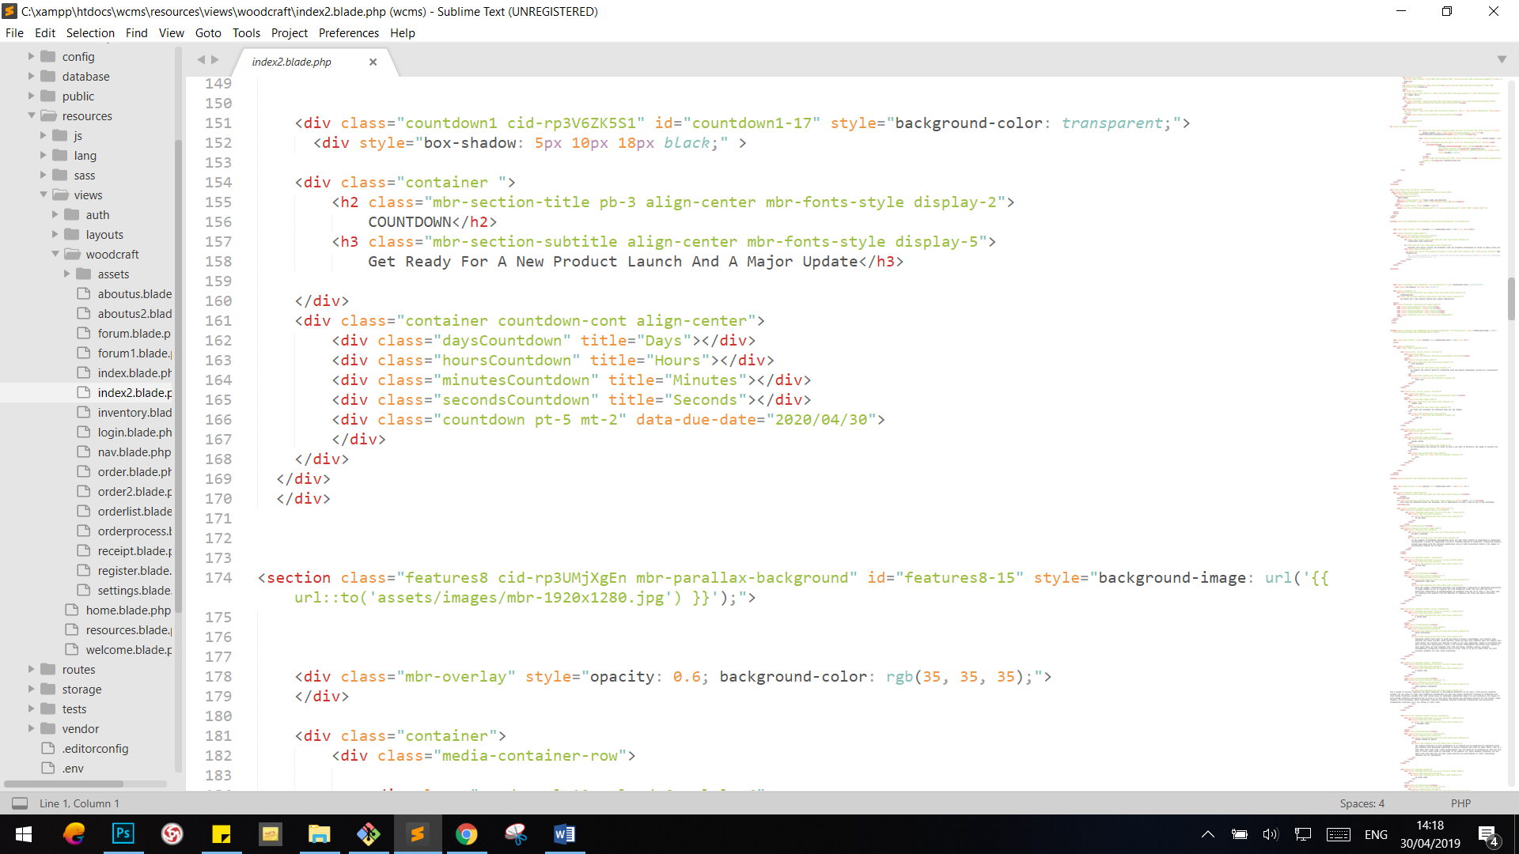

### Order

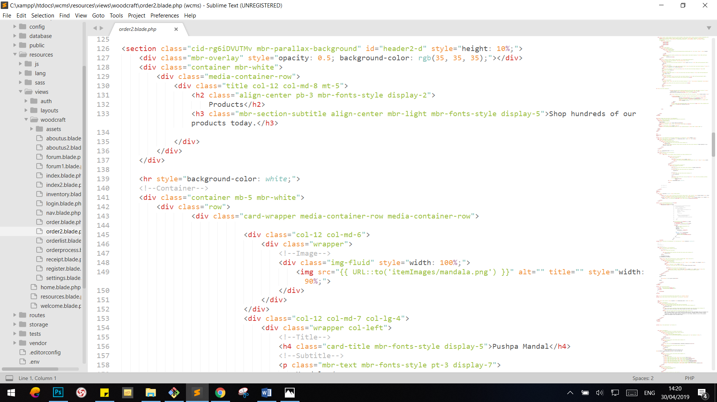

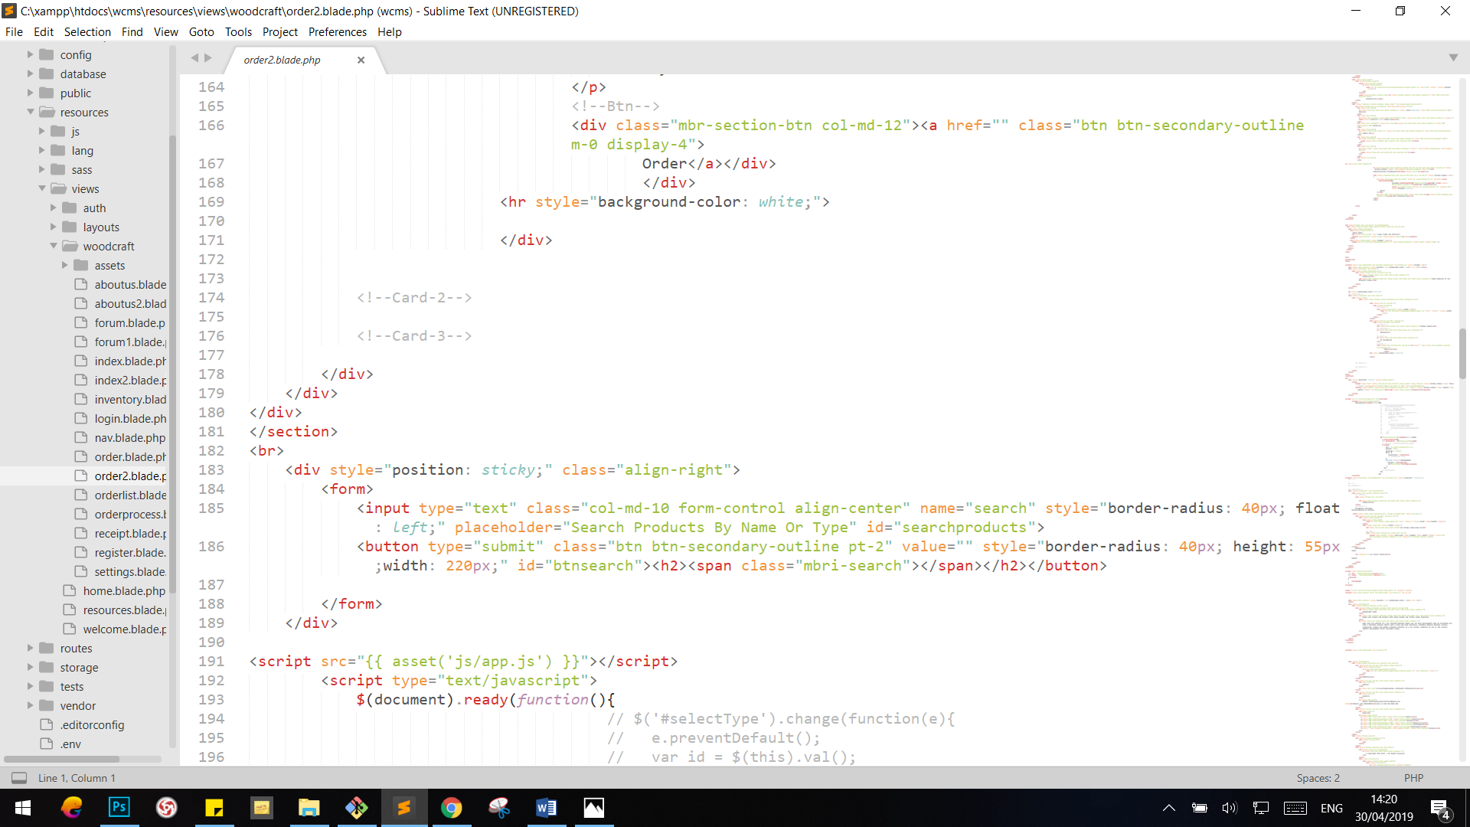

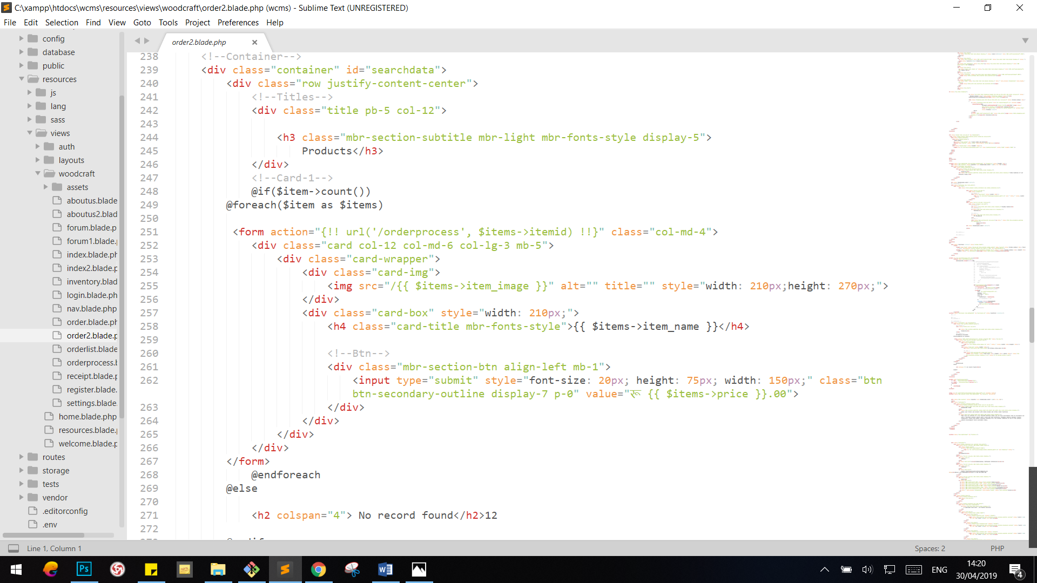

### Order Processing

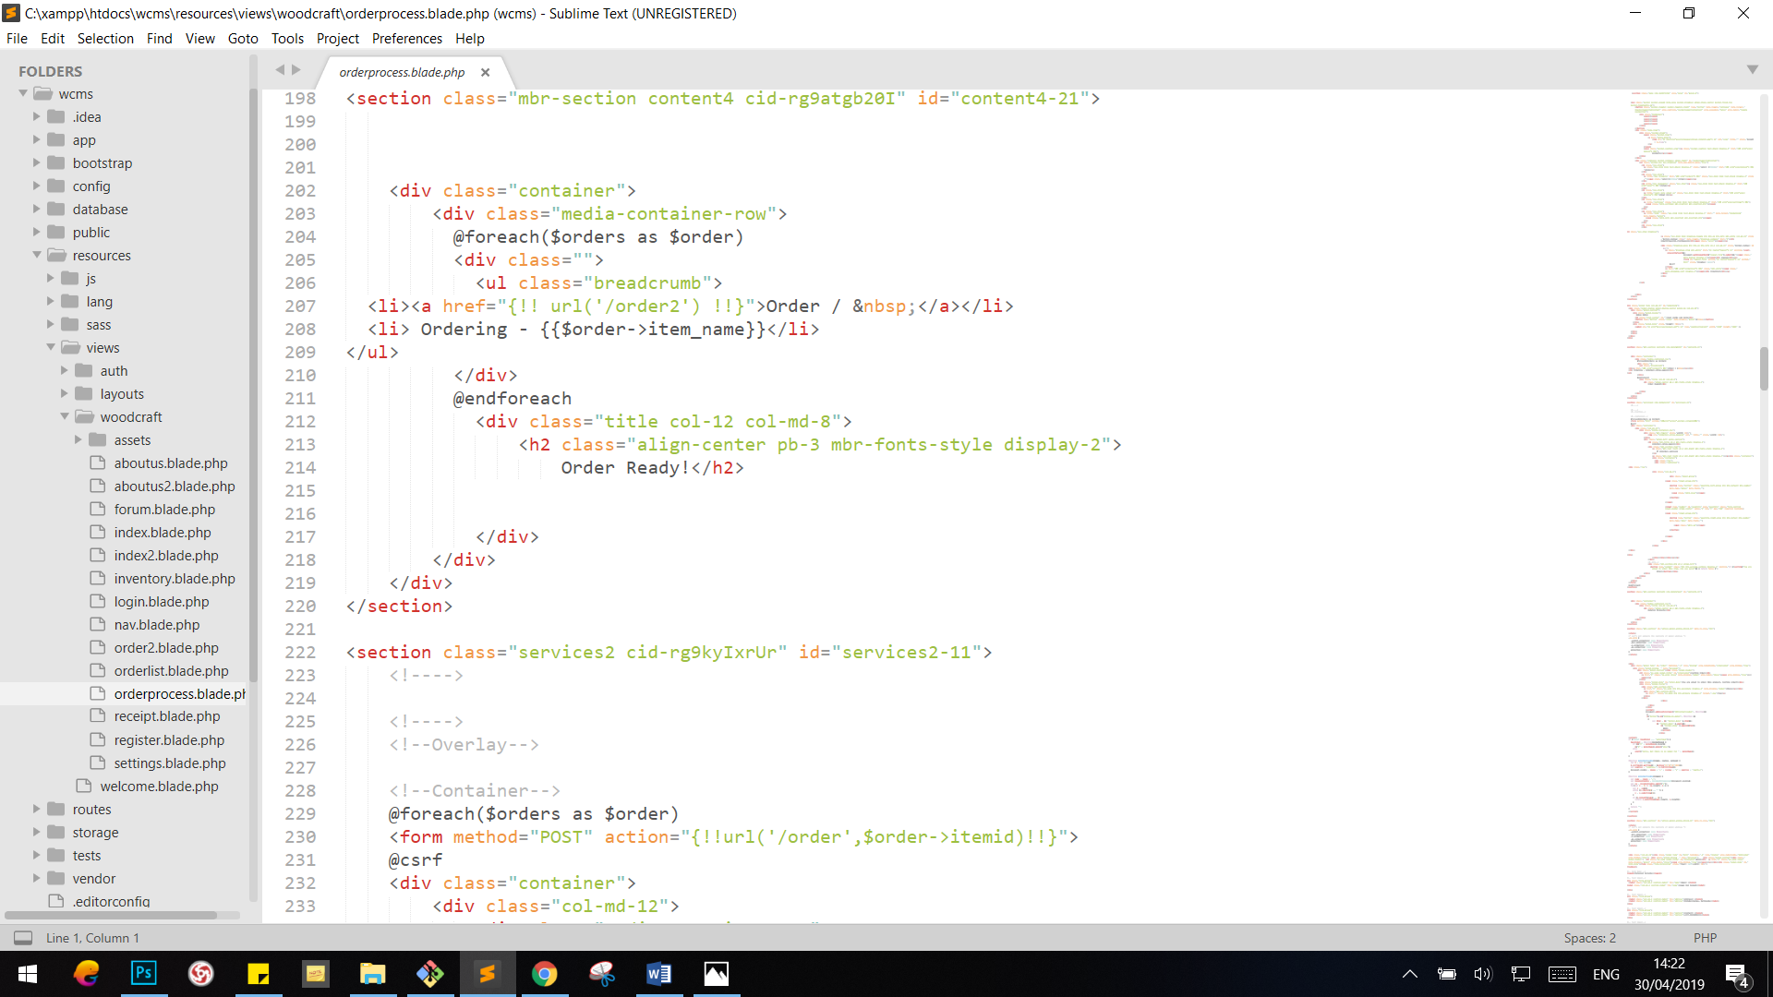

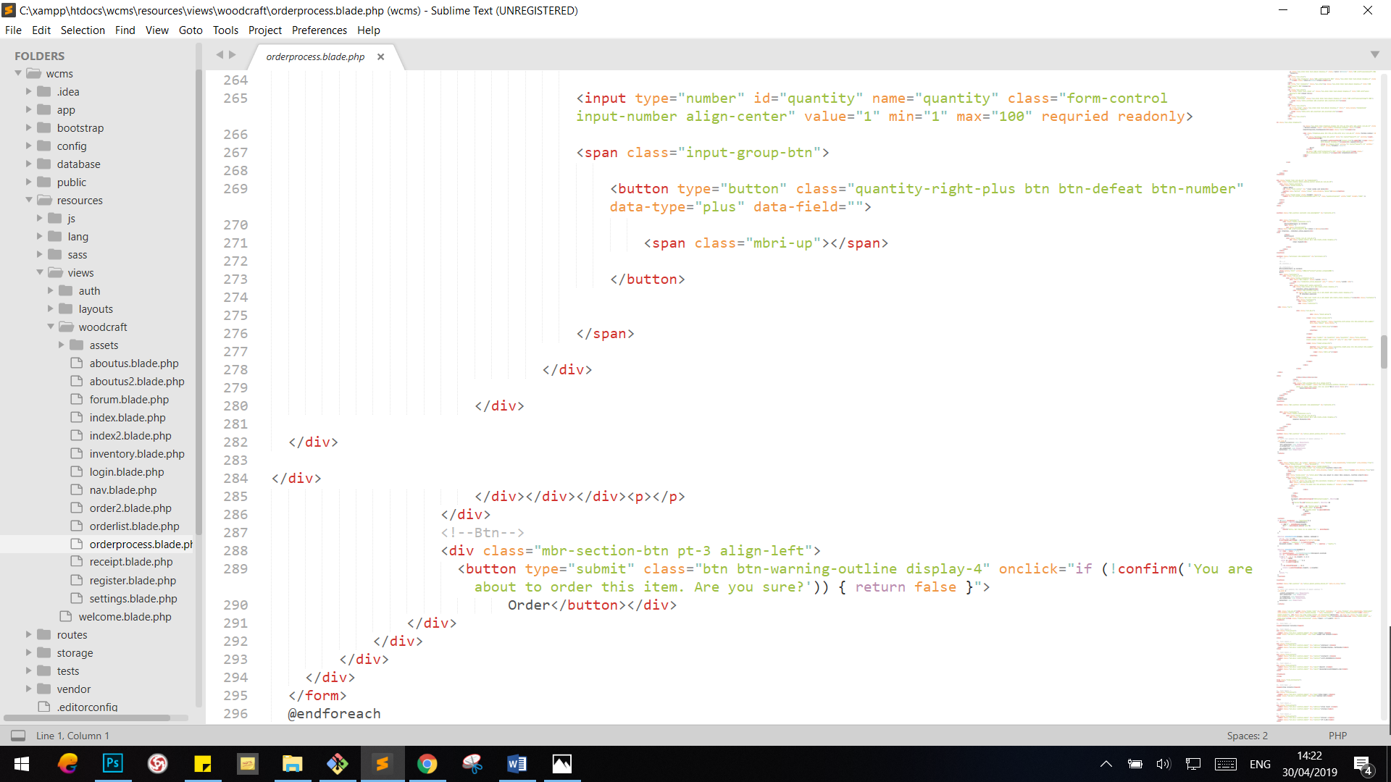

### Bill

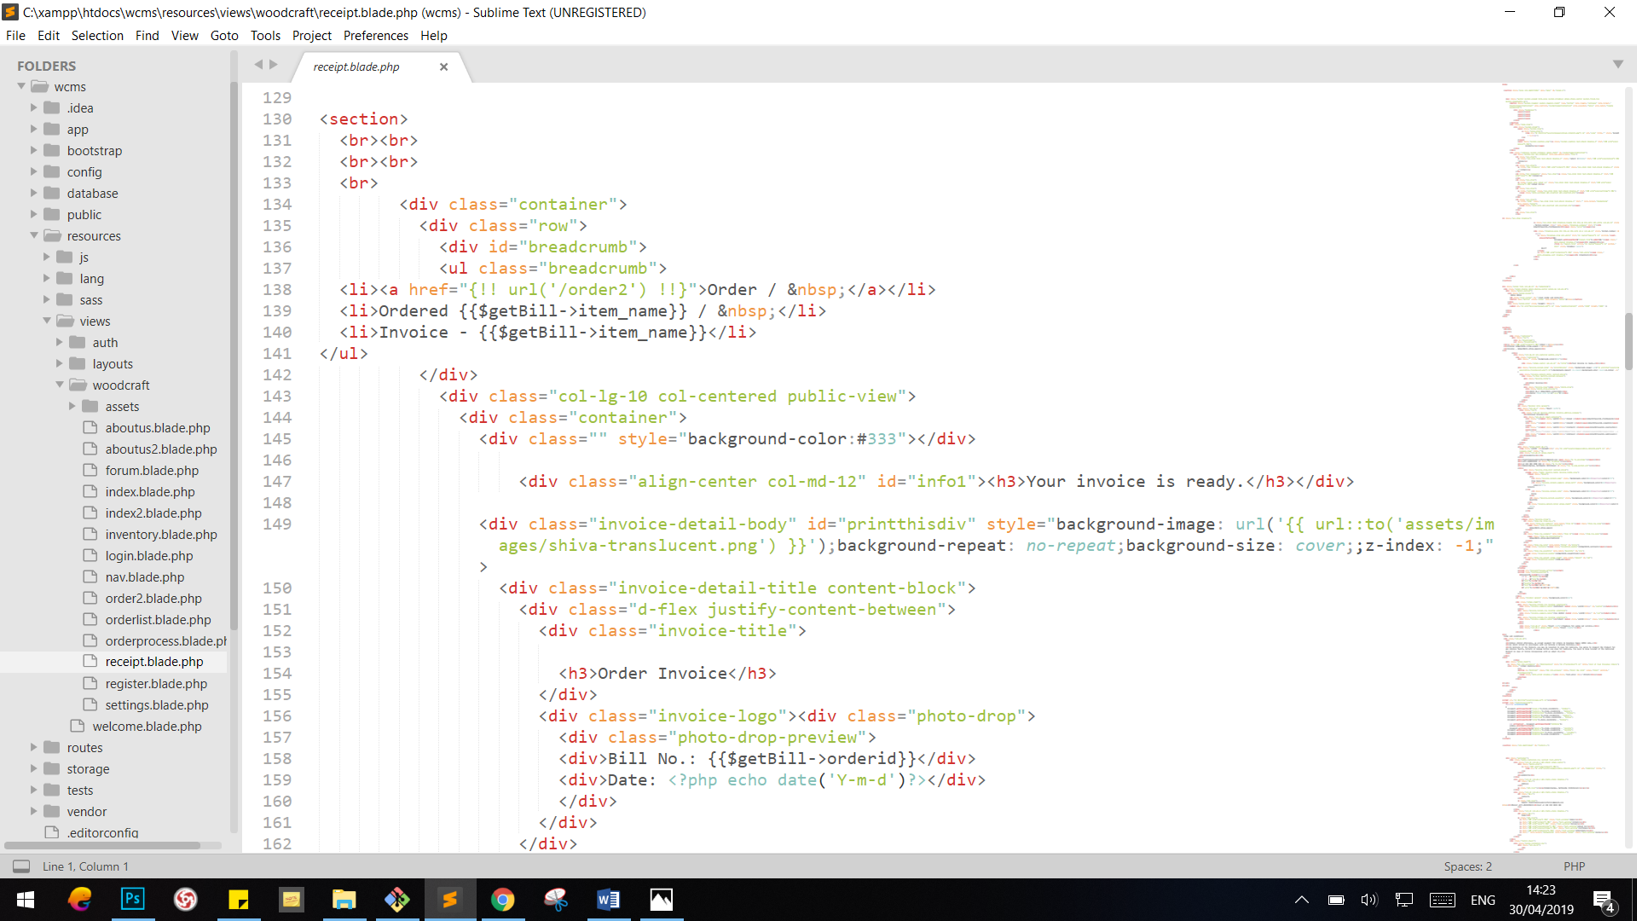

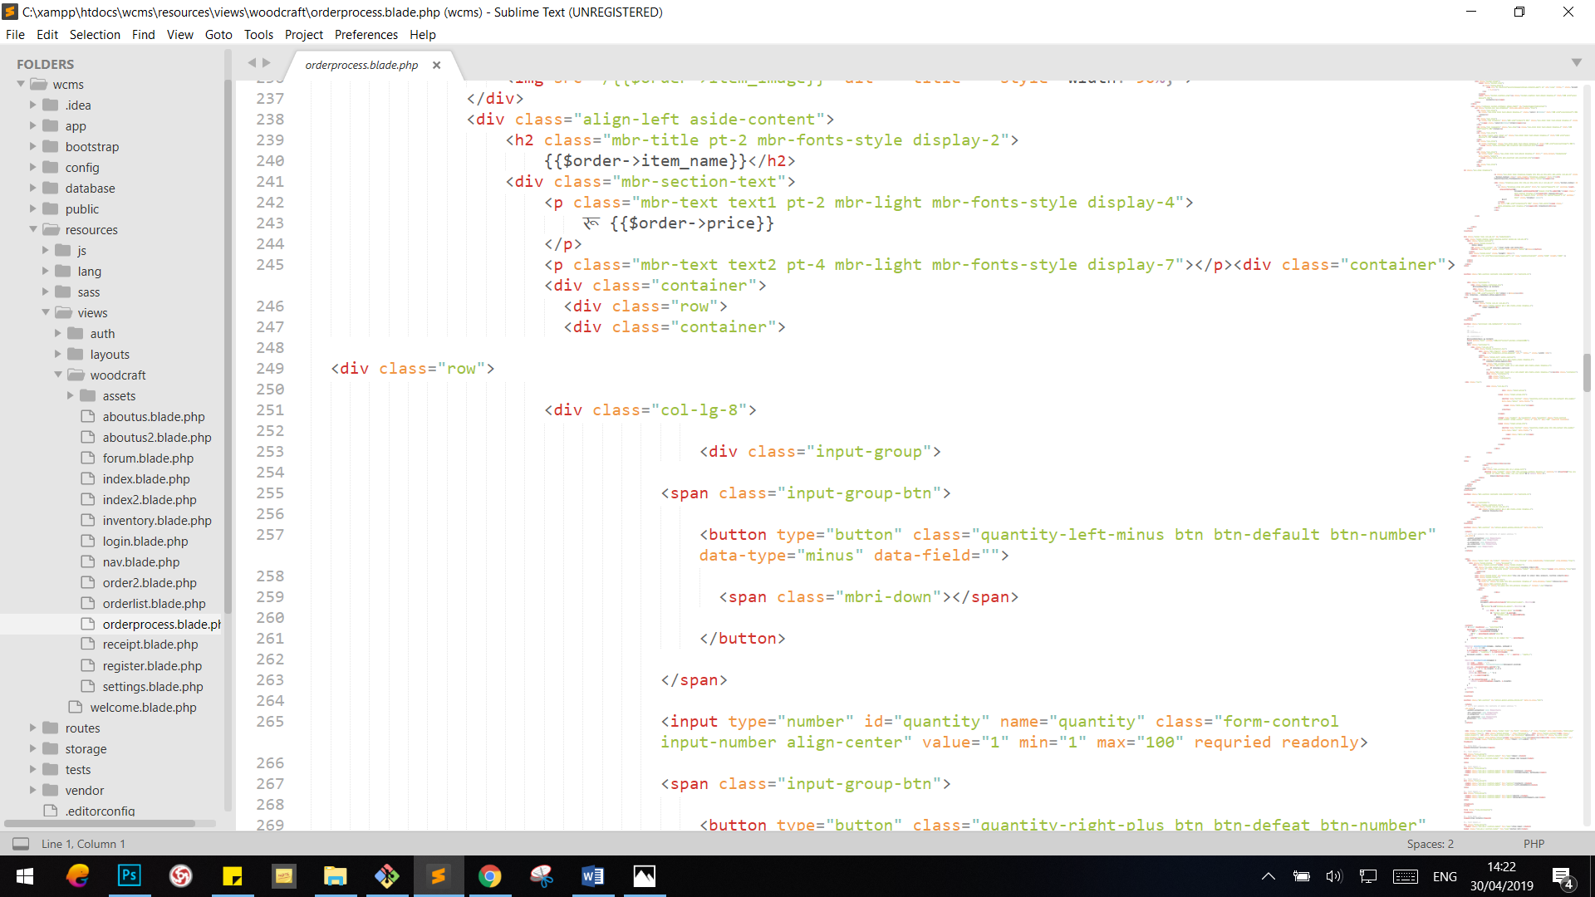

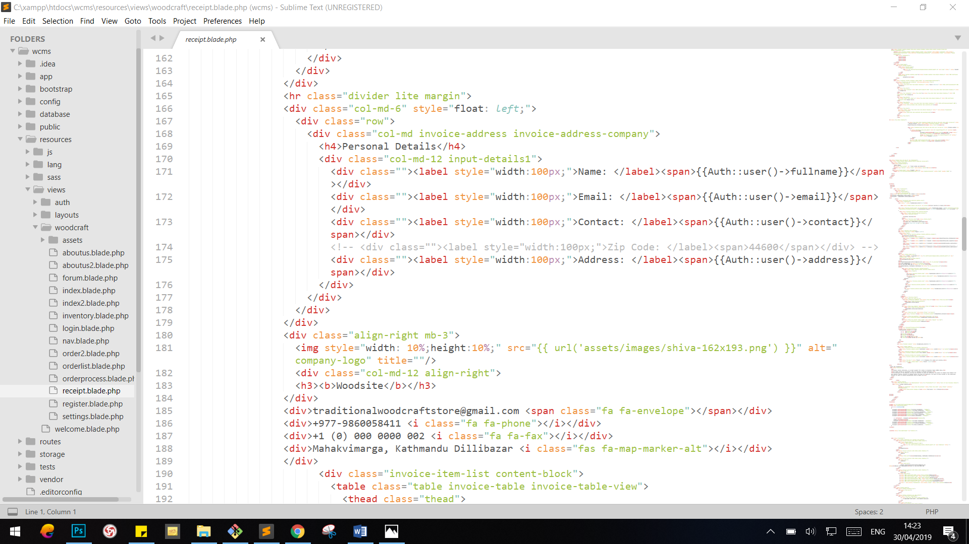

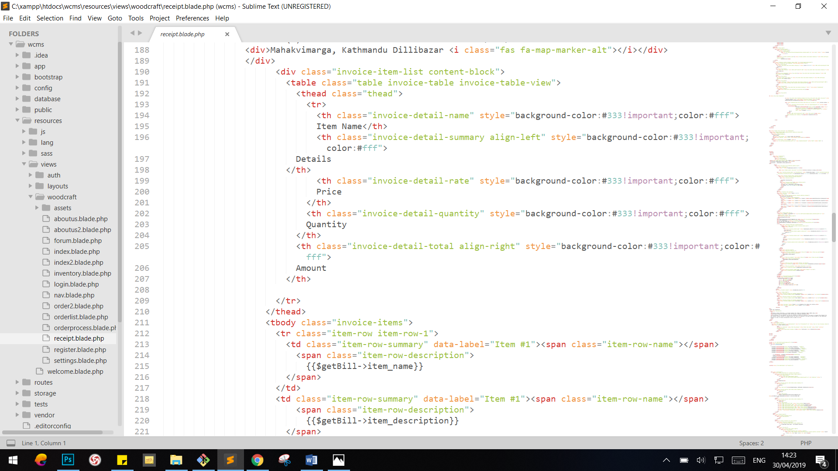

### Orderlist

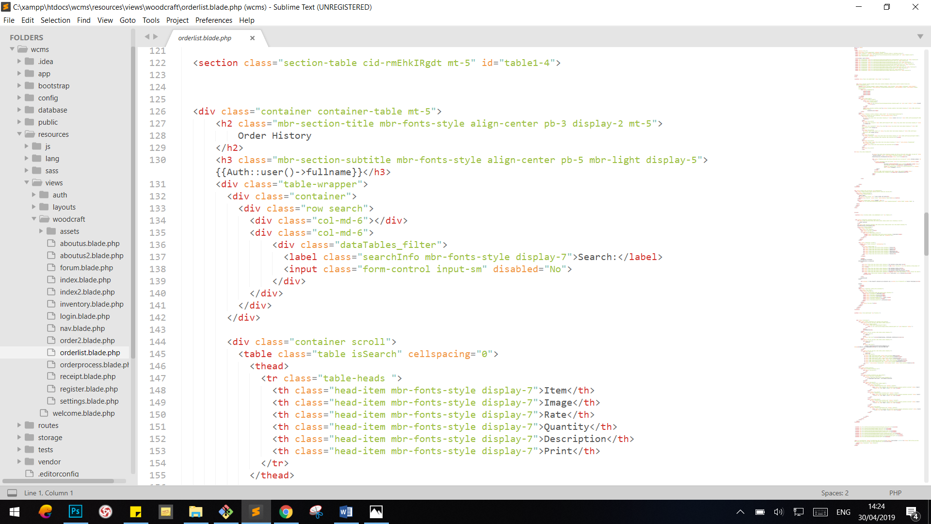

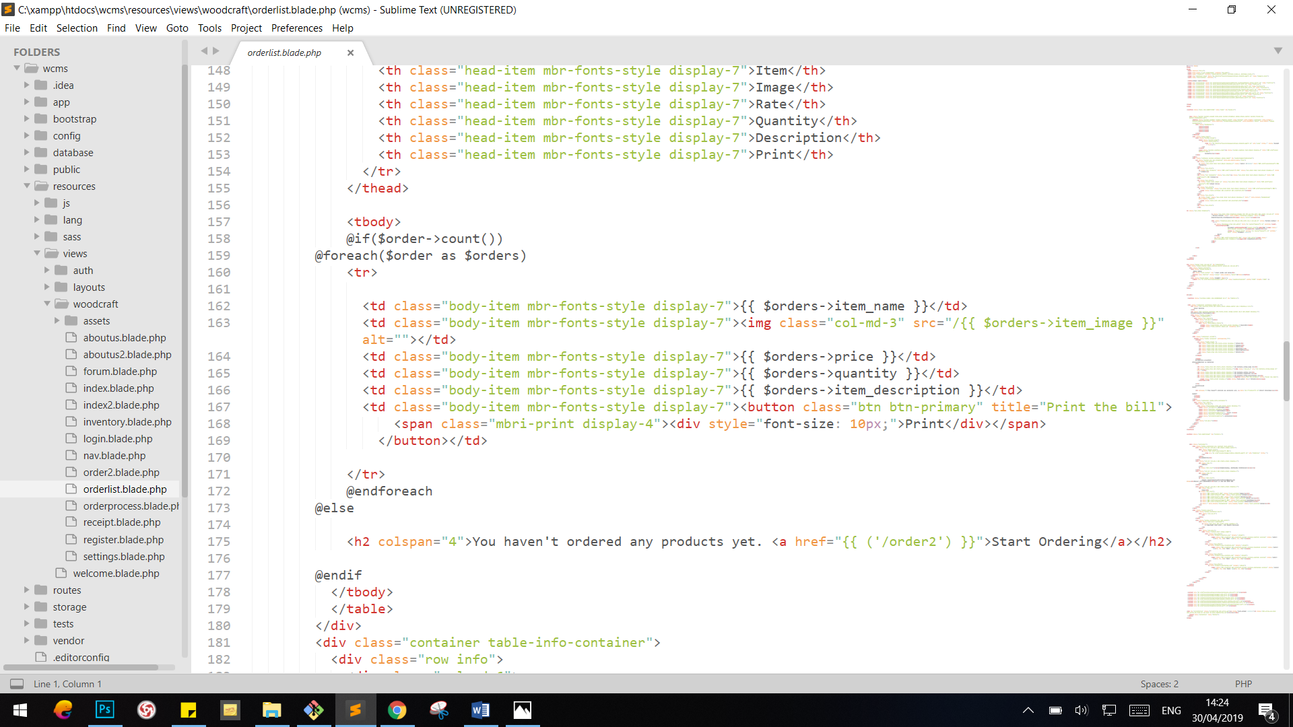

### Forum

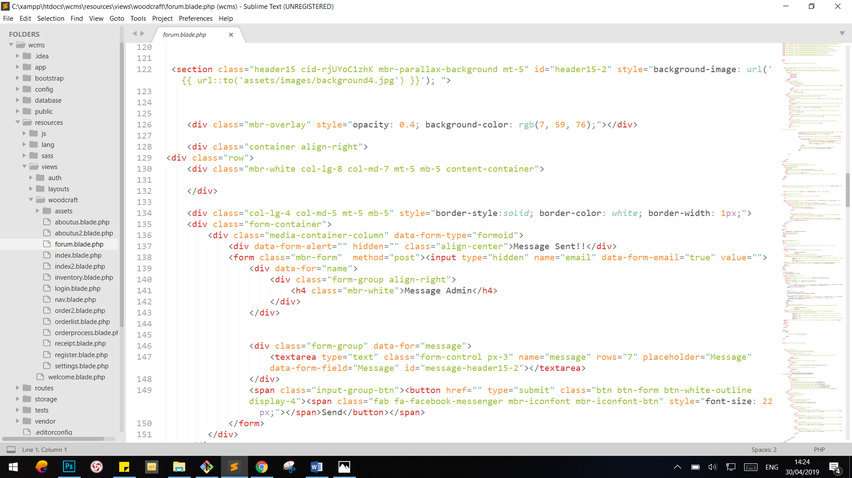

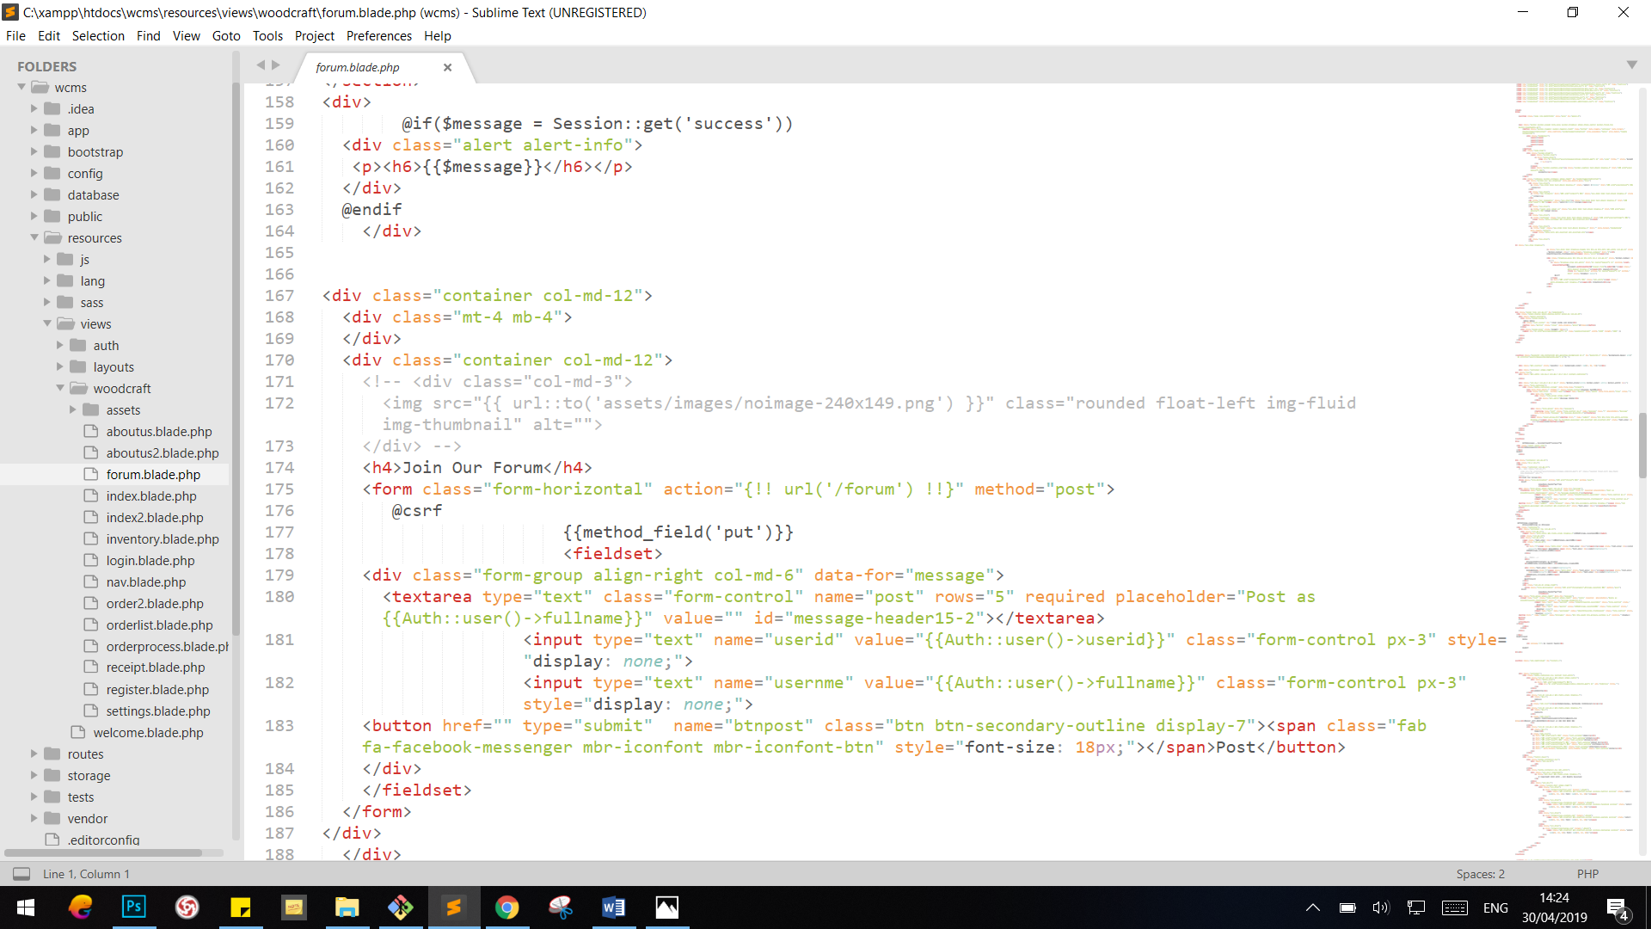

### Update Profile

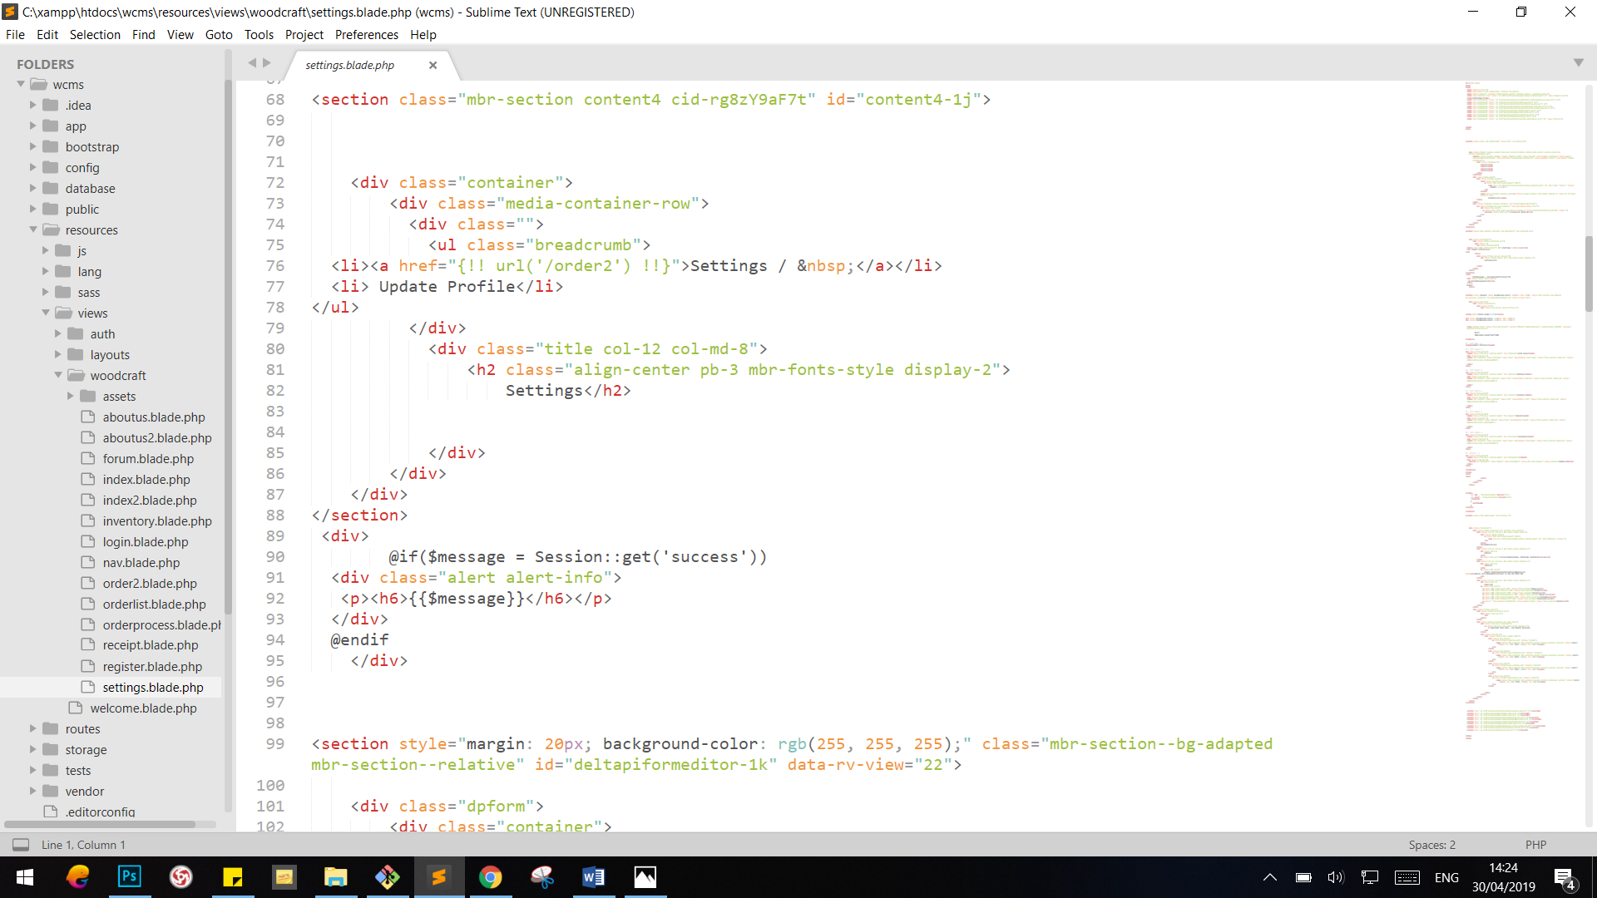

### About Us

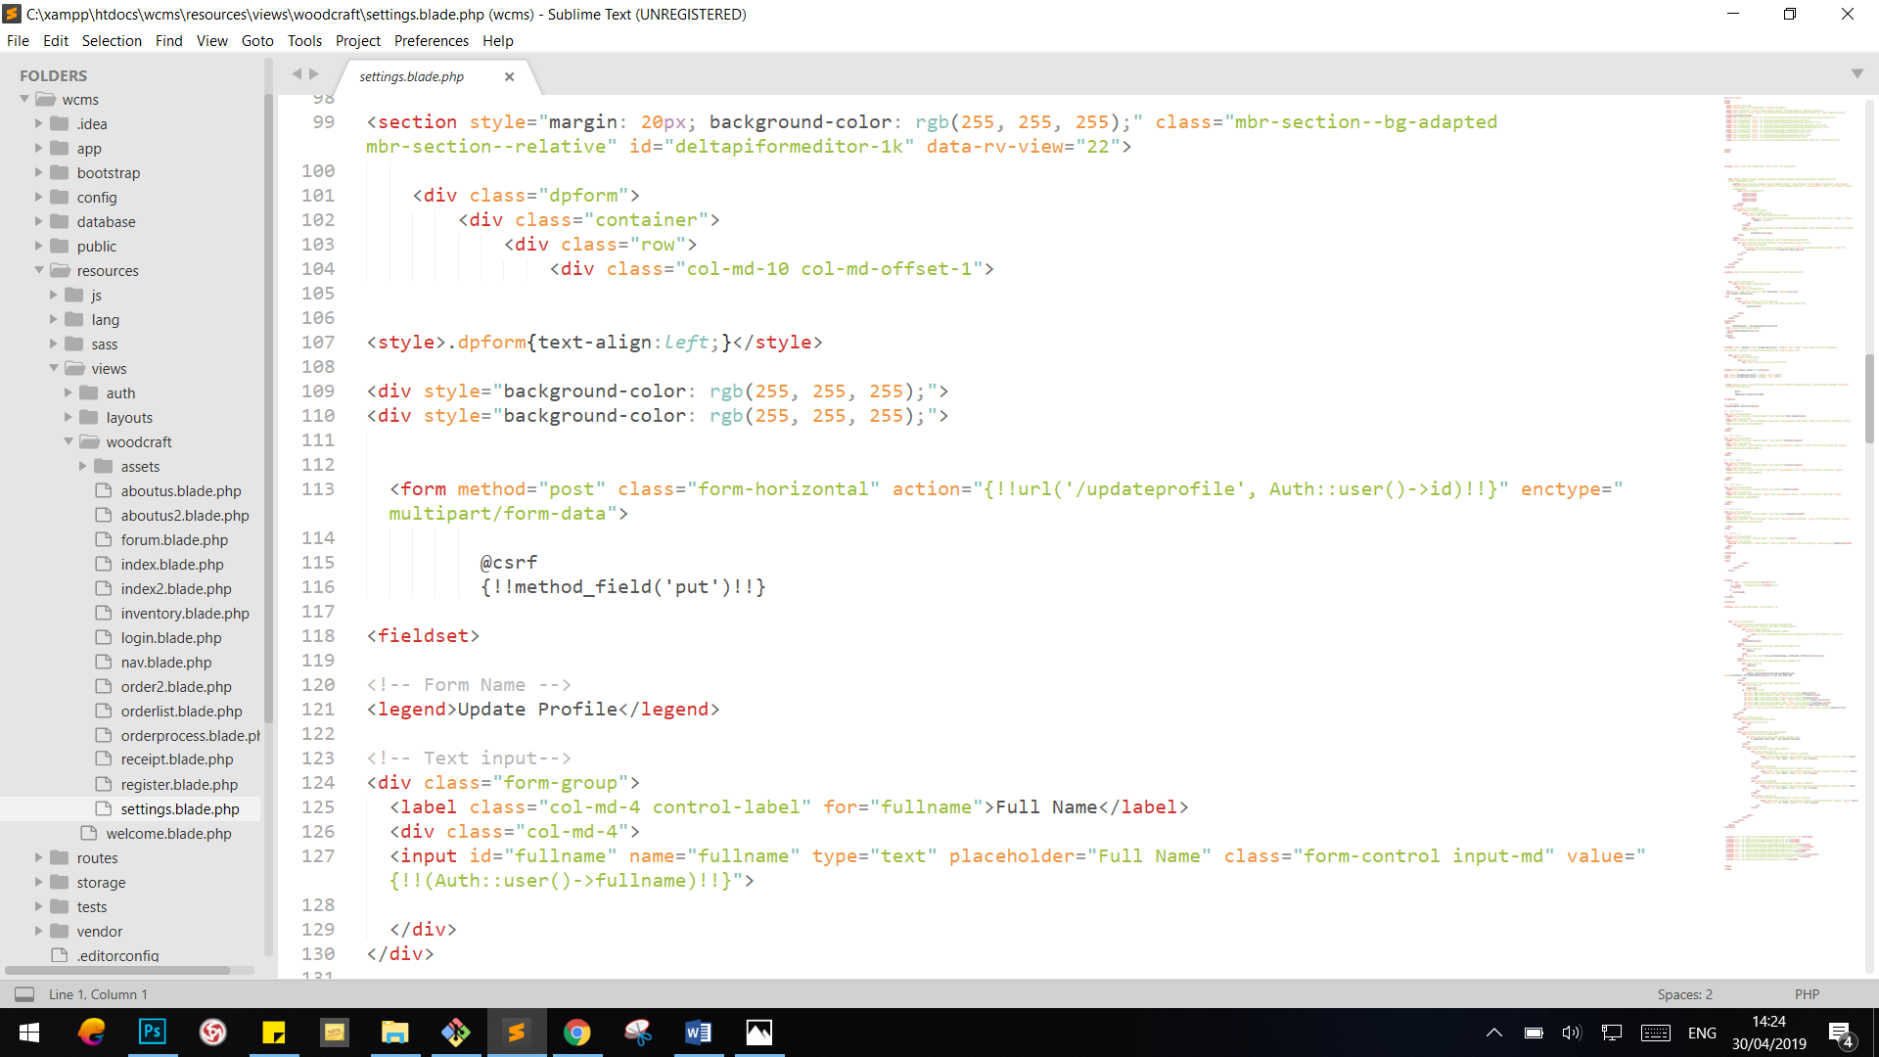

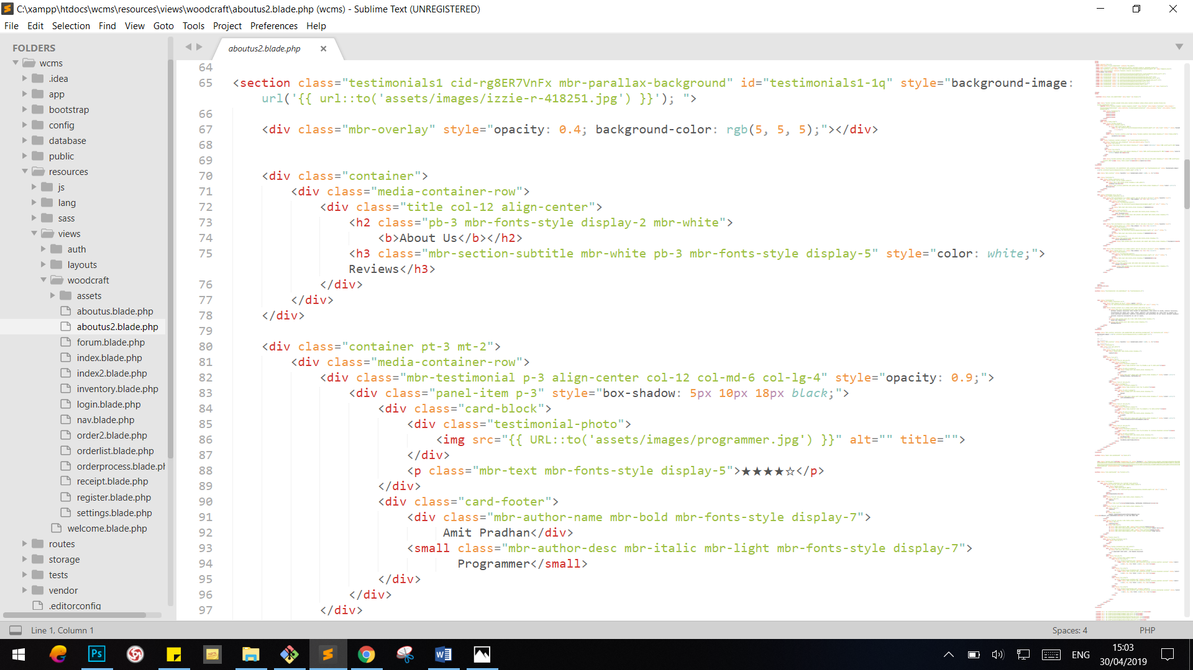

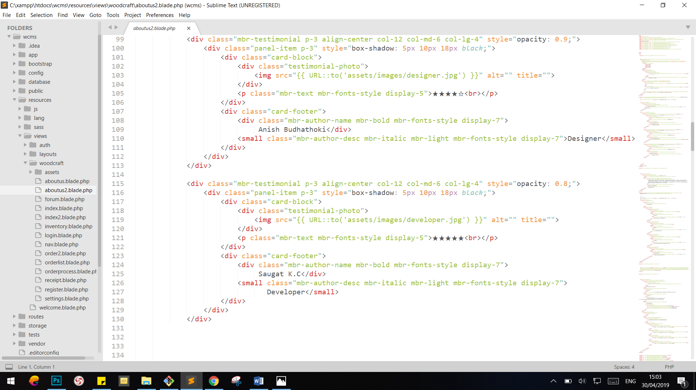

### Inventory

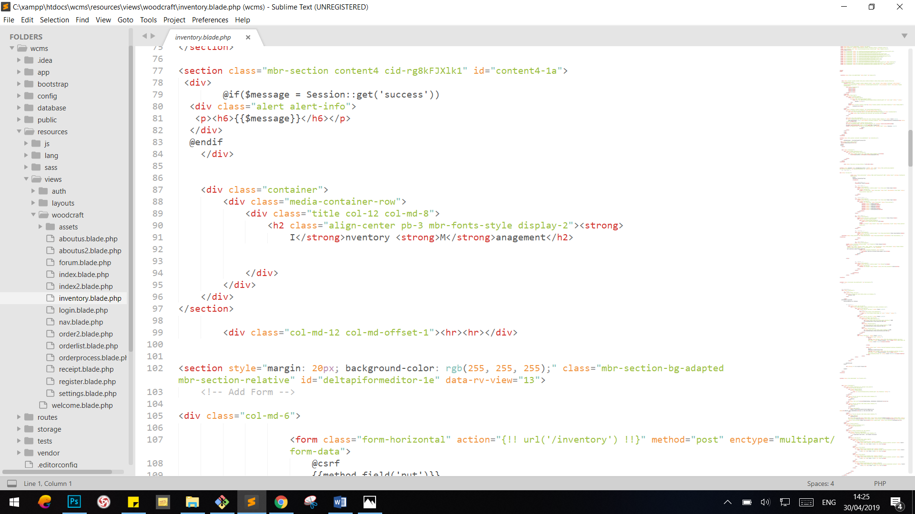

### Help

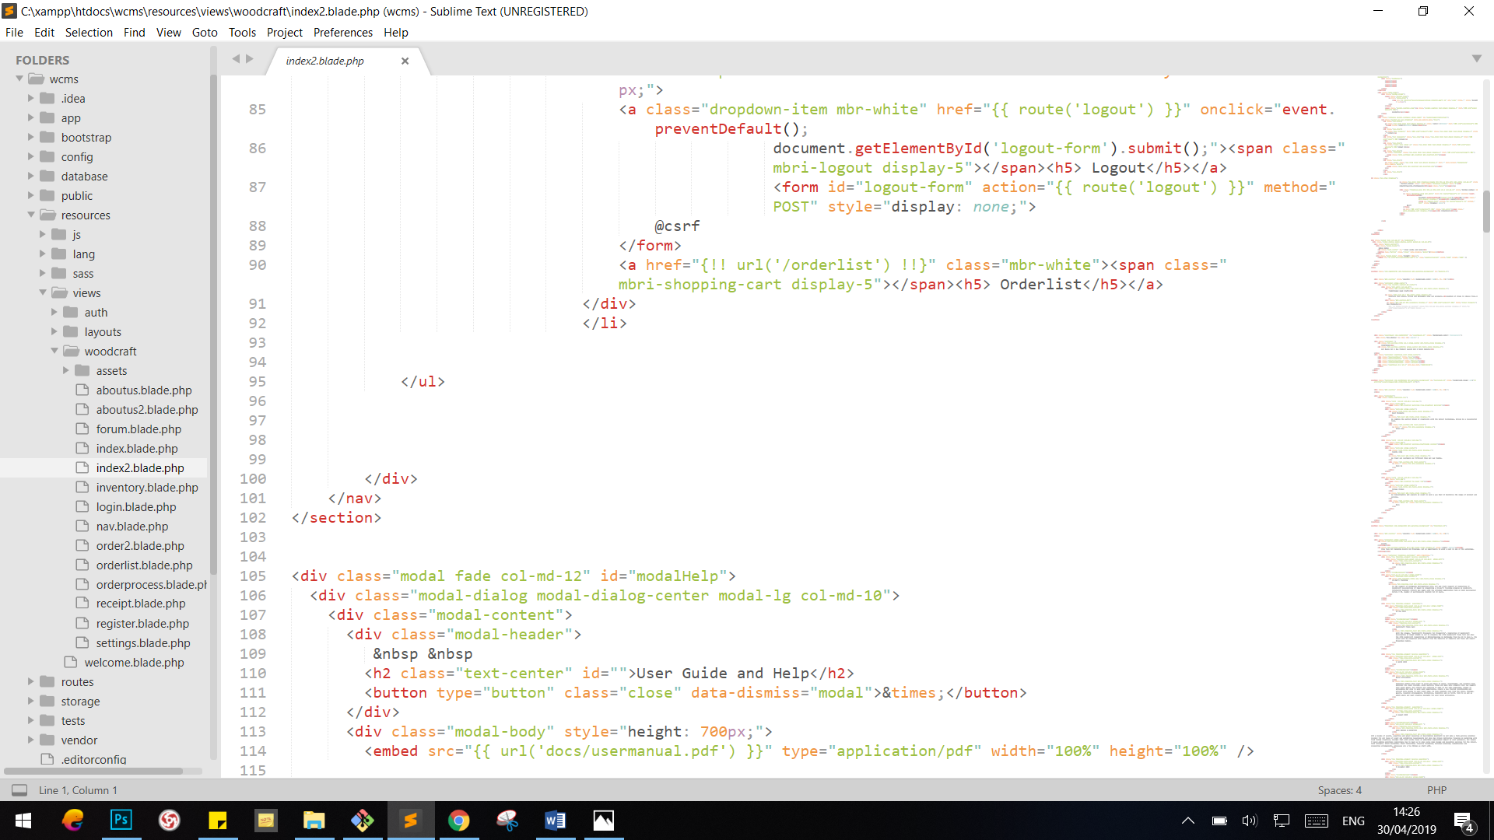

## Controller

Instead of defining all of your request handling logic as Closures in route files, you may wish to organize this behavior using Controller classes. Controllers can group related request handling logic into a single class. Controllers are stored in the app/Http/Controllers directory.

Following are the controllers for the aapplication:

### Wcmscontroller

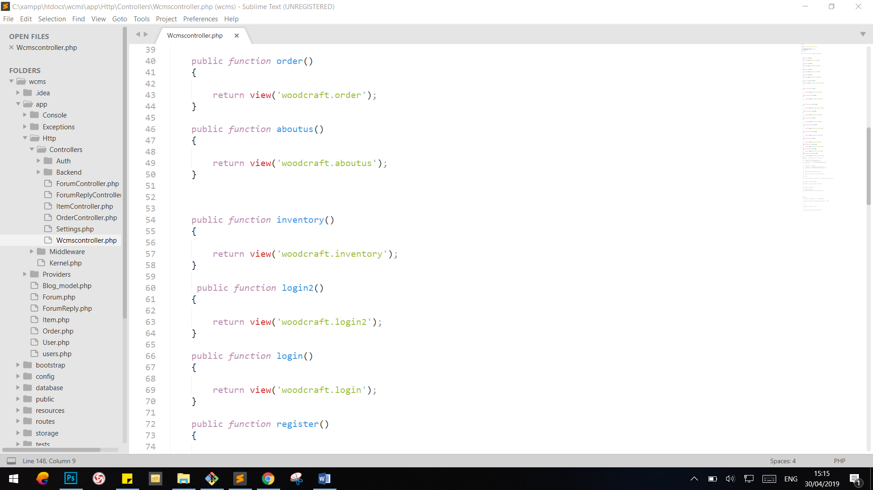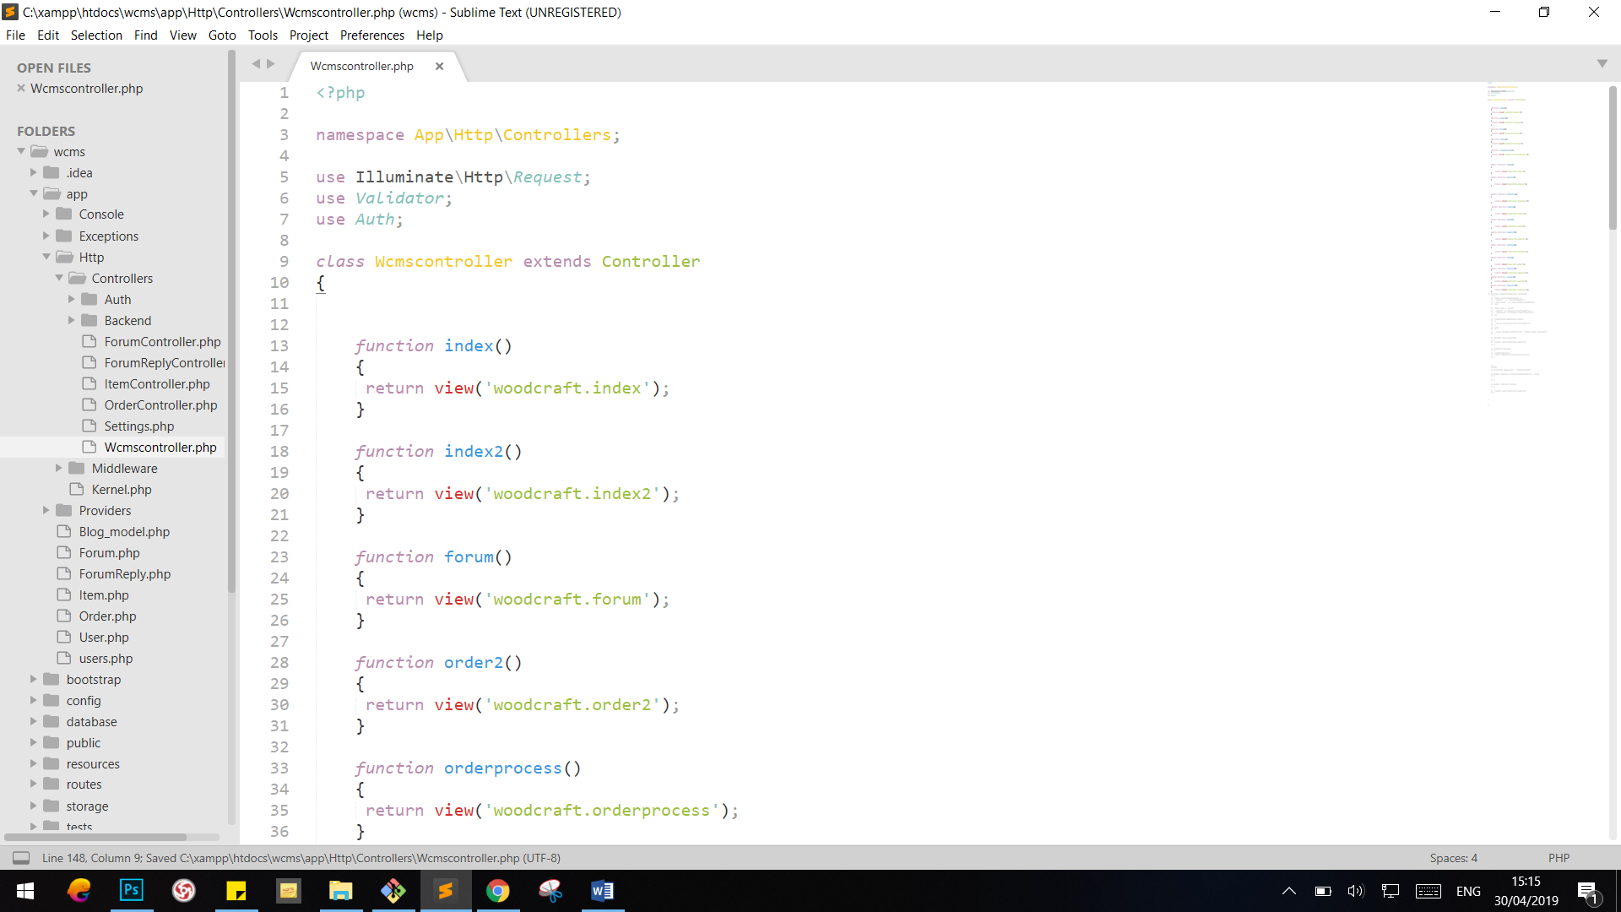

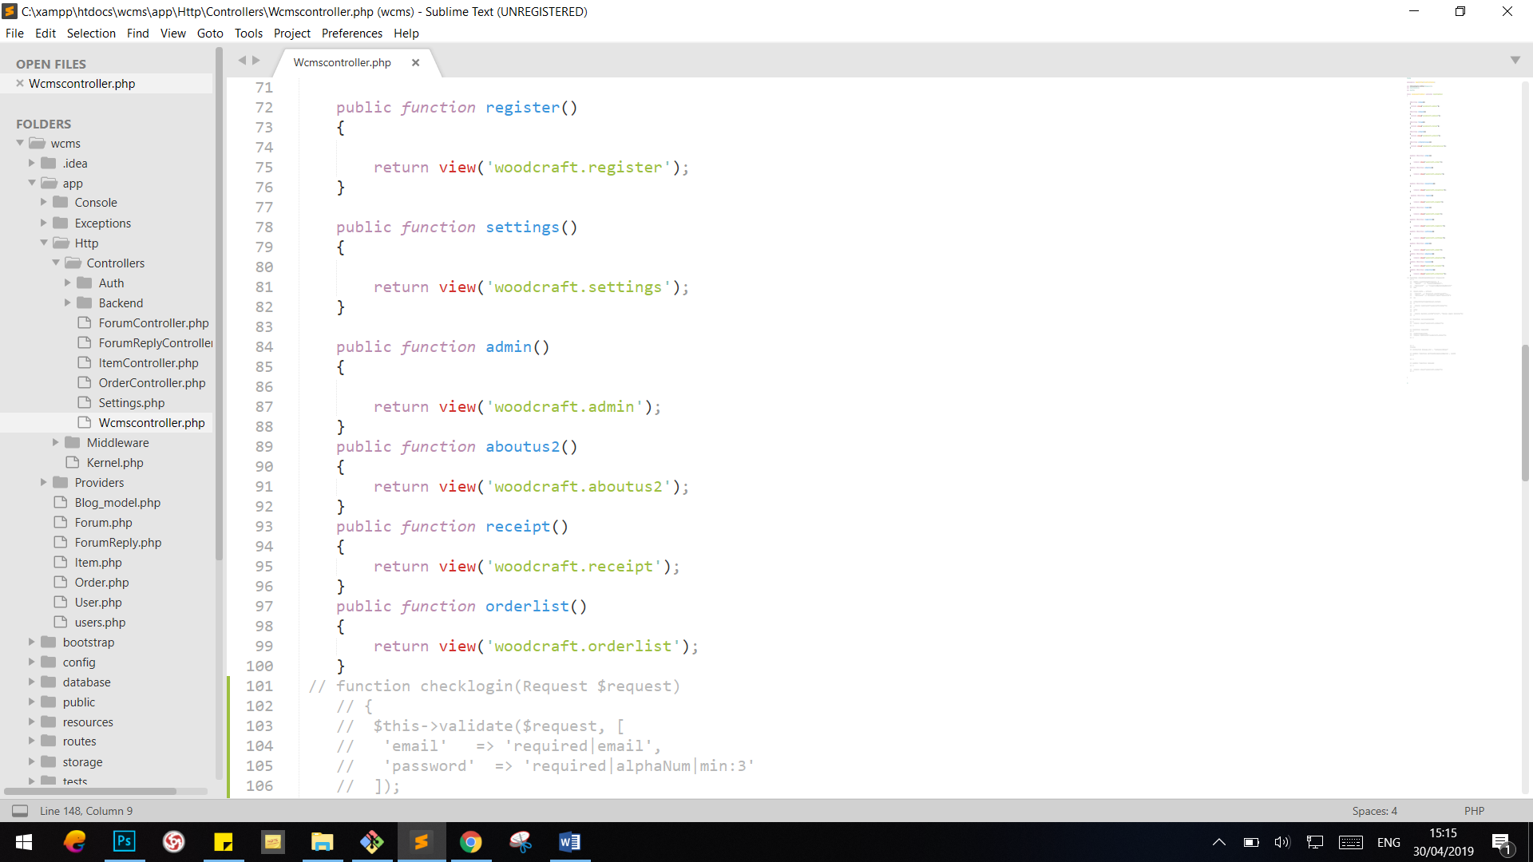

### LoginController

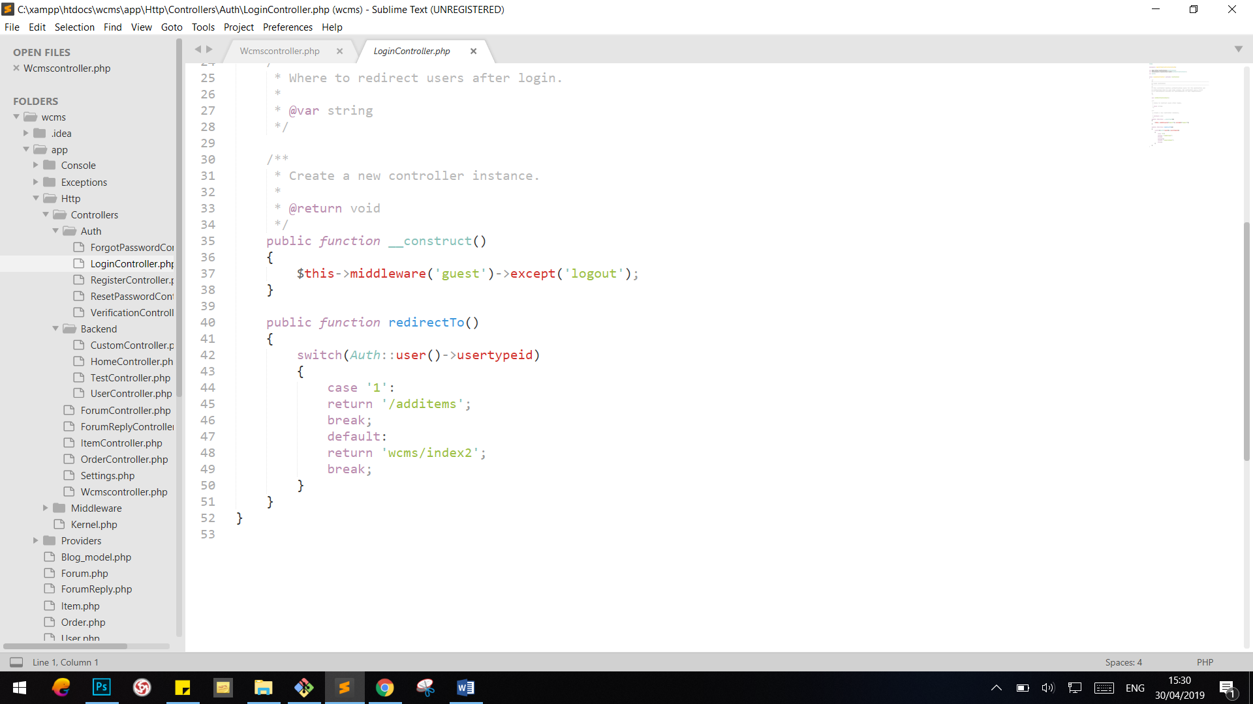

### RegisterController

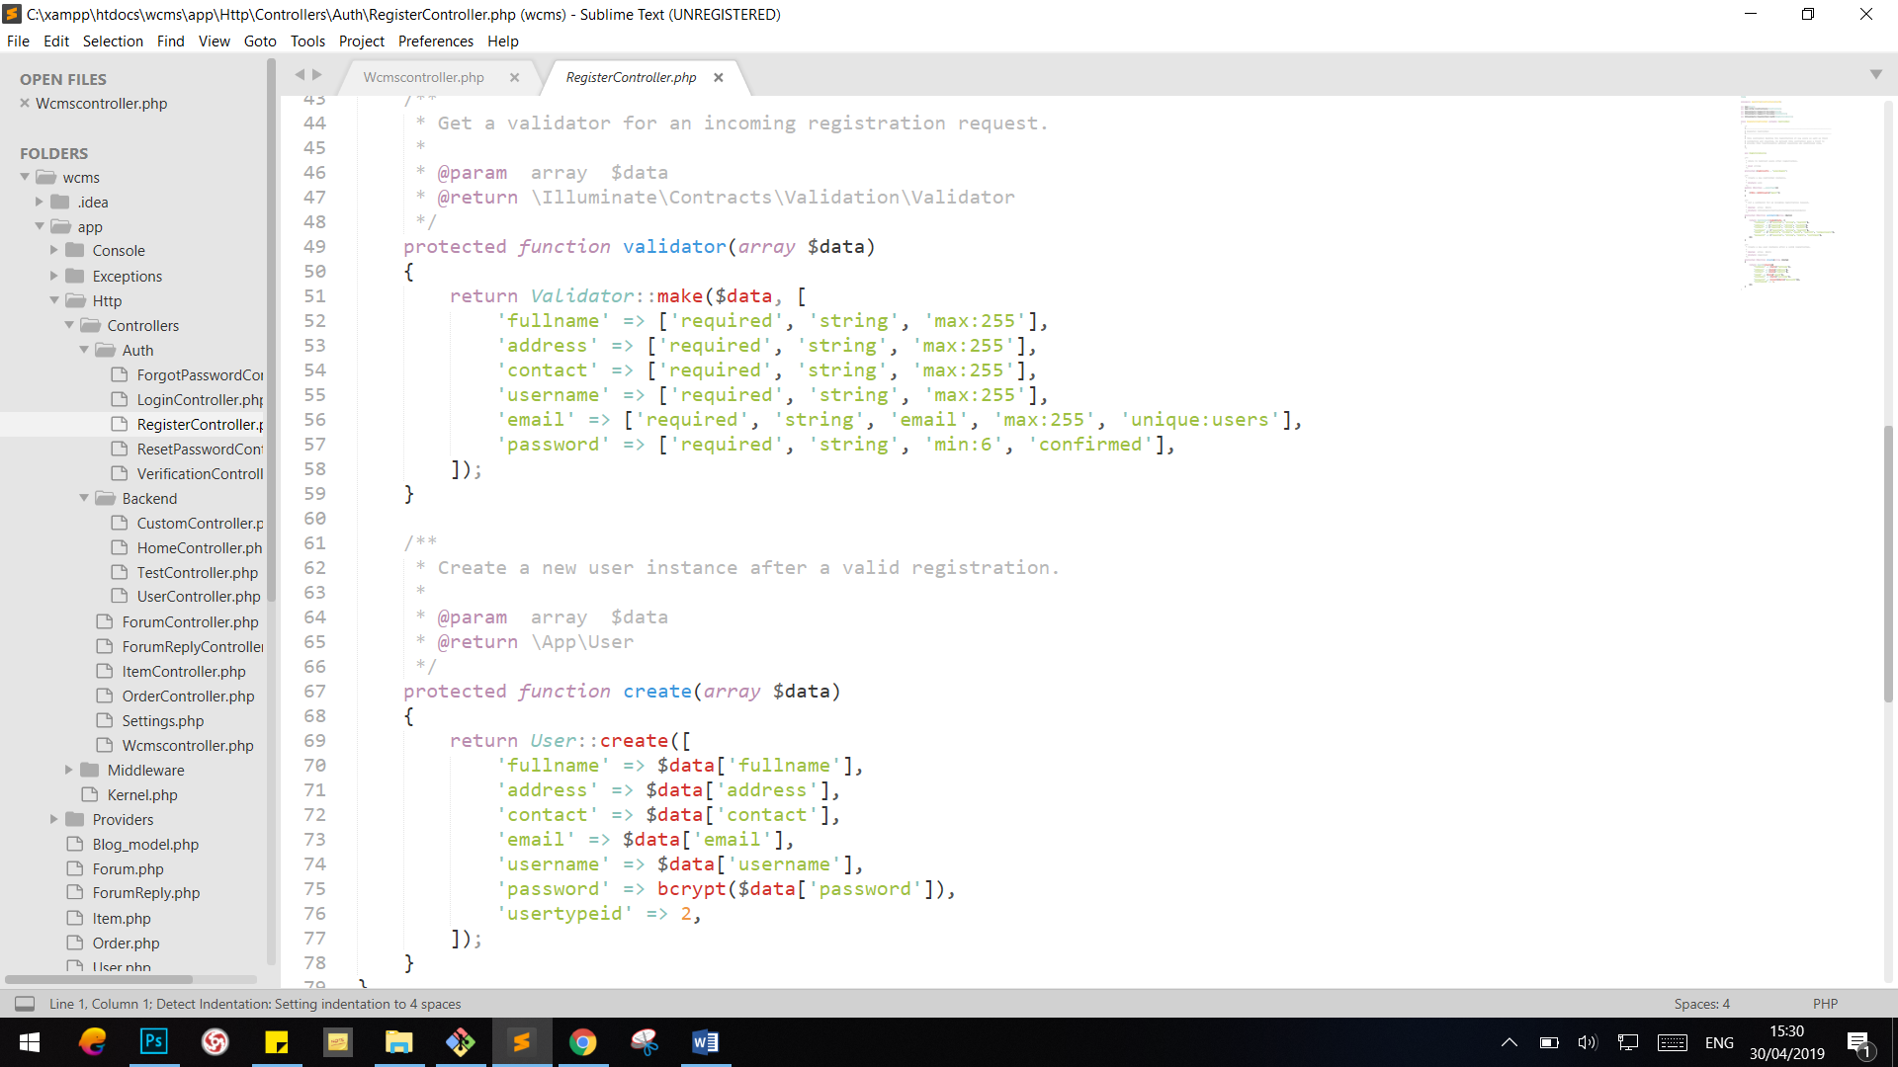

### ForumController

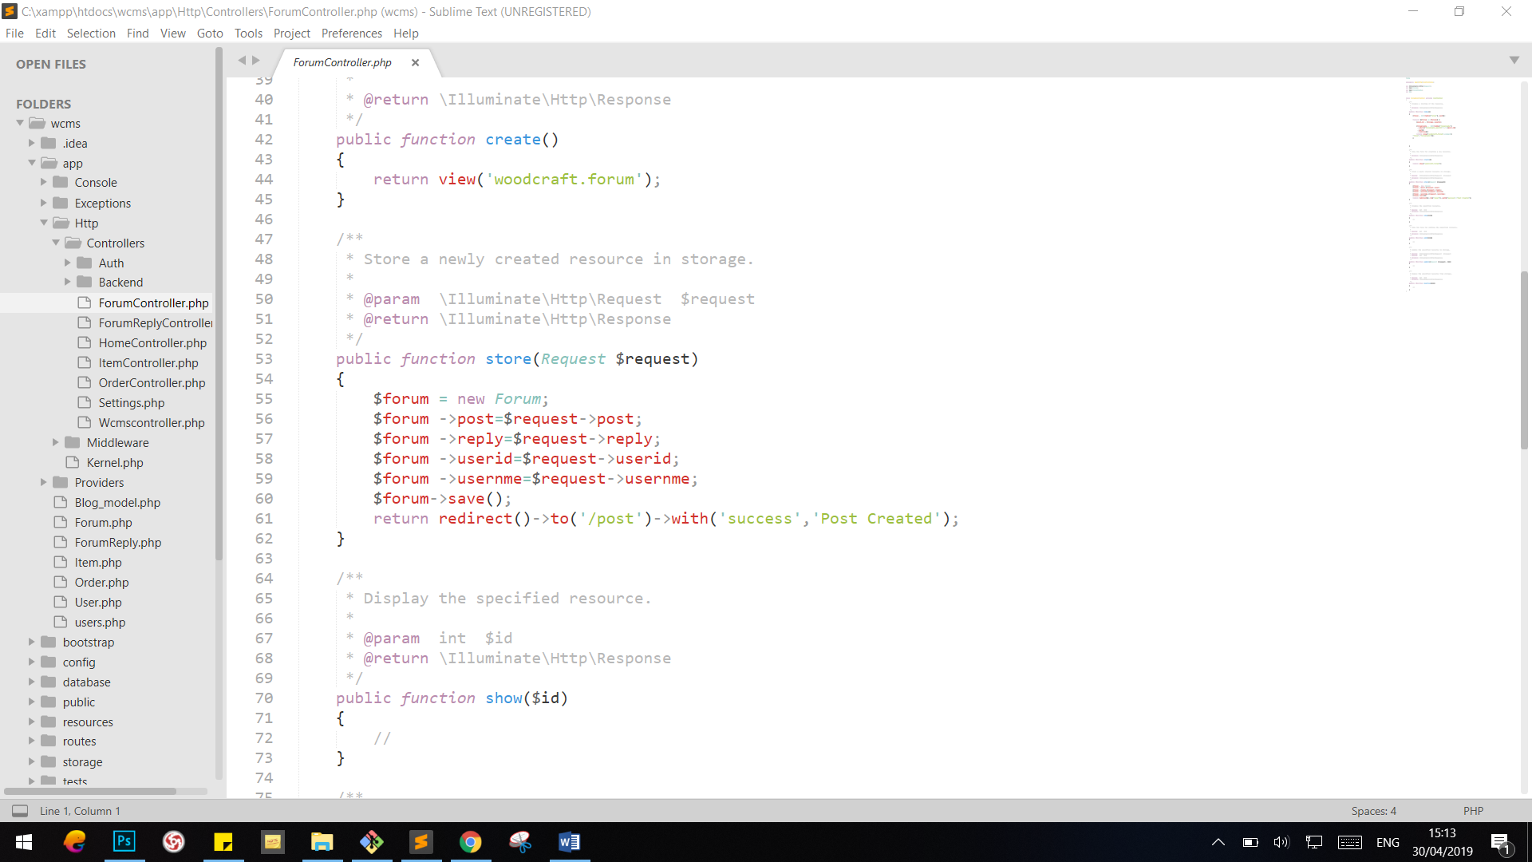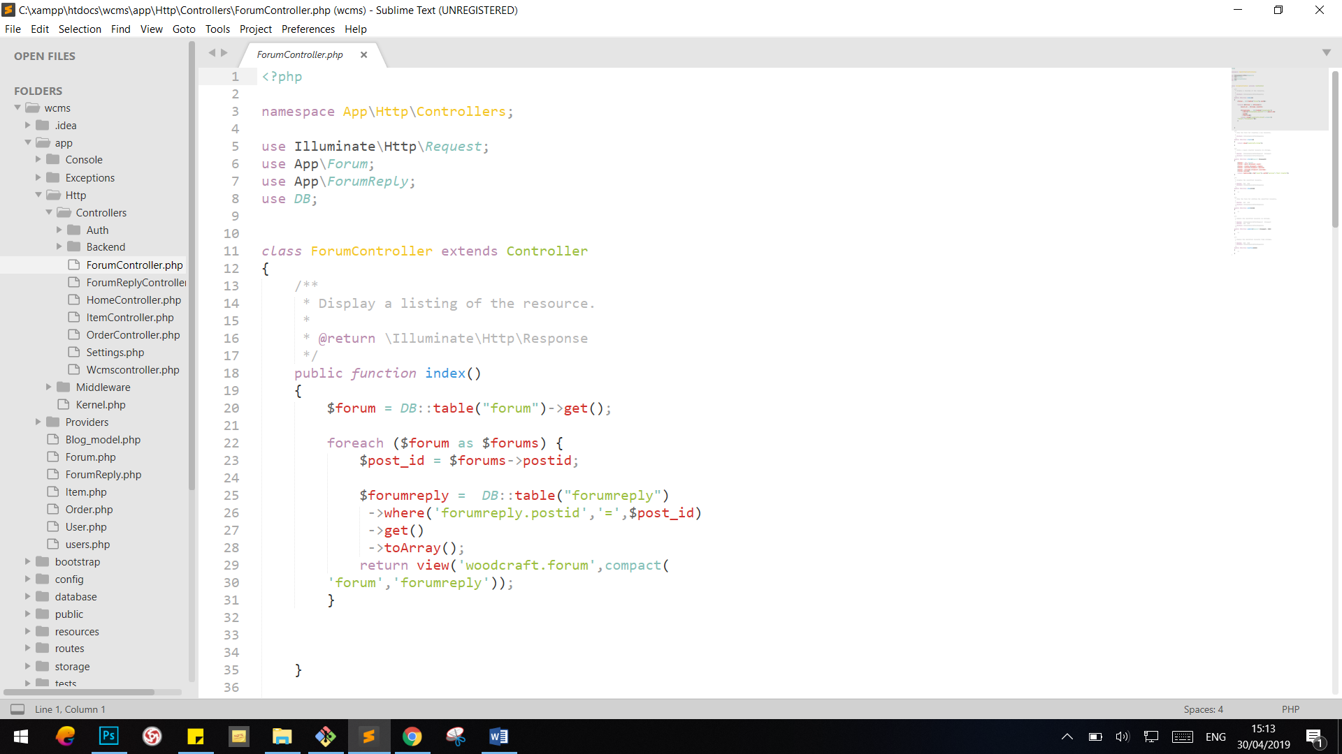

### ForumReplyController

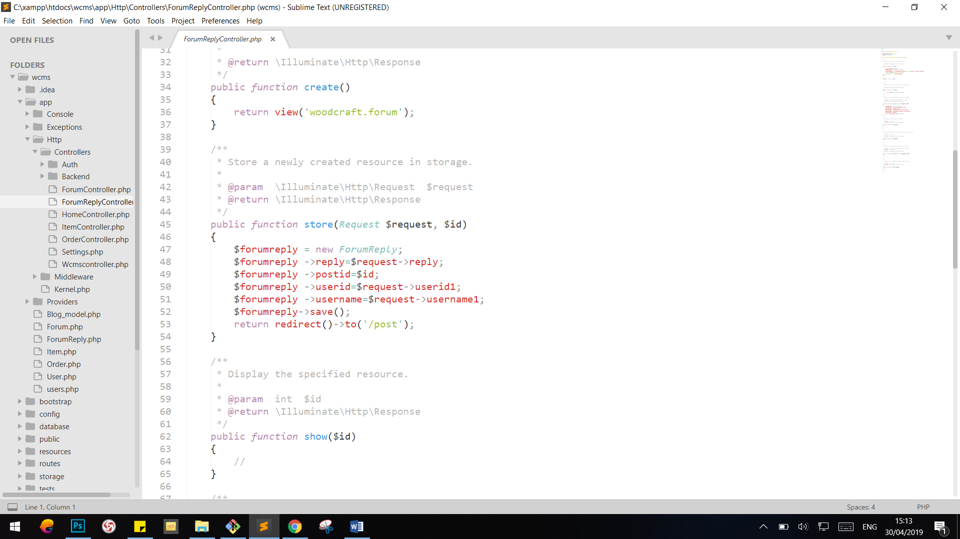

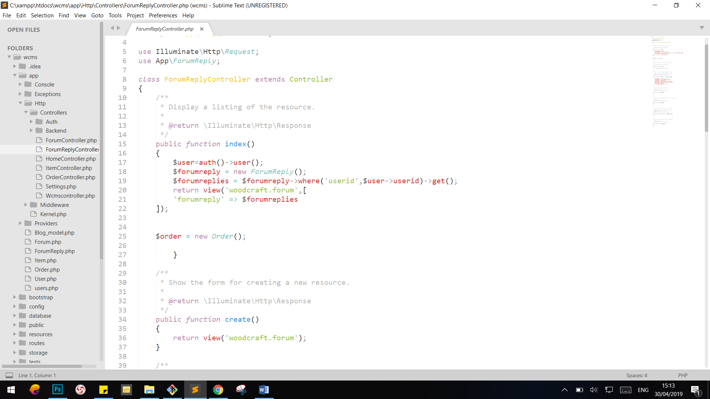

### ItemController

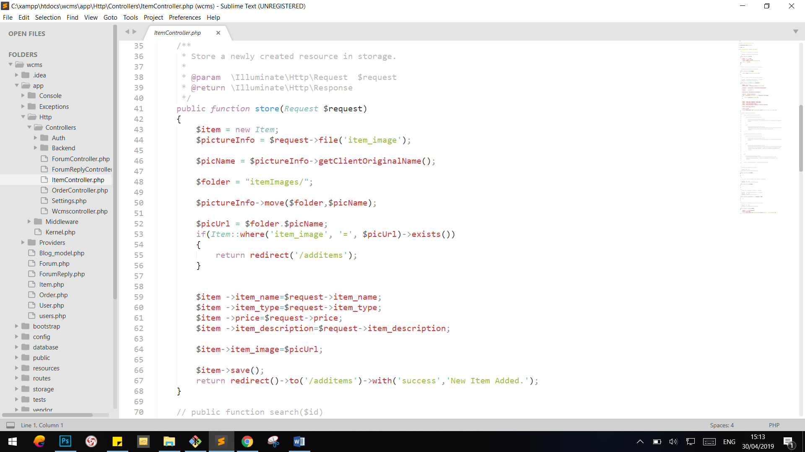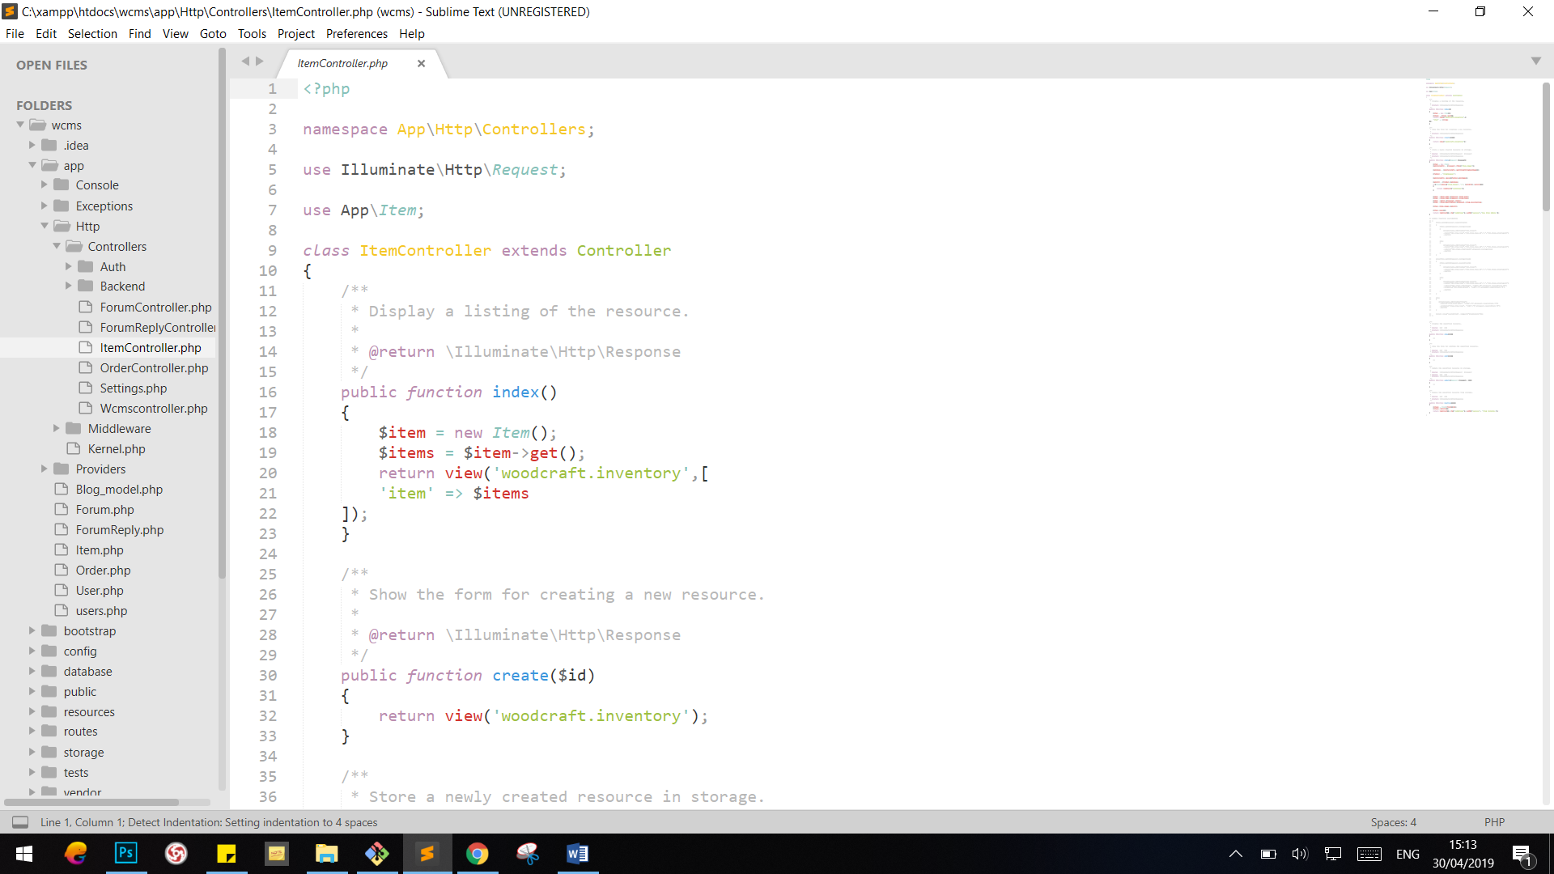

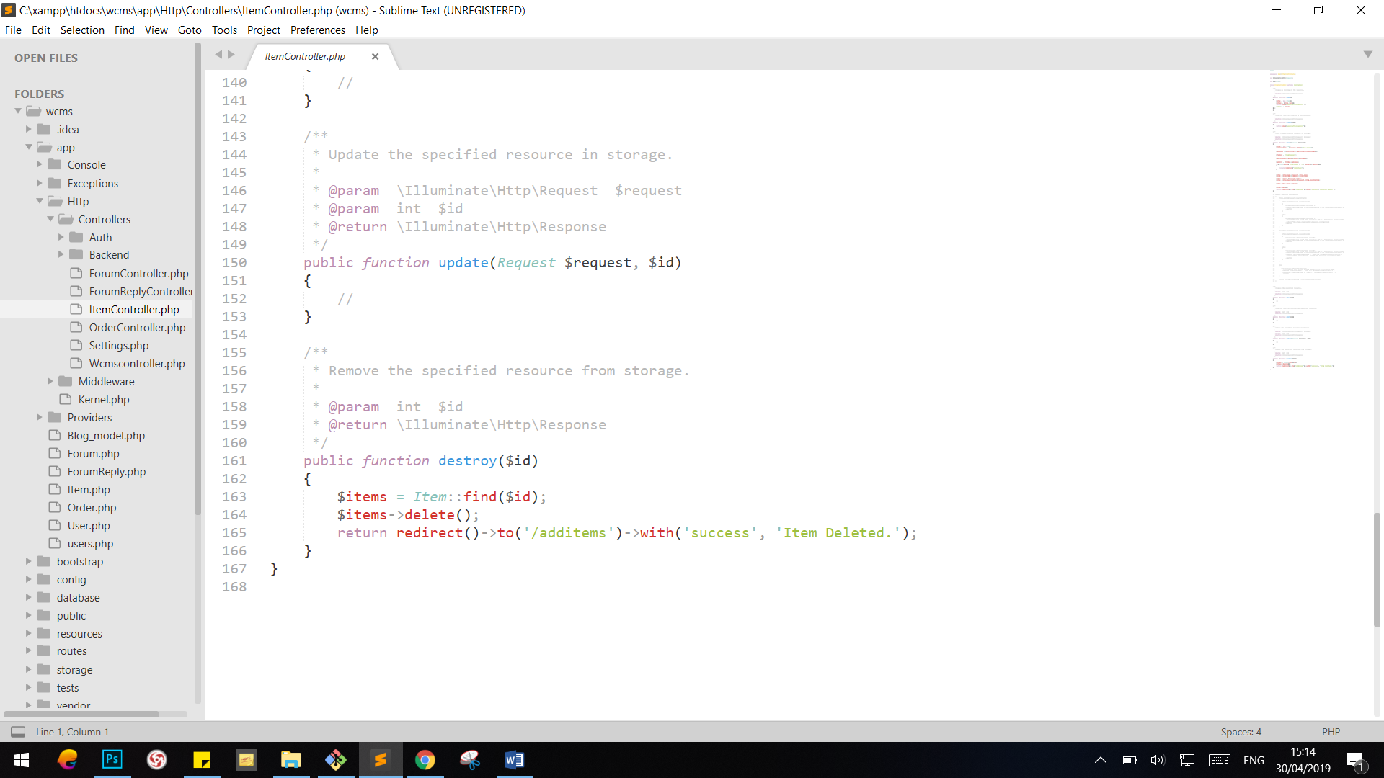

### OrderController

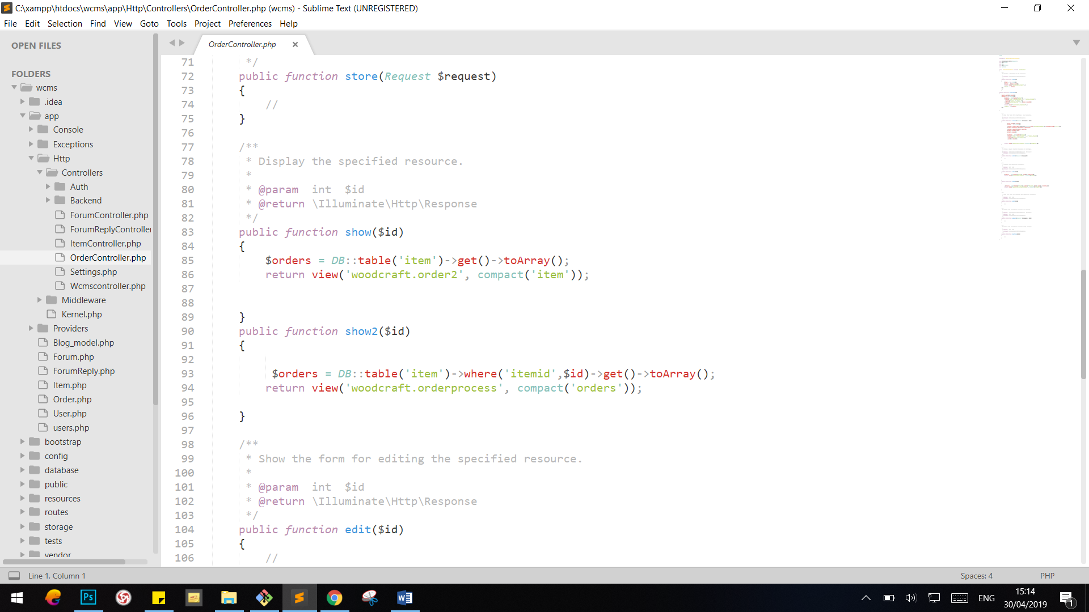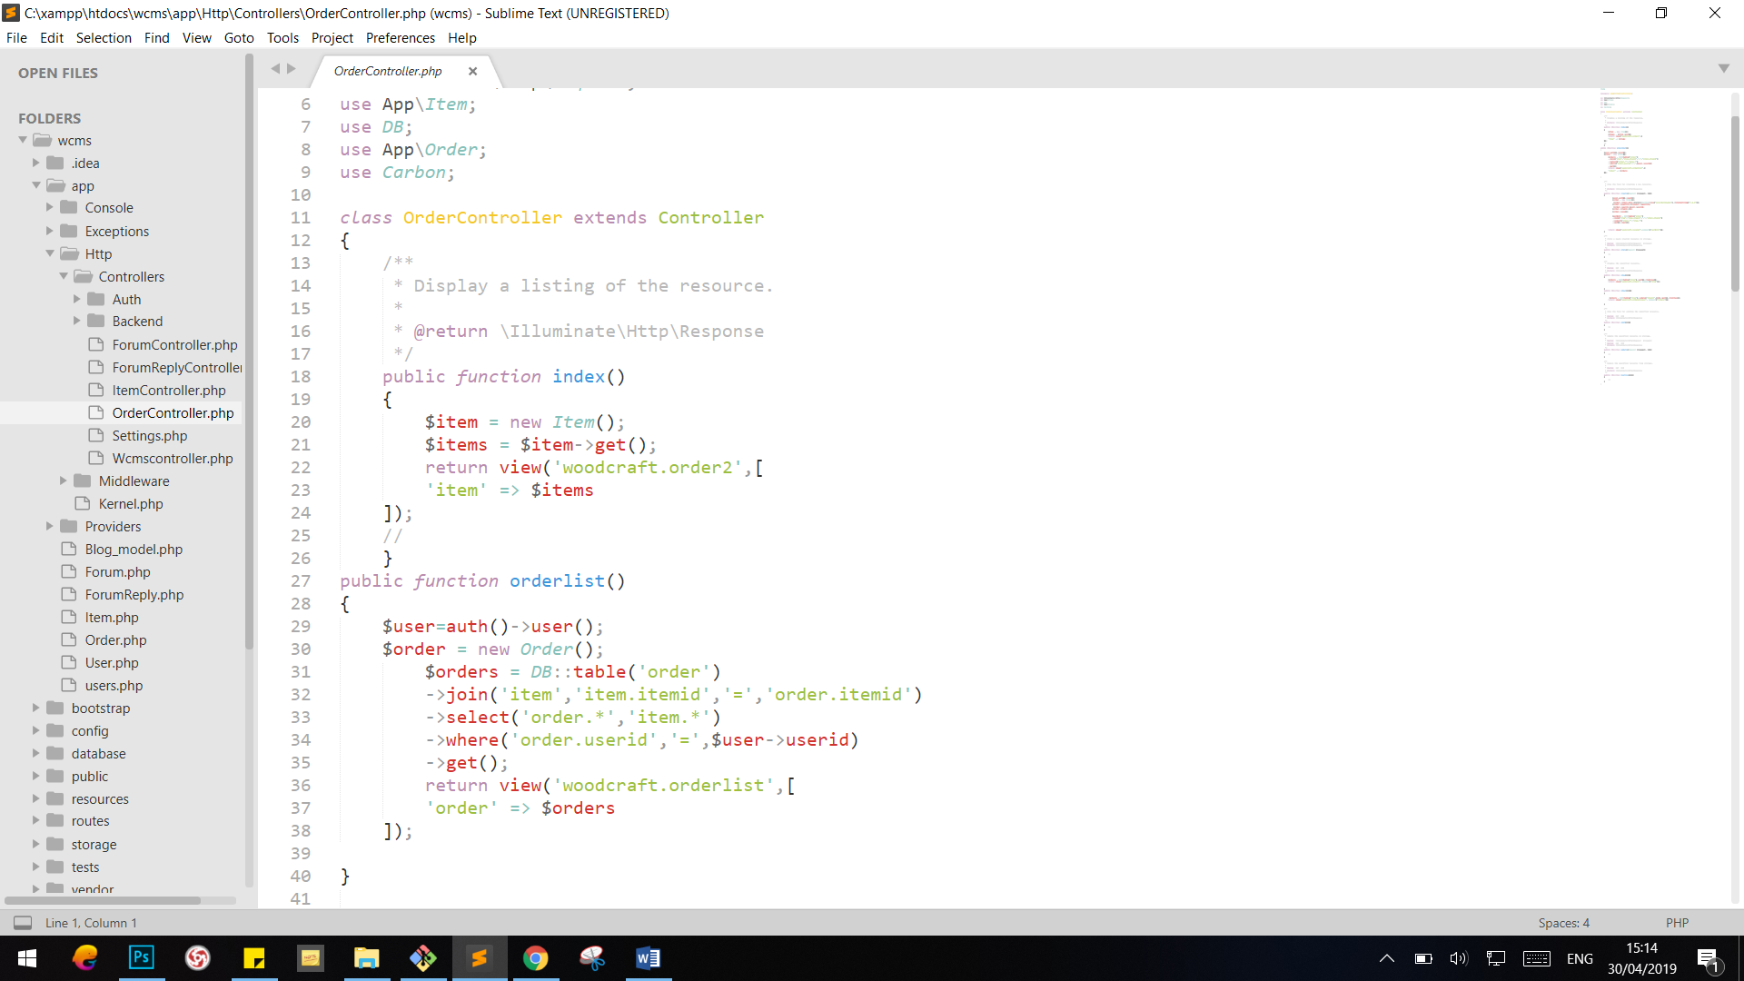

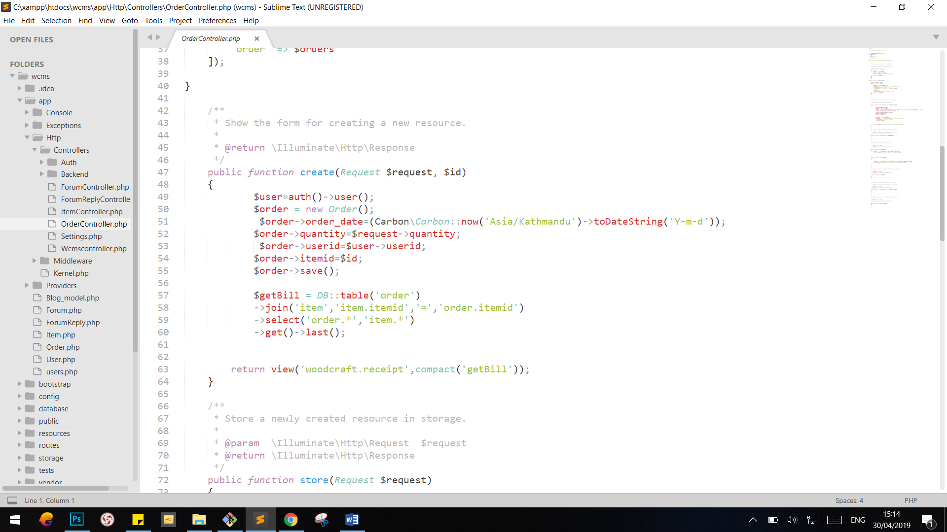

### Settings

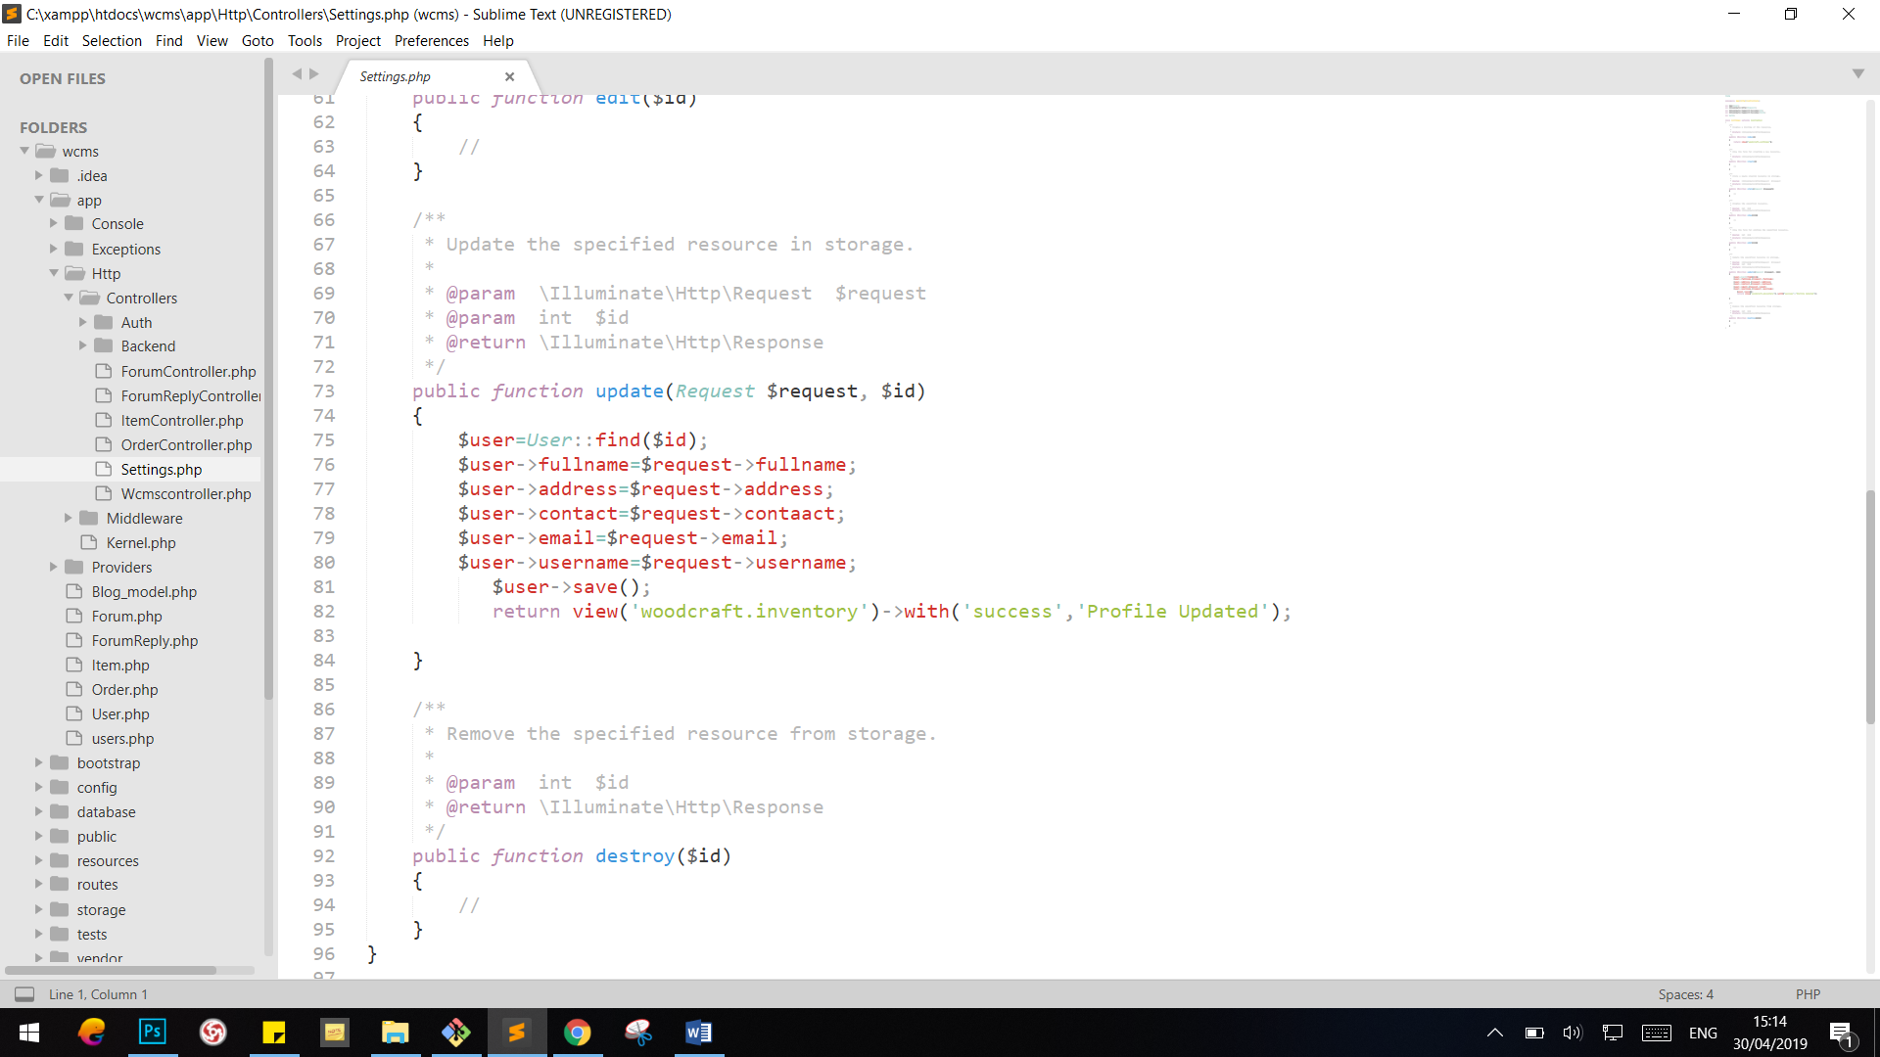

## Migrations

Migrations are like version control for your database, allowing your team to easily modify and share the application's database schema. Migrations are typically paired with Laravel's schema builder to easily build your application's database schema. If you have ever had to tell a teammate to manually add a column to their local database schema, you've faced the problem that database migrations solve.

Following are the migrations of the application:

### usertype

### user

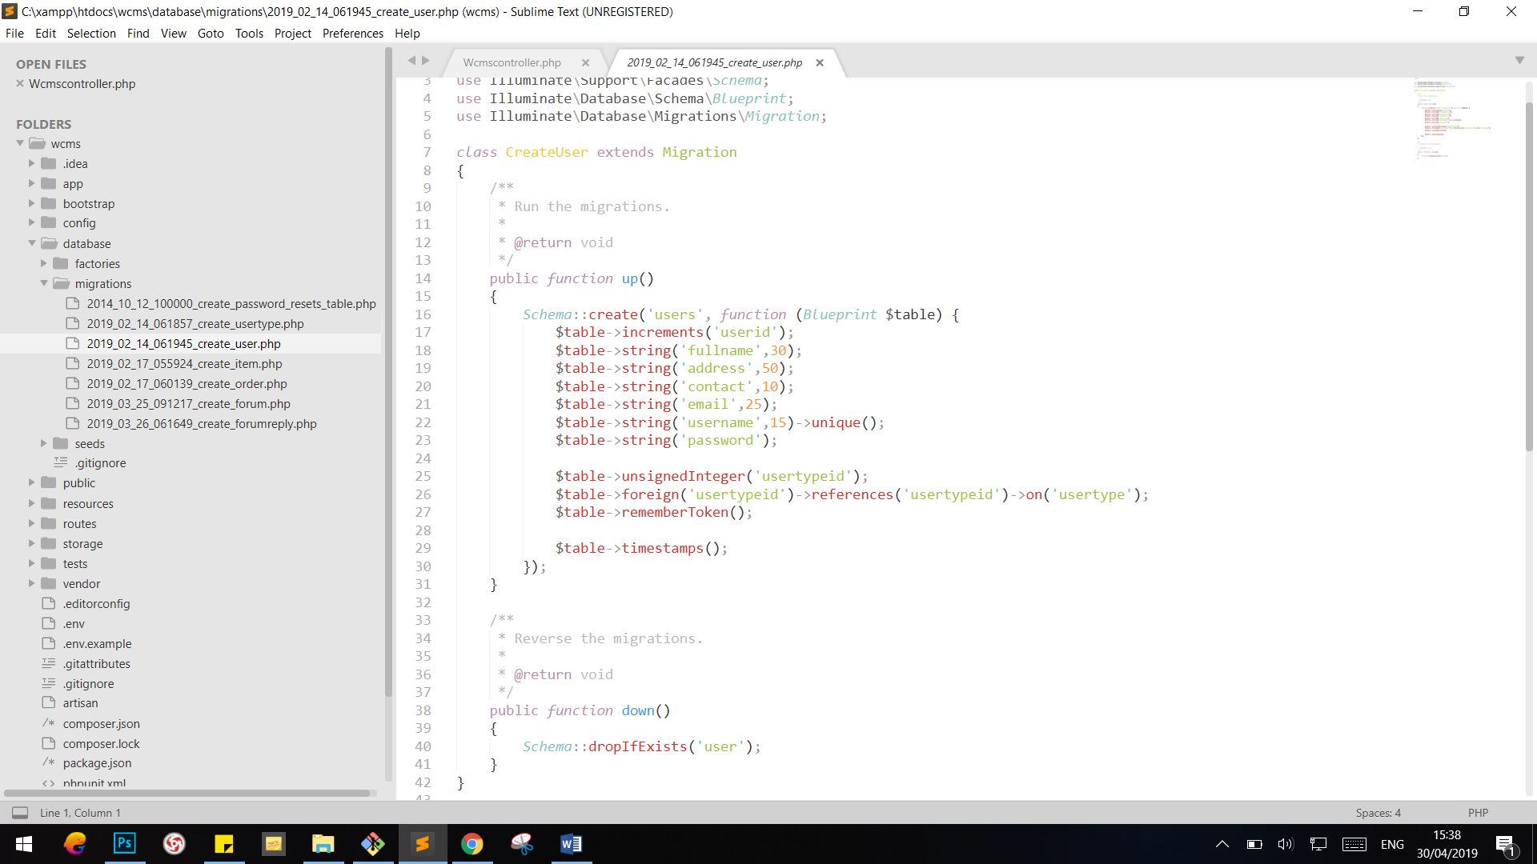

### item

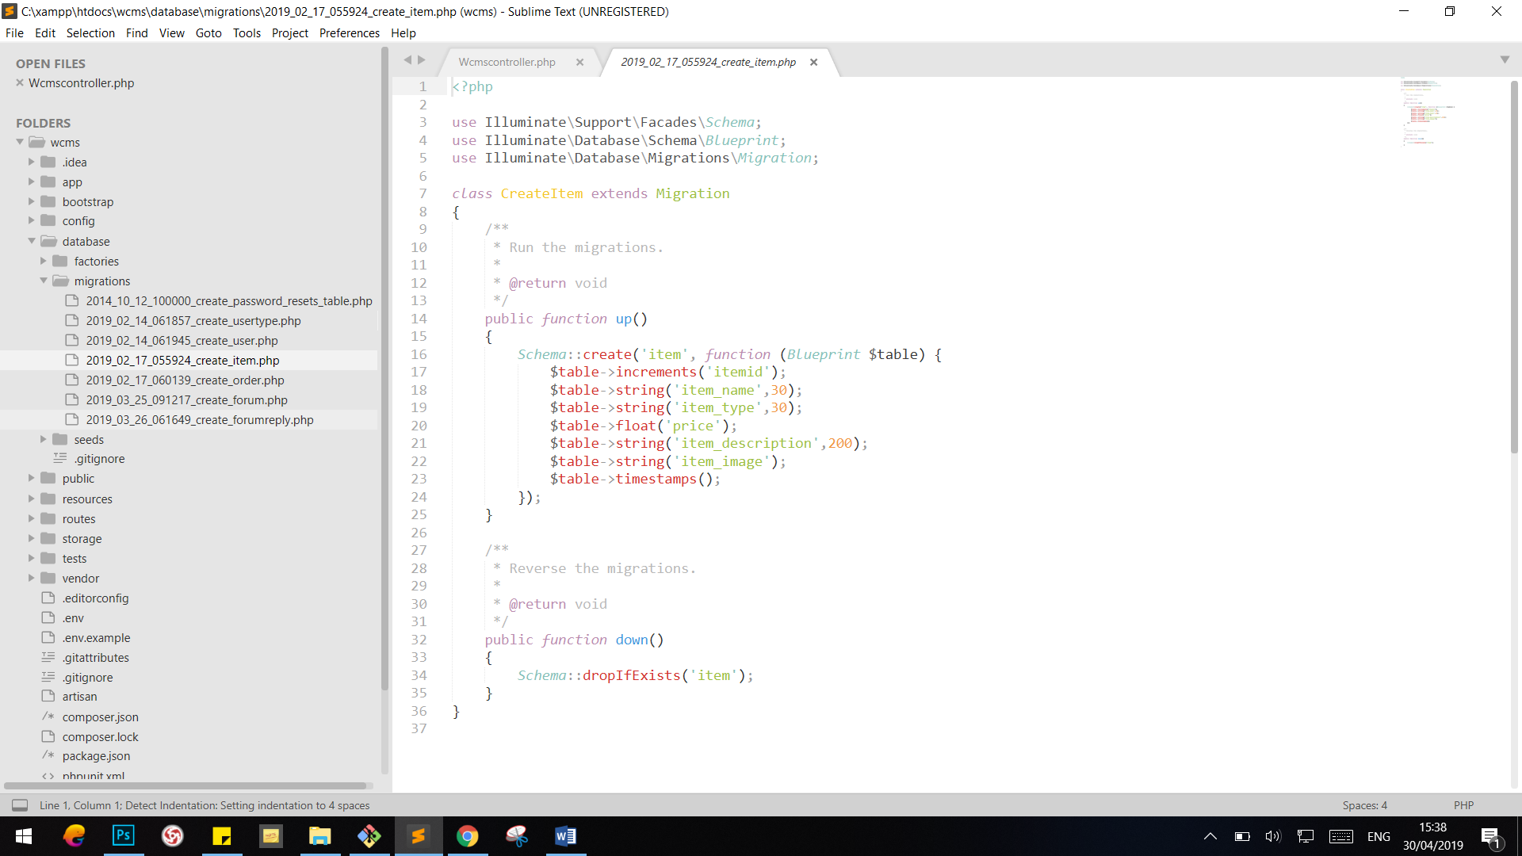

### order

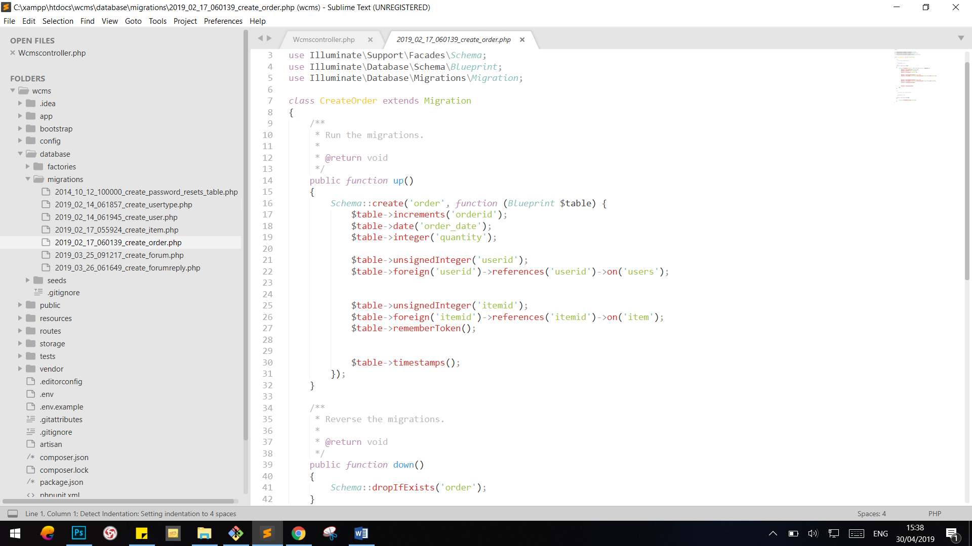

### forum

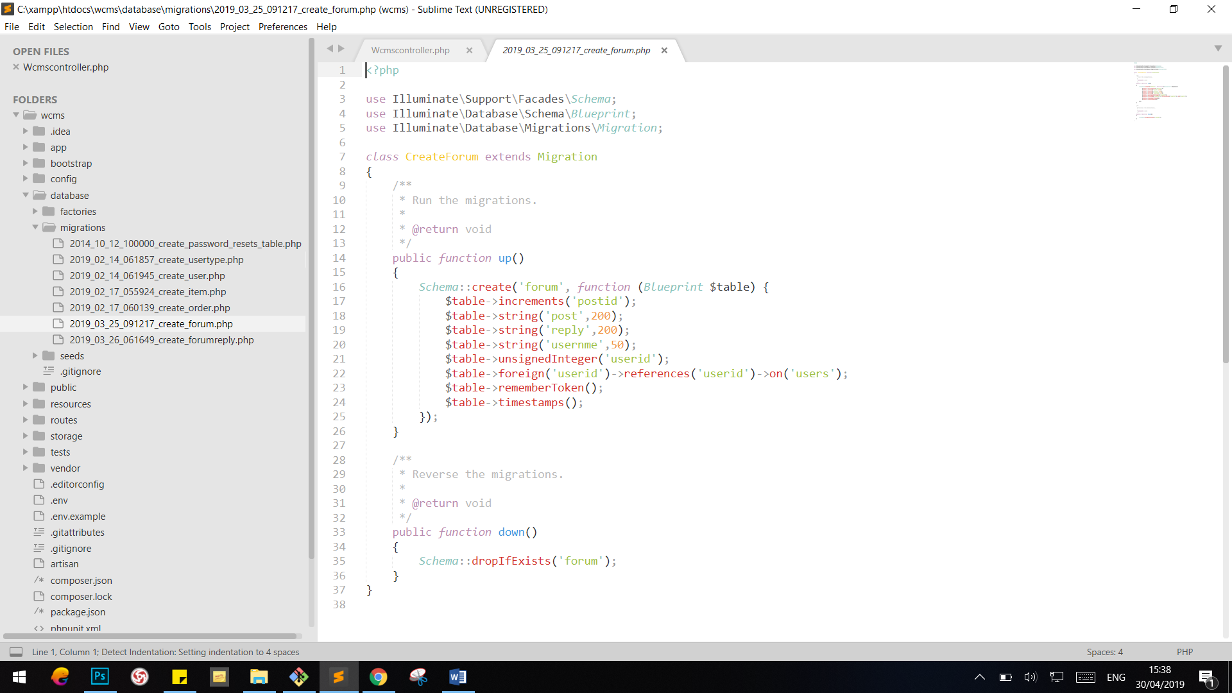

### forumreply

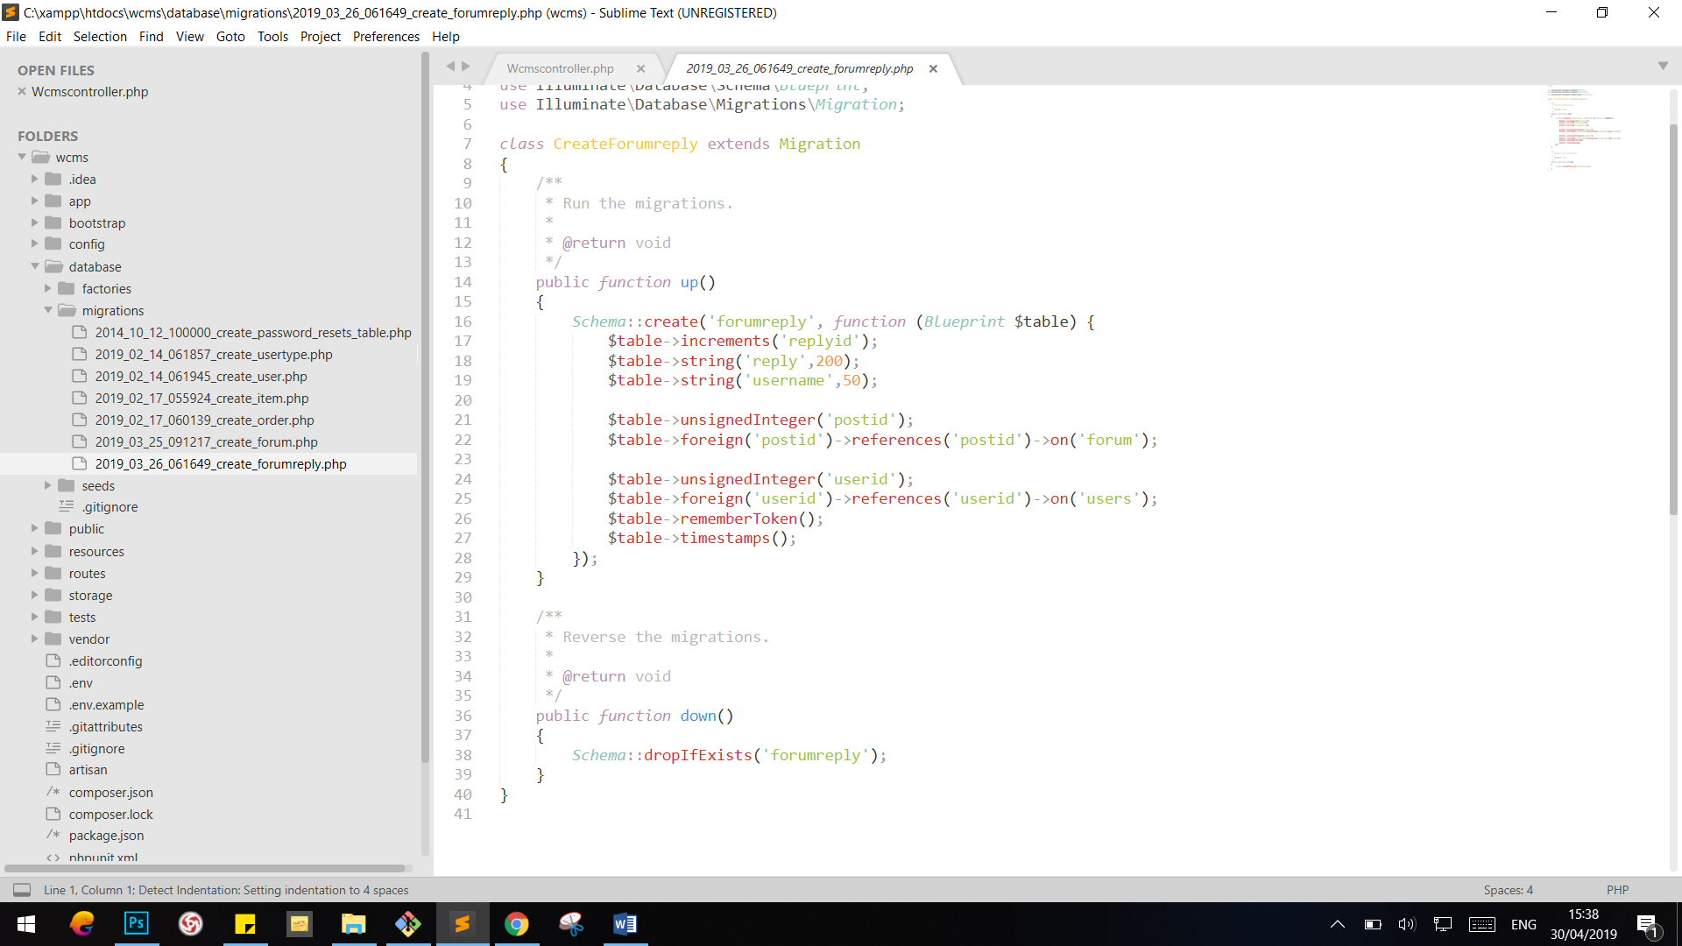

## Database in SQL Server

SQL Server database is of two types; System databases are created automatically when we install MS SQL Server. Users. System User databases are created by users (Administrators, developers, and testers who have access to create databases).

Following are the SQL databases for this application:

### 9.3.1 usertype

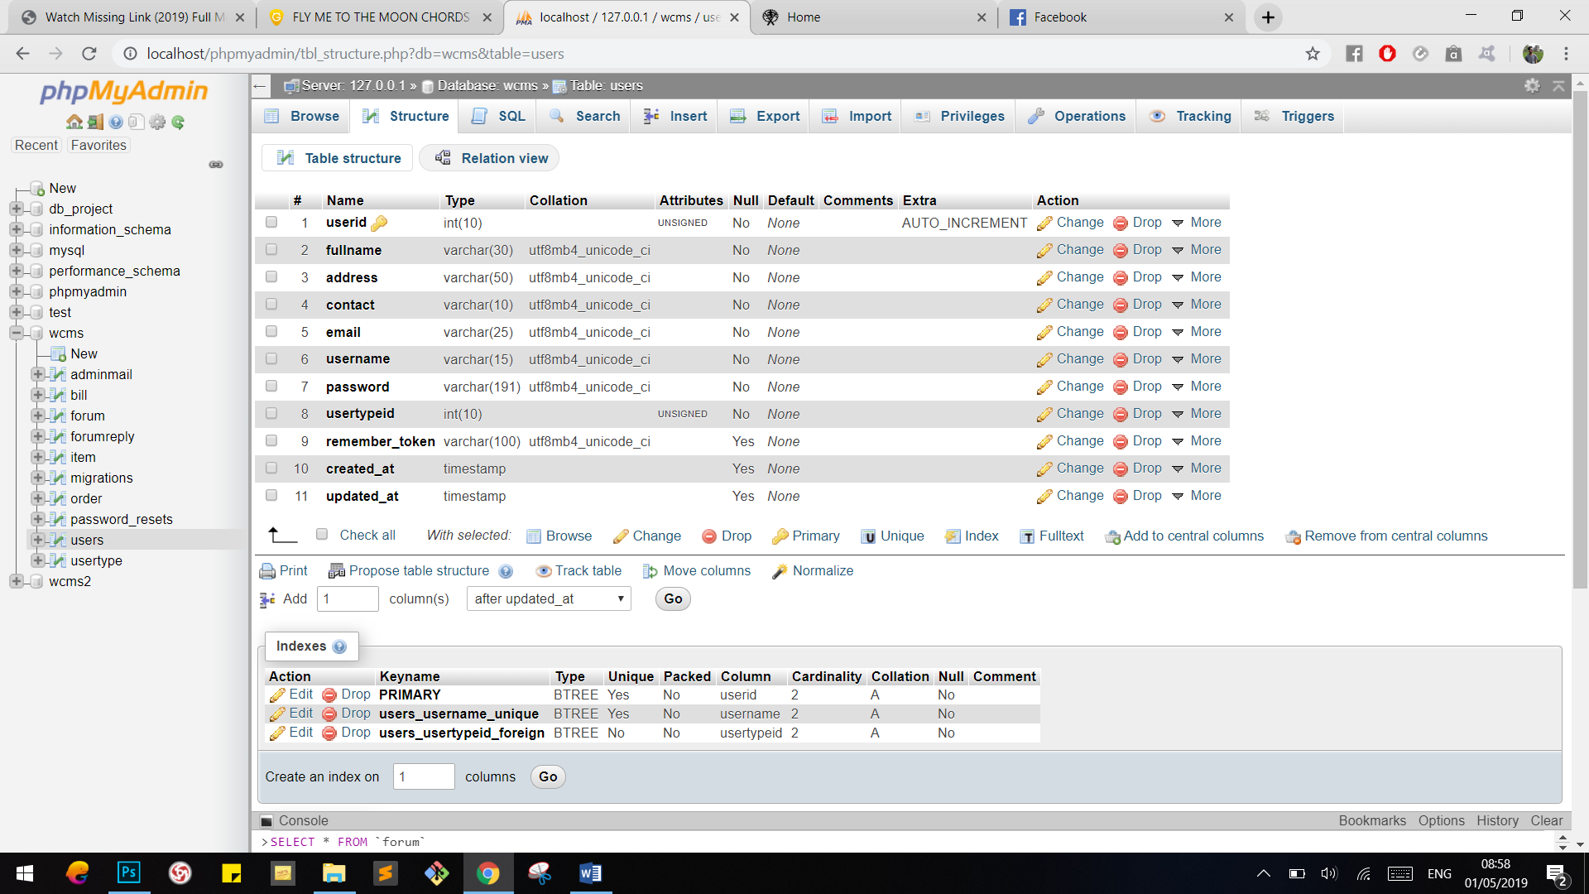

### 9.3.2 user

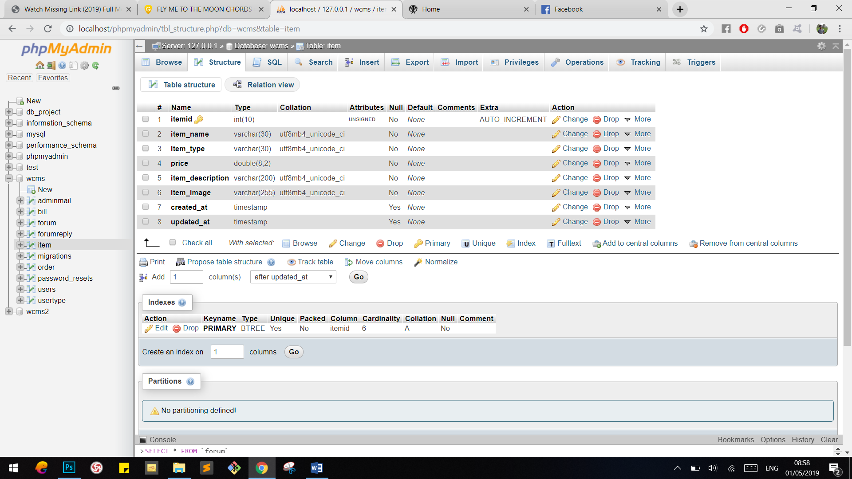

### 9.3.3 item

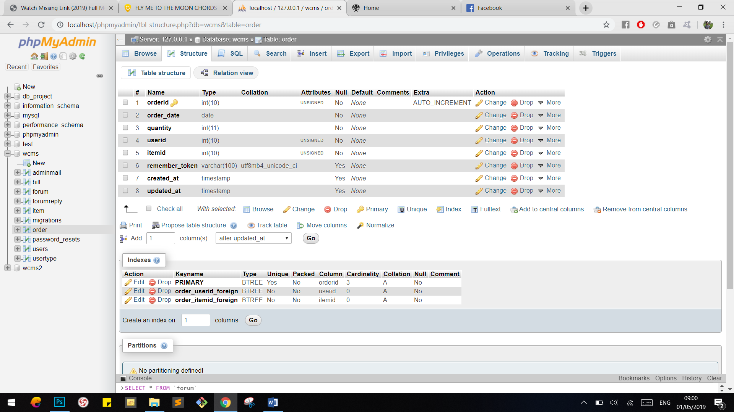

### 9.3.4 order

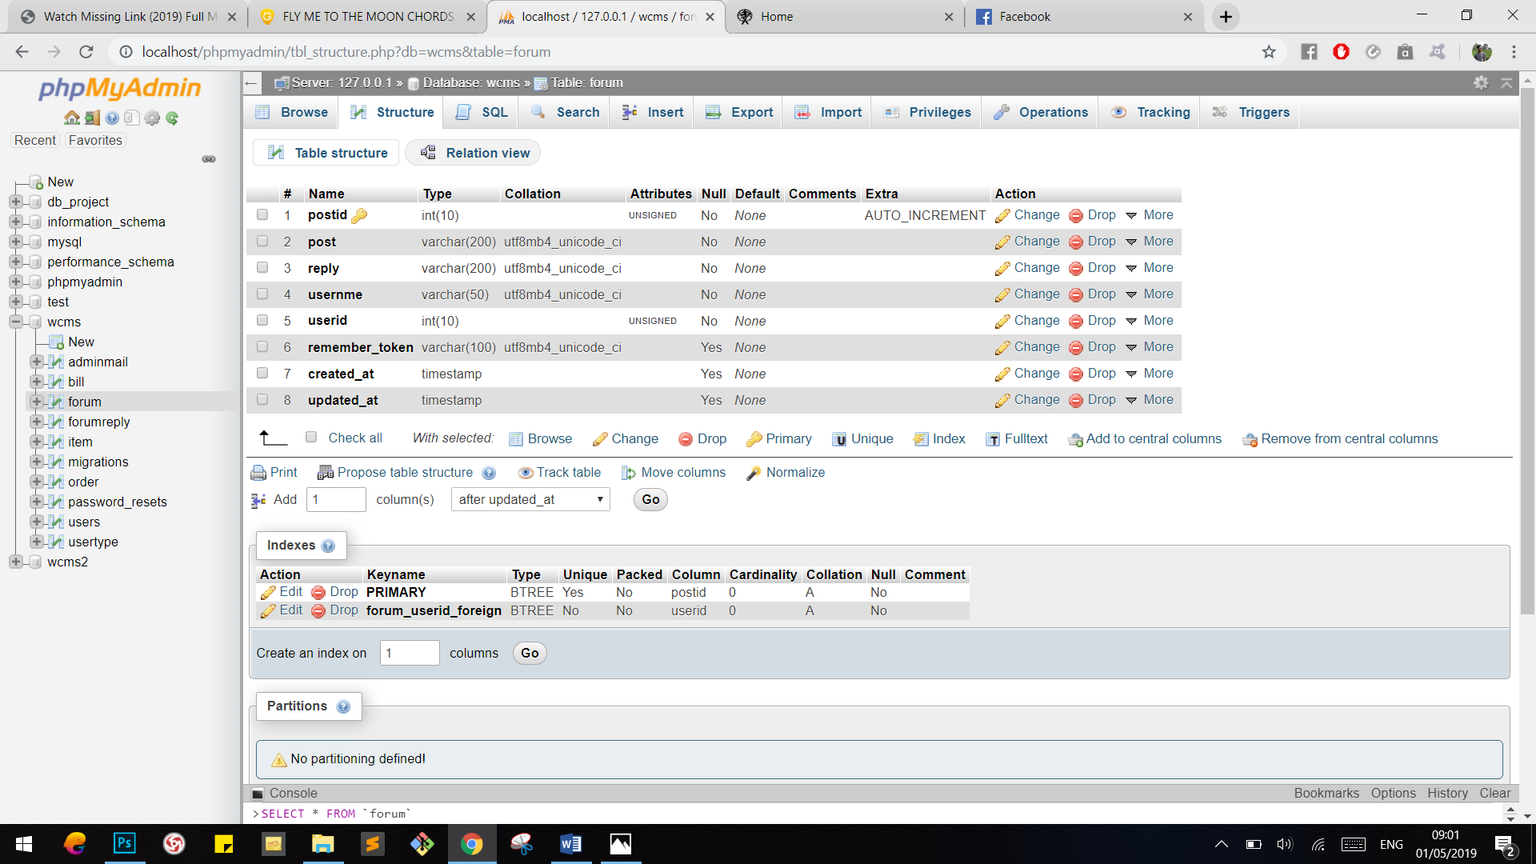

### 9.3.5 forum

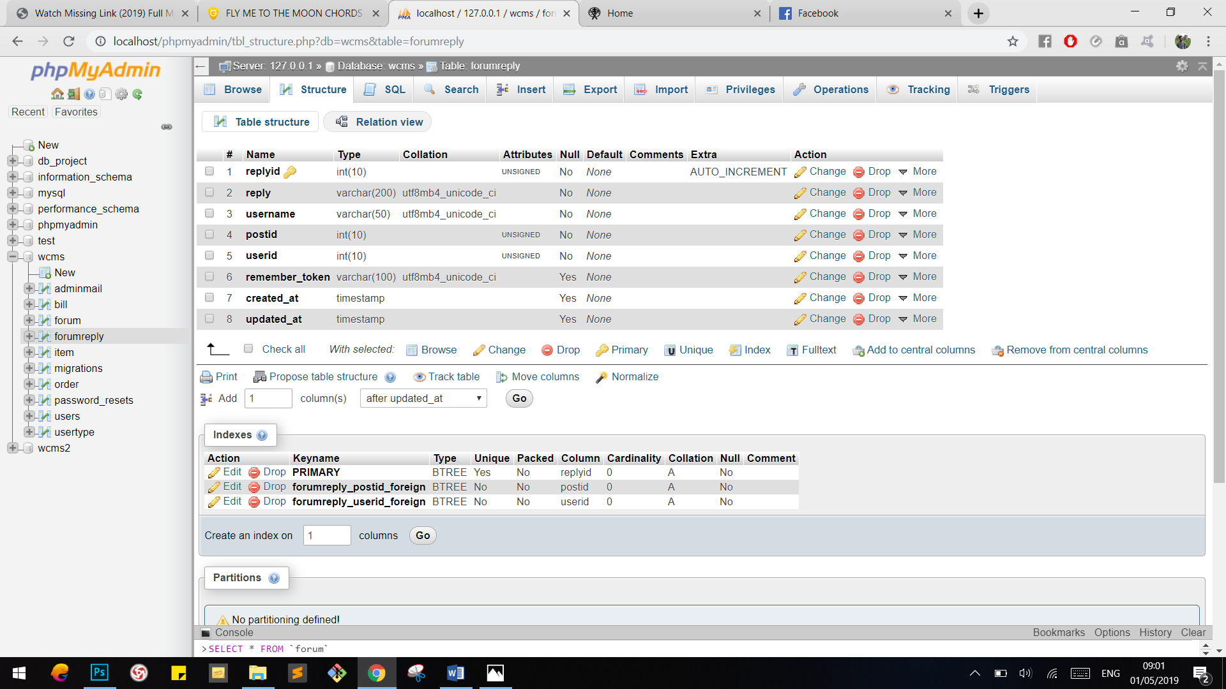

### 9.3.6 forumreply

